

Multidisciplinary Journal of Science Technology Education and Management
Journal homepage: http://www.mjstem.org

Groundwater Flow Dynamics and Structural Controls in a Basement Complex Terrain: Evidence from Hand-Dug Wells in Parts of Minna Sheet 164 SW, North Central Nigeria
Umar Sulaimanª*, Abdullahi Idris-Nda^{b}, Musa Suleiman Tenimu^{b}, Abubakar Abduljaleel Enesi^{b}, Folorunsho Owolabi Wahab^{c}
ªDepartment of Geosciences, Universiti Teknologi PETRONAS, Malaysia;
^{b}Geology Department, Federal University of Technology, Minna, Nigeria;
^{c}Department of Geological Technology, Federal Polytechnic, Offa, Nigeria.
*Correspondence: Umar Sulaiman (umarsulaiman53@gmail.com)

Abstract
Groundwater in basement terrain is predominantly controlled by weathered regolith thickness and fracture systems, yet detailed quantitative characterization remains limited in parts of Minna Sheet 164 SW, North Central Nigeria. This study evaluates groundwater flow dynamics, structural control, and vulnerability within an 81 km² area underlain mainly by granite and schist. Geological mapping at a scale of 1:12,500 was integrated with a systematic grid-based inventory of 117 hand-dug wells. To improve methodological transparency, the study area was subdivided into approximately 500m x 500m grid cells to ensure spatial representativeness of hydrogeological measurements. Static water levels ranged from 0.9-10.3m (mean = 4.23m), well depths from 1.6-10.6 m (mean = 5.05m), and water column thickness from 0-4.8m. Water table elevations were interpolated using Ordinary Kriging, and the hydraulic gradient was quantified using I = Δh/Δl, yielding an average gradient of 0.02-0.03 along the dominant NE-SW flow path. Recharge interpretation was supported by a first-order rainfall-runoff water balance estimate based on NiMet data (2013-2023), indicating potential annual infiltration of approximately 3.9 × 10⁷ m³. Structural analysis reveals alignment between NNE-SSW joint orientation and groundwater flow direction, suggesting fracture-controlled anisotropy. Although vulnerability assessment remains conceptual, the thin overburden (0.5-1.0m) indicates moderate to high susceptibility to contamination. Limitations, including seasonal variability, absence of pumping test data, and interpolation uncertainty, are explicitly acknowledged. The study provides a hydrogeological framework to guide sustainable groundwater development in basement complex terrains.
Keywords: Groundwater flow, hydraulic gradient, structural control, hand-dug wells, basement complex terrains.

Introduction
Groundwater constitutes the most reliable and widely distributed source of freshwater in basement terrains, particularly in sub-Saharan Africa, where public water supply infrastructure is often inadequate (Mukherjee & Singh, 2020). In such geological environments, groundwater occurrence and movement are primarily controlled by secondary porosity developed within weathered and fractured bedrock systems (Salihu & Jimada, 2016). The hydraulic behavior of basement aquifers is therefore inherently heterogeneous and structurally influenced (Bierkens & Wada, 2019). Minna, located within the Nigerian Basement Complex of North Central Nigeria, has experienced rapid urban growth and increasing dependence on groundwater due to the limited efficiency of public water supply systems (Figure 1) (Obateru et al., 2024). Borehole success rates in the region vary considerably, largely as a function of lithological variability and fracture-controlled permeability (Wada & Bierkens, 2014).
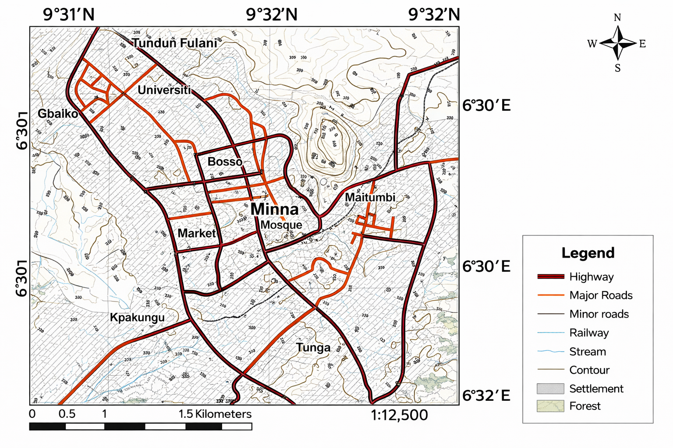
Figure 1: Map of the study area
Although previous investigations have described the regional geology and general hydrogeology of Minna and adjacent sheets, a detailed quantitative evaluation of groundwater flow dynamics and structural controls in parts of Minna Sheet 164 SW remains limited (Konikow & Kendy, 2005). In particular, few studies have integrated systematic well inventory data with structural orientation analysis to quantitatively assess the relationship between fracture systems and groundwater flow direction in this part of the basement complex (Nouradine et al., 2024; Pires et al., 2021). Understanding this relationship is essential in crystalline terrains, where groundwater movement is strongly influenced by structural anisotropy rather than primary porosity (Mukherjee & Singh, 2020). Mapping the potentiometric surface and quantifying hydraulic gradients are fundamental to identifying recharge and discharge zones, predicting contaminant transport pathways, and guiding sustainable well placement (Ajayi, 2006; Keegan-Treloar et al., 2023).
Additionally, overburden thickness (vadose zone thickness) plays a critical role in intrinsic aquifer vulnerability. Thin weathered profiles, common in granitic terrains, may reduce natural attenuation capacity and increase susceptibility to surface-derived contamination. However, vulnerability interpretation must distinguish between conceptual hydrogeological indicators and quantitative index-based modelling approaches (Acey, 2019). The study focuses on parts of Minna Sheet 164 SW, bounded by latitude 9°35′00″N to 9°40′00″N and longitude 6°30′E to 6°35′E, covering approximately 81 km² and underlain predominantly by granitic rocks with localized schist occurrences. Within this context, this study aims to provide a quantitative hydrogeological framework by constructing a detailed potentiometric surface map from systematic hand-dug well inventory data, quantifying groundwater flow direction and hydraulic gradient using geostatistical interpolation, evaluating the influence of joint orientation on subsurface flow patterns, and assessing aquifer vulnerability based on overburden thickness and first-order recharge estimation 9°40′00″N and Longitude 6°30′E to 6°35′E, covering approximately 81 km² and underlain predominantly by granitic rocks with localized schist occurrences Within this context, this study aims to provide a quantitative hydrogeological framework by constructing a detailed potentiometric surface map from systematic hand-dug well inventory data, quantifying groundwater flow direction and hydraulic gradient using geostatistical interpolation, evaluating the influence of joint orientation on subsurface flow patterns, and assessing aquifer vulnerability based on overburden thickness and first-order recharge estimation.

Methodology

Study Area and Preliminary Reconnaissance
The study area covers approximately 81 km² within parts of Minna Sheet 164 SW, North Central Nigeria. A preliminary reconnaissance survey was conducted to verify lithological boundaries, assess well distribution, and validate accessibility before systematic data collection. This reconnaissance also enabled refinement of field logistics and ensured uniform spatial coverage during the hydrogeological inventory.

Geological Mapping
Geological mapping was conducted using a 1:12,500 topographic base map derived from Minna Sheet 164 SW. Lithological units were identified through field observation of outcrops and verified using structural measurements where exposures permitted. Rock types were georeferenced using a handheld GPS receiver. Structural data, including joints and fractures, were measured using a compass-clinometer. Multiple joint orientations were recorded across representative outcrops to determine principal structural trends. These measurements were compiled and plotted as a rosette diagram to identify dominant fracture orientations controlling potential secondary permeability pathways.

Hydrogeological Inventory
A systematic hydrogeological inventory of hand-dug wells was conducted across the study area. To ensure spatial representativeness and minimize clustering bias, the study area was subdivided into approximately 500m × 500m grid cells. Within each grid cell, accessible and functional hand-dug wells were inventoried. Where multiple wells existed within a single grid, representative wells were selected to maintain spatial uniformity. A total of 117 hand-dug wells were recorded. For each well, the following parameters were measured: 1. Geographic coordinates (latitude and longitude) 2.Ground surface elevation (m above sea level) 3.Total well depth (m), 4. Depth to static water level (m), 5.Water column thickness (m). All groundwater level measurements were conducted during a single late dry-season field campaign to reduce short-term seasonal variability and ensure internal data consistency. Depth to static water level was measured using a calibrated steel tape with an accuracy of ±0.01 m. Geographic positioning and elevation were obtained using a handheld GPS receiver with an estimated horizontal accuracy of ±3-5 m.

Data Processing and Potentiometric Surface Construction
Water table elevation (h) for each well was calculated using:
h=H-d (I)
where H represents ground surface elevation and d represents depth to static water level.
The computed hydraulic head values were imported into Surfer 13 (Golden Software, 2017) for spatial interpolation. Ordinary Kriging interpolation was employed for its ability to model spatial autocorrelation and provide statistically robust surface estimates from irregularly spaced hydrogeological data. A contour interval of 2m was adopted based on the observed elevation range and spatial data density to ensure appropriate resolution without artificial overfitting. The resulting potentiometric surface map was used to infer groundwater flow direction, based on the principle that groundwater flows perpendicular to equipotential contours from higher to lower hydraulic head.

Hydraulic Gradient Estimation
Hydraulic gradient (I) was quantified using the relationship:
I=∆h/∆I (2)
where Δh is the difference in hydraulic head between two points, and Δl is the horizontal distance separating them. The average hydraulic gradient was calculated along the principal NE-SW flow path identified from the potentiometric surface. The resulting gradient ranged between 0.02 and 0.03, indicating moderate gravity-driven groundwater movement.

Recharge Potential Estimation
To support recharge interpretation beyond contour highs and lows, a first-order recharge potential estimate was developed using long-term rainfall data (2013-2023) obtained from the Nigerian Meteorological Agency (NiMet).
Mean annual rainfall = 1418.174 mm (1.418 m).
Total annual precipitation volume was estimated as:
Vp=P*A (3)
Where:
Vp = Total annual precipitation volume (m³/year)
P = Annual precipitation (m/year)
A = Area of the study region (m²)
Vp = 1.418 x 81,000,000 = 114,872,094 m³/year
Runoff was estimated using a weighted runoff coefficient derived from dominant land-surface types (roads 30%, rooftops 40%, open spaces 30%) with respective coefficients of 0.7, 0.9, and 0.3:
Cw = (0.3×0.7) + (0.4×0.9) + (0.3×0.3) = 0.66
Annual runoff volume:
Vᵣ = 0.66 × 114,872,094 = 75,815,582 m³/year
Potential infiltration (upper-bound recharge proxy):
Vᵢ=0.34×114,872,094=39,056,512m³/year
≈ 107,004 m³/day

Uncertainty and Limitations of Methods
Potential sources of uncertainty include GPS elevation inaccuracies, manual water level measurement deviations, and geostatistical interpolation uncertainty inherent in Ordinary Kriging. Although the dataset comprises 117 wells, localized contour smoothing may occur in areas of lower well density.

Results

Geological Characteristics and Structural Orientation
Geological mapping confirms that the study area is underlain predominantly by granite (>90%), with minor occurrences of schist in the northern portion. The schist exhibits a general NE-SW trend with an average dip of approximately 046°W. Figure 2 shows the geological map and cross section of parts of Minna sheet 164 SW.
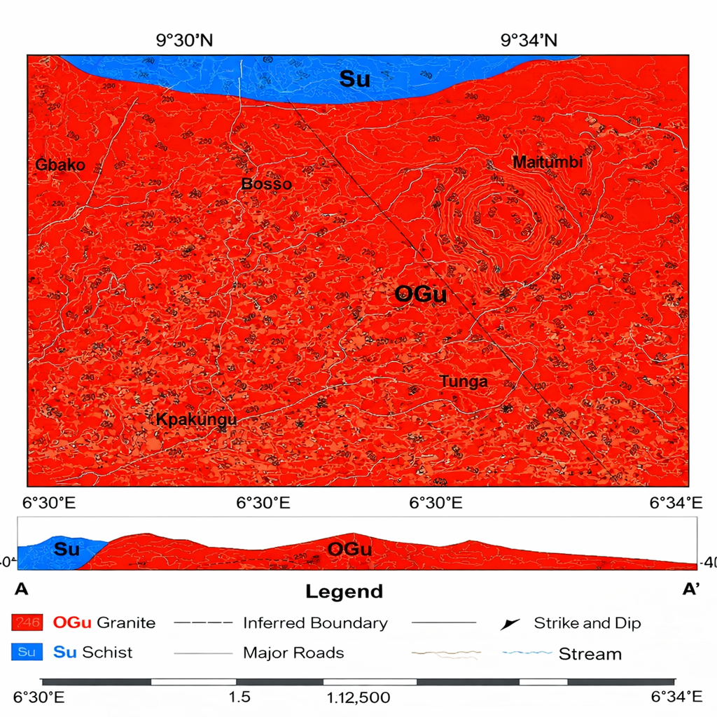
Figure 2: Geological Map and Cross Section of Parts of Minna Sheet 164 SW
Cross-sectional interpretation indicates that granite represents the younger intrusive unit relative to schist. Structural measurements compiled into a rosette diagram reveal that the dominant joint orientation trends NNE-SSW, with a subordinate set trending approximately NWW-SEE. Figure 3 shows the rosette diagram of jointing in the study area.
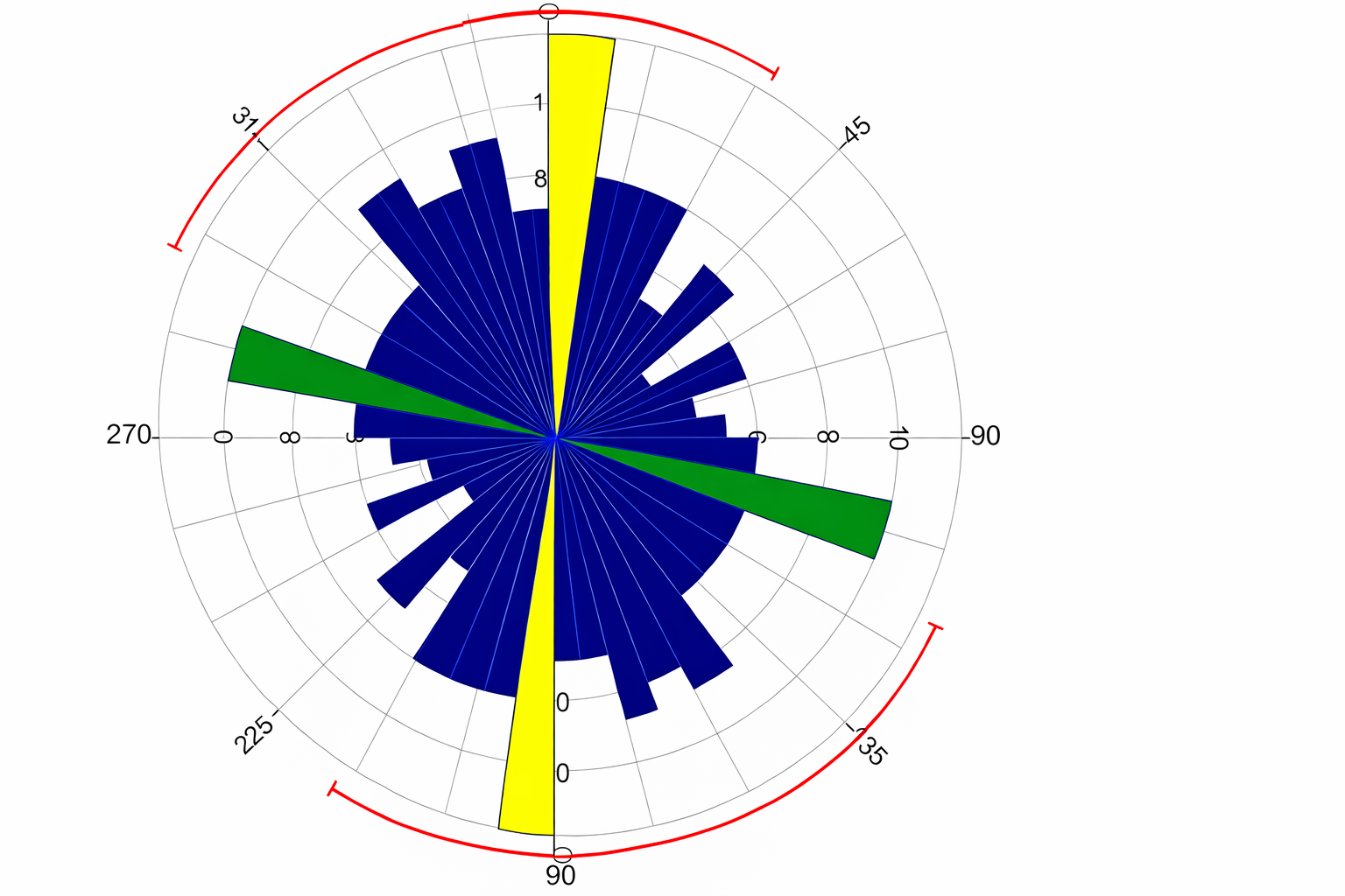
Figure 3: Rosette diagram of jointing in the study area

Descriptive Statistics of Hydrogeological Parameters
A total of 117 hand-dug wells were analysed to characterize the shallow aquifer system. Table 1 presents summary statistics of the measured hydrogeological parameters.

Table 1: Summary Statistics of Well Parameters (n = 117)

Parameter | Minimum | Maximum | Mean | Standard deviation
Well depth | 1.6 | 10.6 | 5.05 | 2.00
Static water level | 0.9 | 10.3 | 4.23 | 1.93
Water column | 0 | 4.8 | 1.46 | 1.16
Water level elevation | 201.8 | 325.8 | 277.50 | 26.40
Well depths indicate generally shallow excavation typical of weathered basement aquifers. Static water levels are relatively shallow (mean = 4.23m), confirming the unconfined nature of the aquifer system. The moderate standard deviation in water level elevation (26.4 m) reflects combined topographic variation and structural control.

Potentiometric Surface and Groundwater Flow Direction
Water table elevations interpolated using Ordinary Kriging define a clear regional hydraulic gradient across the study area. Two principal flow regimes are observed: (1) A dominant NE-SW groundwater flow direction and (2) A subordinate N-S flow component. Groundwater flow follows the expected pattern of movement from higher hydraulic head to lower hydraulic head, perpendicular to equipotential contours. Quantitative analysis of head differences across the study area indicates an average hydraulic gradient ranging between 0.02 and 0.03 along the principal NE-SW axis. This gradient magnitude reflects a moderate gravitational driving force typical of shallow unconfined basement aquifers. High hydraulic head zones occur around Tudun Fulani and Maitumbi, whereas lower head values are recorded toward Kpakungu and surrounding areas. Figure 4 shows groundwater flow direction of the study area and groundwater elevation profile respectively.
Figure 4: Groundwater flow direction of the study area & groundwater elevation profile

Recharge and Discharge Zones
Recharge zones were inferred from potentiometric highs, while discharge zones correspond to hydraulic lows. Recharge interpretation is further supported by first-order rainfall–runoff modelling, which estimates potential annual infiltration of approximately 3.9 × 10⁷ m³ over the 81 km² study area. Although this value represents potential infiltration rather than net recharge, it provides a hydrological context for recharge interpretation derived from the potentiometric surface. Discharge zones identified around Kpakungu correspond to areas where groundwater flow converges and hydraulic head declines, suggesting potential groundwater outflow or surface water interaction. Figure 5 shows the recharge and discharge areas of the study area.
Figure 5: Recharge and Discharge areas of the study area

Relationship Between Structural Orientation and Groundwater Flow
Comparison of structural orientation and groundwater flow patterns reveals geometric correspondence between the dominant NNE-SSW joint orientation and the principal NE-SW groundwater flow direction. This alignment suggests fracture-controlled anisotropy, where structural discontinuities enhance secondary permeability and guide subsurface flow preferentially along structurally weakened zones. While fracture density was not quantitatively measured, the observed structural-flow relationship supports the interpretation that joint systems exert significant control on groundwater movement within the basement complex terrain.

Overburden Thickness and Implications for Vulnerability
Field measurements indicate overburden thickness ranging from 0.5 to 1.0m across the study area. The thin vadose zone suggests limited vertical filtration capacity before groundwater recharge. Although no formal vulnerability index, such as the DRASTIC model, was applied, the observed thin overburden thickness indicates moderate to high vulnerability to surface-derived contamination.

Discussions and Limitations

Structural Control and Groundwater Flow Dynamics of the Area.
The hydrogeological behavior of basement aquifers is fundamentally governed by secondary porosity developed through weathering and fracturing. (Salihu & Jimada, 2016). In the present study area, the dominance of granite and subordinate schist is consistent with regional basement complex geology. Groundwater occurrence is confined primarily to the weathered regolith and underlying fractured zones. The rosette diagram indicates a dominant NNE-SSW joint orientation, while the potentiometric surface reveals a principal groundwater flow direction trending NE-SW. The observed geometric alignment between these structural and hydraulic trends suggests structural anisotropy influencing groundwater movement (De Vargas et al., 2022; Doro et al., 2025).
Although fracture density and aperture were not quantitatively measured, the correspondence between joint orientation and groundwater flow direction supports fracture-controlled permeability typical of basement terrains. Similar structural influence on groundwater flow has been reported in other crystalline environments within Nigeria, where groundwater productivity is strongly linked to fracture connectivity rather than primary porosity. (Bierkens & Wada, 2019). The quantified hydraulic gradient (0.02-0.03) reflects moderate gravitational driving force and indicates that groundwater movement is not solely topographically controlled but likely enhanced along structurally weakened zones.

Recharge and Discharge Zones of the Study Area
Recharge and discharge zones were initially inferred from potentiometric highs and lows. High hydraulic head areas around Tudun Fulani and Maitumbi were interpreted as recharge zones, while lower head areas near Kpakungu represent discharge zones. To reduce reliance solely on contour geometry, a rainfall-runoff water balance model was incorporated, indicating potential annual infiltration of approximately 3.9 × 10⁷ m³ across the 81 km² study area. This represents potential infiltration rather than measured net recharge. However, recharge in basement terrains is typically episodic and strongly seasonal, occurring primarily during intense rainfall events when soil moisture deficits are exceeded. (Lachassagne et al., 2021).

Vulnerability and Overburden Thickness
Overburden thickness across the study area ranges between 0.5 and 1.0 m, indicating a thin vadose zone overlying fractured bedrock. Thin overburden reduces the capacity for filtration and contaminant attenuation before recharge reaches the aquifer. In basement complex terrains, vulnerability is often governed by 1. Thickness of weathered regolith 2. Fracture connectivity, 3. Land-use intensity, 4. Depth to water table. Although no formal vulnerability index model, such as DRASTIC, was applied in this study, the hydrogeological indicators observed, namely shallow water table and minimal overburden thickness, suggest moderate to high vulnerability.

Comparison with Similar Basement Complex Studies
Groundwater flow behavior observed in this study is consistent with other investigations within the Nigerian Basement Complex, where borehole success is strongly controlled by fracture systems. (Idris-Nda et al., 2013). Rates in central Nigeria correlate strongly with fracture orientation and connectivity. Similarly, (Wada & Bierkens, 2014) reported that hydraulic anisotropy in crystalline terrains often aligns with dominant joint sets. The hydraulic gradient magnitude (0.02–0.03) obtained in this study falls within the range reported for shallow unconfined basement aquifers in comparable crystalline environments. This supports the reliability of the potentiometric surface interpretation. Integrating structural analysis, statistical treatment of well data, and hydraulic gradient quantification, the study extends beyond descriptive mapping and provides a more quantitative framework compared to earlier localized hydrogeological assessments.

Study Limitations
This study represents a single-season assessment and therefore does not capture temporal groundwater level fluctuations associated with seasonal recharge. The absence of pumping test data limits estimation of transmissivity and hydraulic conductivity, and therefore, aquifer productivity assessment remains beyond the scope of this study. Recharge modelling was based on simplified rainfall-runoff assumptions and does not account for evapotranspiration losses, soil moisture storage, or delayed percolation processes. Interpolation using Ordinary Kriging may introduce smoothing effects in areas of lower well density; however, the relatively high number of wells (n = 117) enhances the reliability of the potentiometric surface.

Conclusions
This study evaluated groundwater flow dynamics and structural controls within parts of Minna Sheet 164 SW, a crystalline basement terrain dominated by granitic lithology with minor schist occurrences. Hydrogeological inventory of 117 hand-dug wells enabled construction of a potentiometric surface map and quantitative assessment of groundwater flow characteristics.
Static water levels ranged from 0.9-10.3 m (mean = 4.23m), while well depths ranged from 1.6-10.6 m (mean = 5.05m), confirming the shallow and unconfined nature of the aquifer system. Quantitative hydraulic gradient analysis yielded values between 0.02 and 0.03 along the dominant NE-SW flow path, indicating moderate gravity-driven groundwater movement. Groundwater flow direction aligns broadly with the dominant NNE-SSW joint orientation observed in the structural analysis. This structural hydraulic correspondence supports the interpretation that fracture-controlled anisotropy significantly influences groundwater movement within the weathered-fractured basement.
Recharge zones were identified at hydraulic highs around Tudun Fulani and Maitumbi, while discharge zones occur near Kpakungu. Although recharge interpretation was supported by first-order rainfall-runoff modelling, it remains conceptual and requires seasonal monitoring for quantitative validation. Overburden thickness across the study area ranges from 0.5 to 1.0 m, indicating limited vadose zone thickness. While this thin overburden suggests moderate to high vulnerability to surface-derived contamination, no formal vulnerability index model was applied.
Overall, the integration of structural mapping, statistical treatment of well data, hydraulic gradient quantification, and recharge context provides a more rigorous hydrogeological framework for groundwater assessment in basement complex terrains. The findings highlight the importance of incorporating structural analysis and quantitative groundwater mapping into sustainable groundwater development planning in rapidly urbanizing crystalline environments.

Conflict of Interest
The authors declare no competing financial or personal interests that could influence the outcomes of this study.

Author Contributions
Umar Sulaiman: Investigation and writing of original draft
Abdullahi Idris-Nda: Supervision of data acquisition and analysis
Musa Suleiman Tenimu: Data curation, editing, and formatting of draft
Abubakar Abduljaleel Enesi: Fieldwork assistant
Folorunsho Owolabi Wahab: Review of manuscript.

Funding
This research received no funding.

Acknowledgments
Special acknowledgement goes to the staff of the Geology Department, Federal University of Technology, Minna, for their intellectual contributions and constructive criticism during the presentation of this work in different seminars and conferences within the institution.

Ethical Statements
This study involved the collection of non-invasive data through field observations and the taking of well inventory.

Data Availability
Data supporting the findings of this study are available from the corresponding author upon reasonable request.

References
Ajayi, O. (2006). Strategy for effective administration of water resources development in Nigeria. Journal of Mining and Geology, 42(1), 41–50. https://doi.org/10.4314/jmg.v42i1.18843
Bierkens, M. F. P., & Wada, Y. (2019). Non-renewable groundwater use and groundwater depletion: A review. Environmental Research Letters, 14(6). https://doi.org/10.1088/1748-9326/ab1a5f
De Vargas, T., Boff, F. E., Belladona, R., Faccioni, L. F., Reginato, P. A. R., & Carlos, F. S. (2022). Influence of geological discontinuities on the groundwater flow of the Serra Geral Fractured Aquifer System. Groundwater for Sustainable Development, 18. https://doi.org/10.1016/j.gsd.2022.100780
Doro, K. O., Olabode, P. I., Adeniran, M. A., & Oladunjoye, M. A. (2025). Understanding Complex Hydraulic Heterogeneities in Crystalline Basement Aquifers Used as Drinking Water Sources. Geosciences (Switzerland), 15(7). https://doi.org/10.3390/geosciences15070239
Idris-Nda, a., Aliyu, H. K., & Dalil, M. (2013). The challenges of domestic wastewater management in Nigeria: A case study of Minna, central Nigeria. International Society for Development and Sustainability , 2(2), 1169–1182.
Keegan-Treloar, R., Irvine, D. J., Werner, A. D., & Banks, E. W. (2023). Identifying groundwater recharge and discharge zones using geostatistical simulation of hydraulic head and its derivatives. Journal of Hydrology, 617. https://doi.org/10.1016/j.jhydrol.2022.128993
Konikow, L. F., & Kendy, E. (2005). Groundwater depletion: A global problem. Hydrogeology Journal, 13(1), 317–320. https://doi.org/10.1007/s10040-004-0411-8
Lachassagne, P., Dewandel, B., & Wyns, R. (2021). Review: Hydrogeology of weathered crystalline/hard-rock aquifers—guidelines for the operational survey and management of their groundwater resources. Hydrogeology Journal, 29(8), 2561–2594. https://doi.org/10.1007/s10040-021-02339-7
Mukherjee, I., & Singh, U. K. (2020). Delineation of groundwater potential zones in a drought-prone semi-arid region of east India using GIS and analytical hierarchical process techniques. Catena, 194. https://doi.org/10.1016/j.catena.2020.104681
Nouradine, H., Schamper, C., Valdes, D., Moussa, I., Ramel, D., & Plagnes, V. (2024). Integrating geological, hydrogeological and geophysical data to identify groundwater resources in granitic basement areas (Guéra Massif, Chad). Hydrogeology Journal, 32(3), 759–784. https://doi.org/10.1007/s10040-024-02766-2
Obateru, R. O., Okhimamhe, A. A., Fashae, O. A., Aweda, E., Dragovich, D., & Conrad, C. (2024). Community-based assessment of the dynamics of urban landscape characteristics and ecosystem services in the rainforest and guinea savanna ecoregions of Nigeria. Journal of Environmental Management, 360. https://doi.org/10.1016/j.jenvman.2024.121191
Pires, C. A., Athayde, G. B., de Souza Filho, O. A., & Ofterdinger, U. (2021). Litho-structural conditioning in the exploration of fractured aquifers: a case study in the Crystalline Basement Aquifer System of Brazil. Hydrogeology Journal, 29(4), 1657–1678. https://doi.org/10.1007/s10040-021-02312-4
Salihu, H. D., & Jimada, A. M. (2016). Groundwater quality in shallow unconfined sedimentary aquifers in Bida , Nigeria. 1–6.
Wada, Y., & Bierkens, M. F. P. (2014). Sustainability of global water use: Past reconstruction and future projections. Environmental Research Letters, 9(10). https://doi.org/10.1088/1748-9326/9/10/104003

