

Multidisciplinary Journal of Science Technology Education and Management
Journal homepage: http://www.mjstem.org

Characterization of Clay Deposits in Lafia and Doma, Part of the Middle Benue Trough, North Central Nigeria:

Implications for Industrial Applications
Ahmad Ibrahim Aliyu^{a*}, Lucy Ooja Aghoª, Muhammad Sanusi Idrisª, Usman Shehu Saeedª, Fatima Adamu Idrisª, Beatrice Imona Amosª, Sheriff Abdulrafiuª
ªDepartment of Geology, Federal University of Lafia, Nasarawa State, Nigeria.
*Correspondence: Ahmad Ibrahim Aliyu (aliyu.ibrahim@science.fulafia.edu.ng)

Abstract
Clay deposits in the Middle Benue Trough have received limited attention compared to petroleum and metallic mineral resources, despite their industrial relevance. This study presents a comparative mineralogical, geochemical, and geotechnical characterization of clay deposits in Lafia and Doma, North Central Nigeria, to evaluate their industrial potential. Representative samples were analyzed using X-ray fluorescence for major oxides, X-ray diffraction with Rietveld refinement for mineral quantification, and standard geotechnical tests for particle size distribution and plasticity. The clays are mostly kaolinitic, with an average kaolinite content of 42.0 wt% and a quartz content of 38.25 wt%. Major oxide composition is dominated by SiO₂ and Al₂O₃, with mean Al₂O₃ values higher in Lafia samples. Chemical Index of Alteration values above 89 indicate intense weathering of the source materials. Particle size analysis shows dominant fine fractions, and plasticity tests classify Doma clays as moderately plastic and Lafia clays as highly plastic inorganic clays. Comparison with reported industrial compositional ranges suggests that the clays possess favorable characteristics for ceramic products such as tiles, bricks, and stoneware, while Lafia clays compare well with reported compositional requirements for cement raw feed or calcined clay applications. Elevated Fe₂O₃ contents may limit direct use in high-grade paint applications without further processing. The study provides baseline mineralogical and geochemical data for industrial screening of clay resources in the Middle Benue Trough and establishes a foundation for further performance-based testing.
Keywords: Clay deposits, Geochemical, Mineralogical, Industrial applications, X-ray diffraction, X-ray fluorescence.

Introduction
Clay deposits are widely distributed across Nigeria and occur both as residual products of basement rock weathering and as transported sediments within sedimentary basins (Onyekuru et al., 2018; Adeola et al., 2020; Bolarinwa et al., 2021). In the Middle Benue Trough, clay deposits form part of the sedimentary succession of the Lafia Formation, where favorable depositional and weathering conditions supported their development.
Geologically, Lafia and Doma lies within the Middle Benue Trough, which contains a thick succession of marine and continental sedimentary units, including the Albian Asu River Group and the Cenomanian Awgu Formation (Akande et al., 2012). Figures 1 and 2 show the location of the Middle Benue Trough and the stratigraphic succession respectively. The target clay deposits are hosted within the Campanian–Maastrichtian Lafia Formation, which consists of interbedded sandstone, siltstone, and clay horizons deposited in fluvial to continental environments (Patrick et al., 2013).
Clays are important industrial raw materials due to their mineralogical composition, particle size distribution, plasticity, and chemical characteristics. The global kaolin market was valued at approximately 4.41 billion US dollars before 2022 and is projected to grow steadily due to increasing demand from ceramics, cement, paints, refractories, and environmental applications (Grant View Research, 2019–2020; Buyondo et al., 2022). Their industrial suitability depends primarily on mineralogical composition, oxide chemistry, and geotechnical behavior (Singh, 2022), which influence the performance and quality of kaolin in various applications such as ceramics, cement, and paints, ultimately affecting the overall market growth and demand for kaolin in these sectors, particularly as industries seek higher-quality materials to meet evolving standards and consumer preferences.
Kaolinite-rich clays are widely used in ceramic products such as tiles, bricks, and pottery due to their plasticity and firing behavior. In the cement industry, clays contribute silica, alumina, and iron to kiln feed and may serve as supplementary cementitious materials when properly processed (Mousavi et al., 2021; Cheah et al., 2025). In paints and coatings, clay minerals function as fillers and stabilizers, though their performance is strongly influenced by iron oxide and titanium contents (Buyondo et al., 2022; Igwe et al., 2016). These applications require systematic mineralogical and chemical characterization before industrial adoption to ensure that the clay minerals meet the necessary performance standards and compatibility with other components in the formulations.
Despite the economic importance of industrial minerals, most geological investigations in the Middle Benue Trough have focused on hydrocarbon potential and metallic mineralization. Studies addressing clay deposits in the Lafia Formation are limited in scope and spatial coverage. Obrike et al. (2019) examined clay members in Shabu and Doma; however, the comparative assessment of Lafia and Doma clay deposits remains limited, particularly with integrated mineralogical, geochemical, and geotechnical evaluation.
Given increasing industrial development within Nasarawa State and the need for locally sourced raw materials, a systematic assessment of these clay deposits is necessary. This study provides a comparative mineralogical, geochemical, and geotechnical analysis of clay deposits in Lafia and Doma within the Middle Benue Trough. The objective is to evaluate their industrial potential based on compositional screening and established industrial reference ranges, thereby providing baseline data for future performance-based testing and resource development. While the geological context is established through field mapping, the analytical focus of this study remains strictly on the mineralogical, geochemical, and geotechnical characterization of the clay horizons to determine their preliminary industrial suitability. Detailed sedimentological facies modeling and architectural stratigraphic logging are beyond the scope of this performance-based assessment.
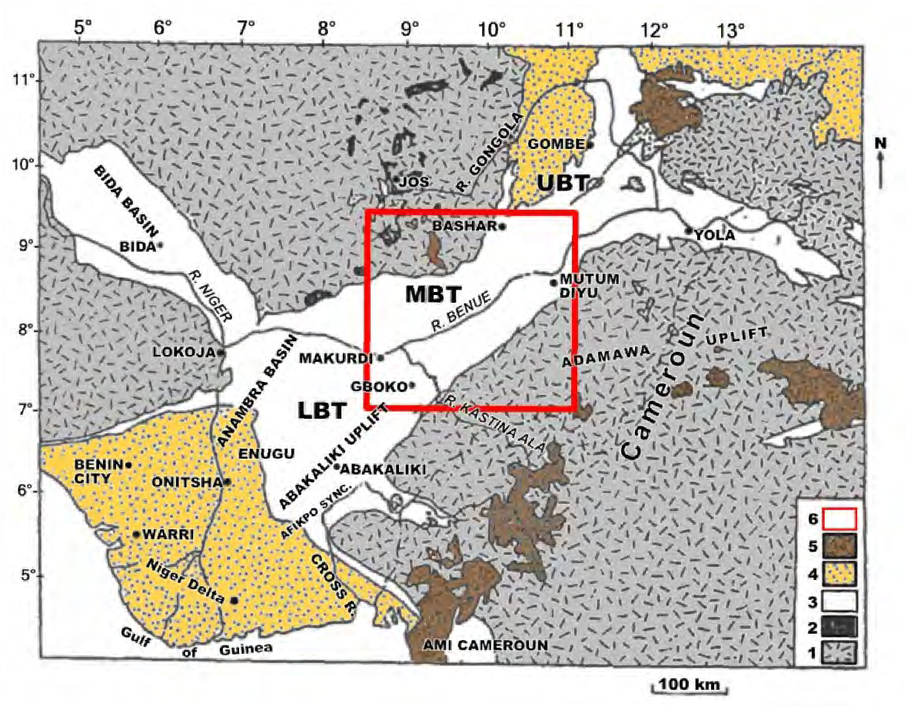
Figure 1. Geological Map of the Benue Trough and its Environs (after Zaborski, 1998). LBT - Lower Benue Trough; MBT - Middle Benue Trough; UBT - Upper Benue Trough. 1. Precambrian Basement Complex. 2. Jurassic Younger Granite Complexes. 3. Cretaceous sediments. 4. Tertiary sediments. 5. Cenozoic-Recent volcanics. 6. Middle Benue Trough
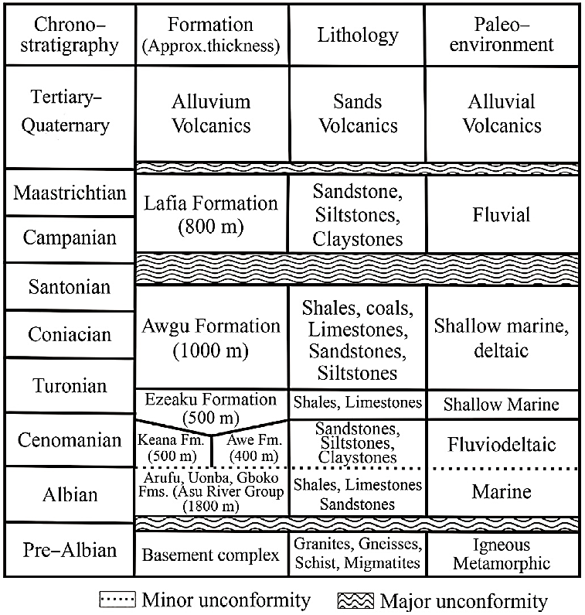
Figure 2. Stratigraphic successions of the Middle Benue Trough (Obaje, 2009)

Methodology
This study employed field geological mapping and sampling, X-ray fluorescence (XRF) for analysis of major oxide compositions, X-ray diffractometry (XRD) for mineralogical analysis, the hydrometer test for particle size distributions, and the Atterberg limit test for determination of plasticity.

The Study Area
This study covers areas around Lafia and Doma, situated within the Middle Benue Trough in North Central Nigeria. It covers about 250 square kilometers and is located within coordinates of latitude of 08° 21ʹ 00ʺN to 08° 30ʹ 00ʺN and longitude 8° 21ʹ 00ʺE to 8° 36ʹ 00ʺE. It is covered by rock units of the Awgu Formation (Cenomanian) and Lafia Formation (Maastrichtian) located within the Middle Benue Trough of North Central Nigeria (Figure 3). The defined study area represents the spatial extent of observable clay occurrences around the Lafia and Doma areas, rather than a uniformly sampled surface. Sampling density is controlled by the distribution of natural exposures (example, gullies, river channels, and road cuts), which is typical of reconnaissance-level geological investigations in sedimentary terrains.
The litho-section study of the Awgu Formation in the study area reveals a sequence of coal seams, carbonaceous shale, sandstone, clay, and siltstone. The Lafia Formation is composed of layers of sandstone, siltstone, clay, and ferruginous sandstone. Obrike et al. (2019) reported the thickness of the Lafia Formation around Lafia town to range from 10 m to 150 m, and it becomes thicker southward toward Doma town.
The clay occurs as a layer in the Lafia Formation, forming a stratigraphic sequence with sandstone and siltstones (Figure 4a) and ranging in thickness from 10 cm to 5 m within the section. Good exposures were seen along the gullies. The clay varies in color: creamy white (Figure 4b), light gray (Figure 4c), and mottled purple (Figure 4d) with a content of sand and silt particles.
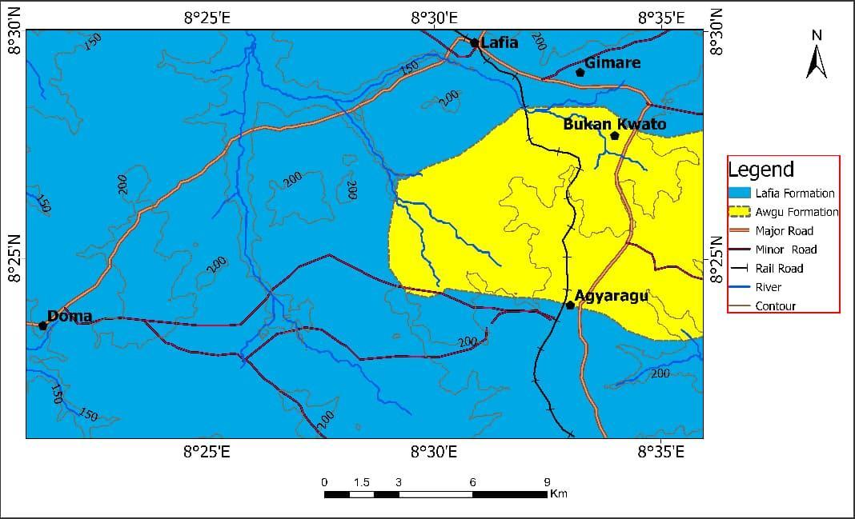Figure 3. A lithological map of the study area shows the distribution of rock units.
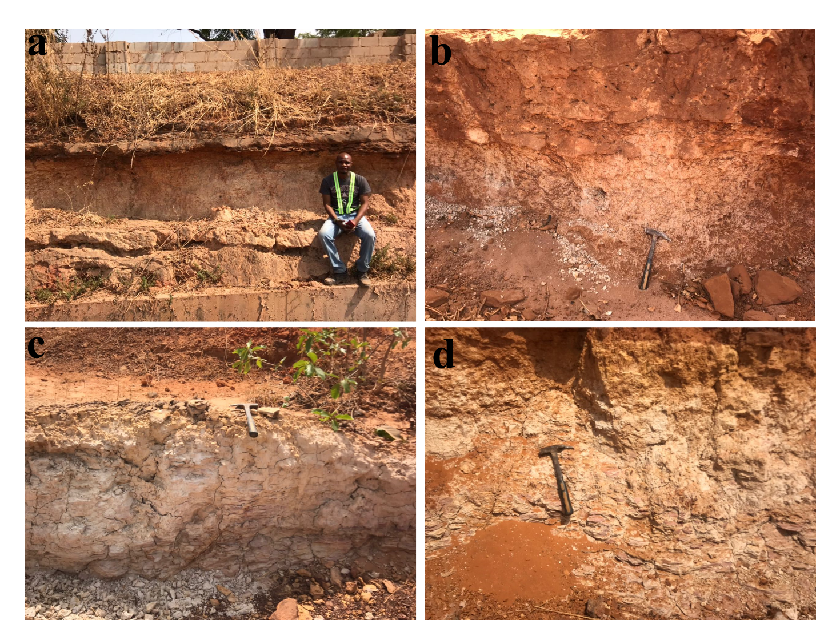
Figure 4. The different exposures of clay in the study area. (a) clay interbedded with sandstone (b) creamy white clay (c) light grey clay (d) mottled purple clay

Fieldwork and Sampling
Field geological mapping and sampling form the first phase of the research. Mapping was performed by following exposures along road cuts, stream channels, gullies, and valleys to delineate various lithological units. At each site, detailed notes were made on the rock type, texture, color, and mineral content in the hand specimen.
Although the clay horizons are typically thin (≤1.5 m) and laterally continuous, with limited vertical exposure, compositional variation in vertical section was not quantitatively assessed, and this serves as a limitation in this study. Consequently, potential vertical geochemical or mineralogical gradients within the clay units remain unresolved and require further investigation using systematically stratified sampling. Field observations revealed variations in color (creamy white, light grey, and mottled purple), texture, and degree of ferruginization, which are interpreted to reflect differences in weathering intensity and depositional conditions. These variations were used to guide representative sampling across the study area.
Given the limited thickness and apparent lateral continuity of the clay units, formal stratigraphic logging and layer-by-layer sampling were not conducted due to the absence of complete vertical sections. As a result, stratigraphic control on compositional variability is limited, and the present study focuses on representative sampling rather than detailed stratigraphic resolution. The locations of sample points were recorded with a Global Positioning System (GPS) and used to produce a sample location map (Figure 5).
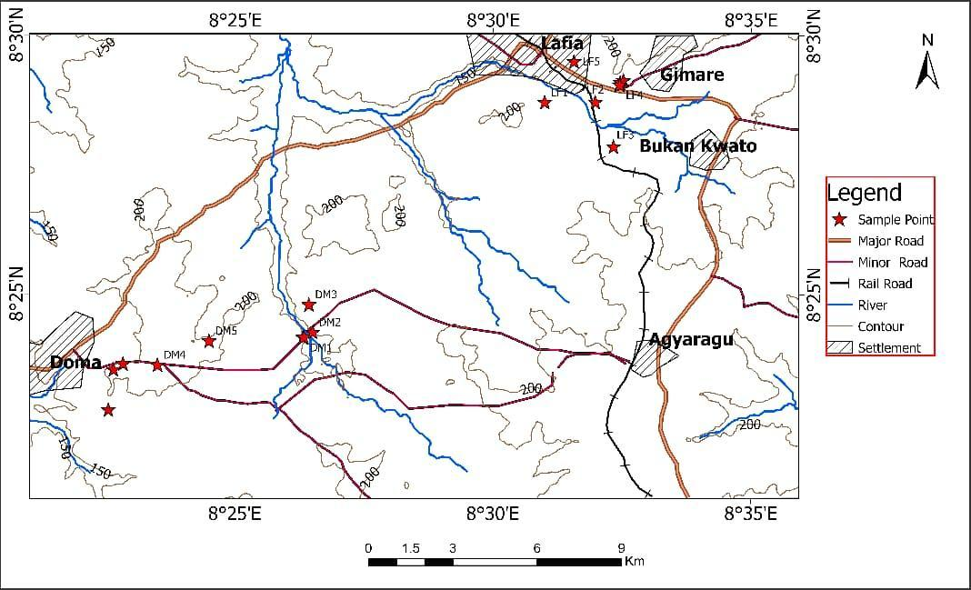
Figure 5. A map of the study area shows locations where clay samples were collected.

Laboratory Analyses
Five samples of clay were selected, each from the Lafia and Doma areas (making a total of ten samples), for XRF, hydrometer test, and Atterberg limit test. Four representative samples were selected for XRD analysis to determine mineralogical composition. For this preliminary mineralogical characterization, the selected four samples were selected to serve as end-members to capture the primary mineralogical trends across the study area. These samples were chosen based on distinct lithological variations, including color differences and spatial distribution, to establish baseline compositional characteristics.
The samples were oven-dried and pulverized to particle sizes below 150 µm. XRD measurements were conducted using a Rigaku Miniflex 600 diffractometer equipped with Cu-Kα radiation operating over a 2θ range of 2° to 70°. Quantitative phase analysis was performed using full-pattern Rietveld refinement implemented in the PANalytical software package. Background fitting, peak profile modeling, scale factor refinement, and instrumental broadening corrections were applied during the refinement process. Mineral phase identification was based on comparison with the ICDD database, and phase abundances were determined from refined scale factors.
0.4 g of the powdered sample was fused with 7.6 g of flux to form glass beads, which were used for XRF analysis employing Genius–IF Xenemetrix XRF equipment. The XRF instrument was calibrated using certified reference materials to ensure analytical accuracy. Instrument calibration was performed using certified reference materials to ensure analytical accuracy. Analytical precision for major oxides is better than ±0.5 wt%, and detection limits (LOD) are approximately 0.01 wt%, depending on the specific oxide and instrument configuration. No replicate analyses were performed; therefore, analytical reproducibility is inferred from instrument calibration and precision rather than duplicate measurements. The level of chemical alterations of the analyzed clays was evaluated using the chemical alteration index in Equation 1. Relative oxides were normalized and plotted as triangular diagrams.
Laboratory tests to determine the grain size, physical, and geotechnical performance of the clays were also carried out. A hydrometer test to determine the grain size distribution of the clay was performed based on ASTM D7928 standards. Samples were dispersed using sodium hexametaphosphate solution as a dispersing agent. Temperature corrections were applied according to ASTM D7928. Atterberg limit tests, comprising Liquid Limit (LL), Plastic Limit (PL), and Plasticity Index (PI), were performed in line with ASTM D4318 standards.
CIA = $\left[\frac{{Al}_{2}O_{3}}{Al_{2}O_{3}+CaO^{*}+Na_{2}O+K_{2}O }\right]×100$ 1
CaO* represents the value of CaO derived only from silicate minerals.

Results
The XRD investigation reveals that quartz and kaolinite are the predominant minerals in the diffraction patterns. Additional minerals comprise orthoclase, illite, muscovite, and albite.
The percentage composition of the mineral phases and the diffractogram are presented in Table 1 and Figure 6, respectively. The mineralogical percentage of the clay samples in Lafia has more kaolinite and less quartz content than the clay samples in Doma. Generally, the quartz composition ranges from 30 wt% to 45 wt% with an average of 38.25 wt%. Kaolinite has an average of 42.0 wt% with a range of 32.0 wt% to 51.0 wt%. Other mineral phases in the clays have less than 10.0 wt%.
Table 1. Percentage composition of mineral phases in clay deposits of the study area
S/No. | Quartz | kaolinite | Orthoclase | Illite | Muscovite | Albite
DM2 | 45 | 32 | 9 | 3 | 9 | 2
DM3 | 40 | 36 | 9 | 5 | 6 | 4
LF1 | 38 | 49 | 5 | 2 | 4 | 2
LF2 | 30 | 51 | 7 | 3 | 6 | 3
Average | 38.25 | 42 | 7.5 | 3.25 | 6.25 | 2.75
NB: DM2 and DM3 are Doma clays, while LF1 and LF2 are Lafia clays.
The oxide compositions of the clay samples, as presented in Table 2, show that SiO₂ and Al₂O₃ are the dominant oxides, followed by a significant concentration of Fe₂O₃. Other oxides, such as TiO₂, CaO, K₂O, MnO, and MgO, were present in small quantities, although one clay sample from Doma exhibits relatively elevated MgO compared to the other analyzed samples. The concentration of SiO₂ ranges from 45.55 wt% to 52.73 wt% with a mean value of 49.47 wt%. Al₂O₃ has a range of concentrations between 24.01 wt% and 44.87 wt%, with an average of 37.18 wt%. Fe₂O₃ and TiO₂ have little significance, with concentrations of 3.95 and 2.04 wt%, respectively. Other oxides have a concentration of less than 1.5 wt%. There is noticeable variation in the concentration of Fe₂O₃ and Al₂O₃ in the Doma and Lafia clay samples. Samples in the Doma area have higher Fe₂O₃ content compared to those in Lafia, while samples in Lafia have higher Al₂O₃ content than the samples in Doma.
Table 2. Major oxide compositions of clay deposits
Oxides  (wt%) | Doma clay |  |  |  | Lafia clay
Oxides  (wt%) | Min | Max | Average | Stdev. | Min | Max | Average | Stdev.
SiO₂ | 46.20 | 52.73 | 49.30 | 2.48 | 45.55 | 52.13 | 49.63 | 2.66
Na₂O | 0.18 | 0.45 | 0.28 | 0.11 | 0.21 | 0.55 | 0.43 | 0.13
MgO | 0.21 | 4.32 | 1.61 | 1.58 | 0.42 | 1.12 | 0.75 | 0.29
Fe₂O₃ | 6.66 | 17.28 | 10.47 | 4.47 | 2.55 | 5.12 | 3.95 | 0.96
CaO | 0.11 | 0.93 | 0.55 | 0.31 | 0.20 | 0.78 | 0.39 | 0.22
Al₂O₃ | 24.01 | 38.44 | 32.71 | 5.59 | 40.05 | 44.87 | 41.64 | 1.95
K₂O | 0.55 | 2.1 | 1.47 | 0.63 | 0.32 | 1.71 | 0.80 | 0.53
MnO | 0.04 | 0.09 | 0.06 | 0.02 | 0.04 | 0.07 | 0.05 | 0.01
TiO₂ | 1.85 | 4.384 | 2.91 | 1.15 | 1.18 | 2.80 | 2.04 | 0.77
SO₃ | 0.12 | 0.92 | 0.58 | 0.33 | 0.05 | 0.40 | 0.28 | 0.15
P₂O₃ | 0.00 | 0.03 | 0.01 | 0.01 | 0.00 | 0.05 | 0.03 | 0.02
CIA | 89.34 | 96.61 | 92.75 | 2.65 | 92.95 | 97.52 | 95.19 | 1.63
The grain size distribution of the clays (Table 3) shows that clay, silt, and sand grains in Doma clay have averages of 71 wt%, 8.8 wt%, and 20.2 wt%, respectively, while the Lafia clay has corresponding values of 74.2 wt%, 9.2 wt%, and 16.4 wt%, respectively. The Atterberg Limit Test result (Table 3) shows Lafia has average Liquid Limit (LL), Plastic Limit (PL), and Plasticity Index (PI) values of 53.76 %, 26.08 %, and 27.68 %, respectively. These corresponding values are lower in the clay samples of Doma, with values of 43.98 %, 20.74 %, and 23.24 %, respectively.
Table 3. Summary results of particle size and Atterberg limit test of clay samples
Sample Code | Doma clay |  |  |  | Lafia clay
Sample Code | Min | Max | Ave | Stdev | Min | Max | Ave | Stdev
Clay particles | 68.0 | 74.0 | 71.0 | 2.24 | 72.0 | 79.0 | 74.20 | 2.95
Sand particles | 6.0 | 10.0 | 8.8 | 1.79 | 8.0 | 11.0 | 9.20 | 1.30
Silt particles | 16.0 | 24.0 | 20.2 | 3.03 | 16.0 | 20.0 | 16.40 | 3.91
Liquid Limit | 38.6 | 48.0 | 43.98 | 3.59 | 49.6 | 58.2 | 53.76 | 3.09
Plastic Limit | 16.1 | 23.4 | 20.74 | 3.44 | 23.3 | 38.6 | 26.08 | 2.27
Plasticity index | 20.6 | 26.4 | 23.24 | 2.46 | 25.55 | 31.1 | 27.68 | 2.69

Discussions
The dominance of kaolinite confirms the kaolinitic nature of the clay deposits, which is consistent with typical weathering products of feldspar-rich source rocks (Boukoffa et al., 2021; Garcia-Valles et al., 2020). The presence of significant quartz reflects its resistance to chemical weathering and contributes to the textural characteristics of the clay (Ayalew & Demir, 2023). The occurrence of feldspar minerals (orthoclase and albite) indicates incomplete alteration of the source material, suggesting that weathering processes were not sufficient to entirely transform all primary minerals. Additionally, the presence of muscovite supports a felsic provenance, consistent with derivation from basement complex rocks (Yuan et al., 2019).
The geochemical composition is consistent with a kaolinitic clay system, characterized by the predominance of SiO₂ and Al₂O₃, which correspond to the dominant quartz and kaolinite phases identified mineralogically. This compositional relationship reflects the aluminosilicate nature of the clay and is typical of kaolin deposits derived from weathering of feldspar-rich source rocks (Ayalew & Demir, 2023; Dewi et al., 2018). The observed oxide proportions therefore support the mineralogical interpretation and confirm the classification of the deposits as kaolinitic clays.
The low concentrations of Na₂O, K₂O, CaO, and MgO indicate significant depletion of mobile elements, consistent with advanced chemical weathering of feldspar- and mica-bearing source rocks (Yuan et al., 2019). This interpretation is supported by the high Chemical Index of Alteration (CIA) values and the position of the samples on the ternary plot (Figure 7), both of which reflect intense weathering conditions. The depletion of these alkali and alkaline earth elements also suggests the absence of expandable clay minerals such as montmorillonite, which is consistent with the mineralogical results showing dominance of kaolinite (Lorentz et al., 2018).

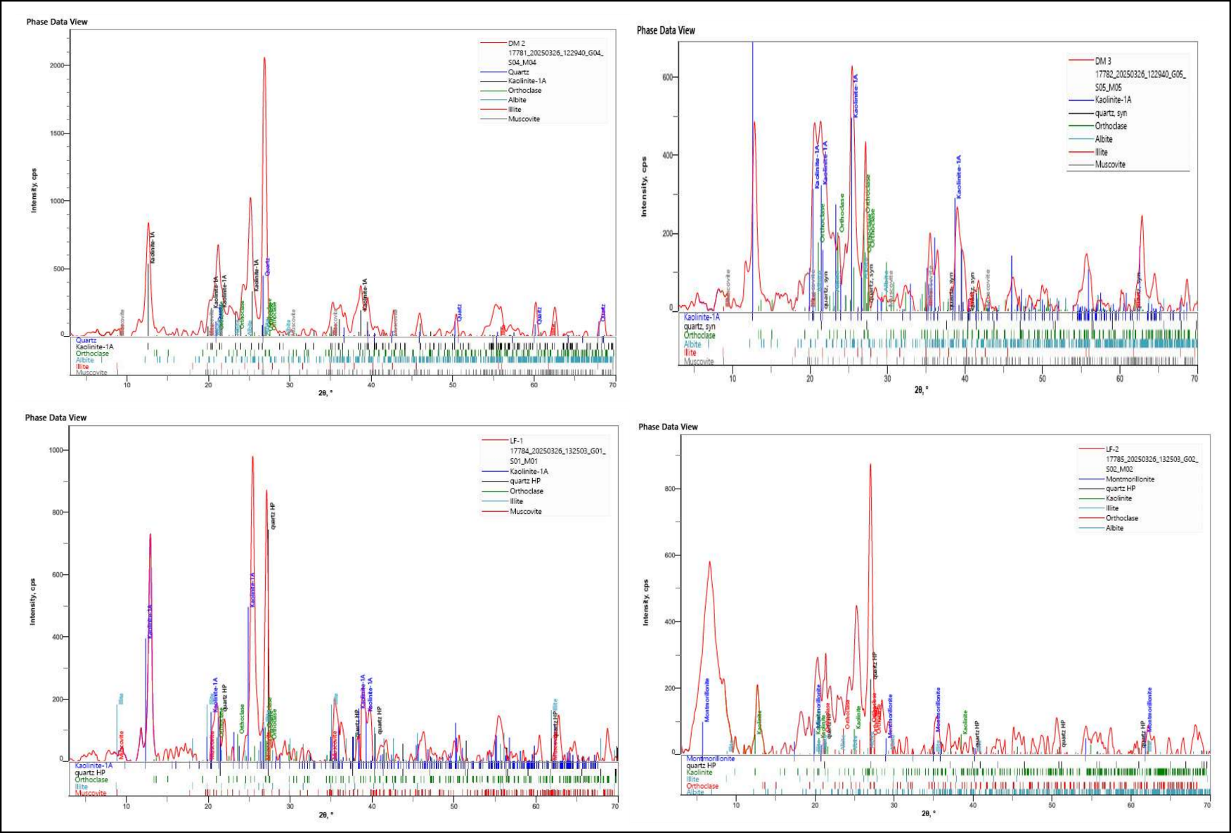
Figure 6. XRD diffractogram for clay samples in the study area.
The low concentrations of MgO and CaO indicate depletion of carbonate-related components and support a felsic provenance for the clay deposits (Onyekuru et al., 2018; Lei et al., 2022). The relatively elevated Fe₂O₃ content observed in some samples is consistent with the ferruginous nature of associated lithologies within the Lafia Formation, where ferruginized sandstones are interbedded with clay, siltstone, and sandstone units. However, XRD analysis does not indicate the presence of identifiable iron oxide minerals such as hematite or goethite. This suggests that the iron is likely present in dispersed, amorphous, or poorly crystalline forms below the detection limit of XRD, rather than as discrete crystalline mineral phases. The observed Fe₂O₃ enrichment is therefore interpreted as reflecting lithological association rather than a specific post-depositional process.
As kaolinite structurally contains negligible Mg, the elevated MgO value observed in one Doma sample is considered a localized geochemical outlier rather than a representative feature of the regional deposit. Since XRD analysis did not identify specific Mg-bearing phases such as smectite or chlorite, the mineralogical host of this enrichment remains unconfirmed at the current resolution. Consequently, this occurrence is treated as localized compositional variability without further inference of widespread geological processes.
The high Chemical Index of Alteration (CIA) values indicate intense chemical weathering (Figure 8), characterized by significant depletion of mobile cations such as Ca²⁺, Na⁺, and K⁺ during feldspar alteration (Mangold et al., 2019). This reflects advanced weathering of the source materials under humid conditions, leading to enrichment in relatively immobile Al-bearing phases such as kaolinite (Goldberg & Humayun, 2010). The slightly higher CIA values observed in Lafia samples suggest a marginally greater degree of weathering compared to those from Doma, consistent with their relatively higher kaolinite and Al₂O₃ contents. Overall, the CIA data supports derivation from strongly weathered felsic source rocks and significant pre-depositional chemical alteration.
The high Chemical Index of Alteration (CIA) values indicate intense chemical weathering (Figure 8), characterized by significant depletion of mobile cations such as Ca²⁺, Na⁺, and K⁺ during feldspar alteration (Mangold et al., 2019). This reflects advanced weathering of the source materials under humid conditions, leading to enrichment in relatively immobile Al-bearing phases such as kaolinite (Goldberg & Humayun, 2010). The slightly higher CIA values observed in Lafia samples suggest a marginally greater degree of weathering compared to those from Doma, consistent with their relatively higher kaolinite and Al₂O₃ contents. Overall, the CIA data supports derivation from strongly weathered felsic source rocks and significant pre-depositional chemical alteration.
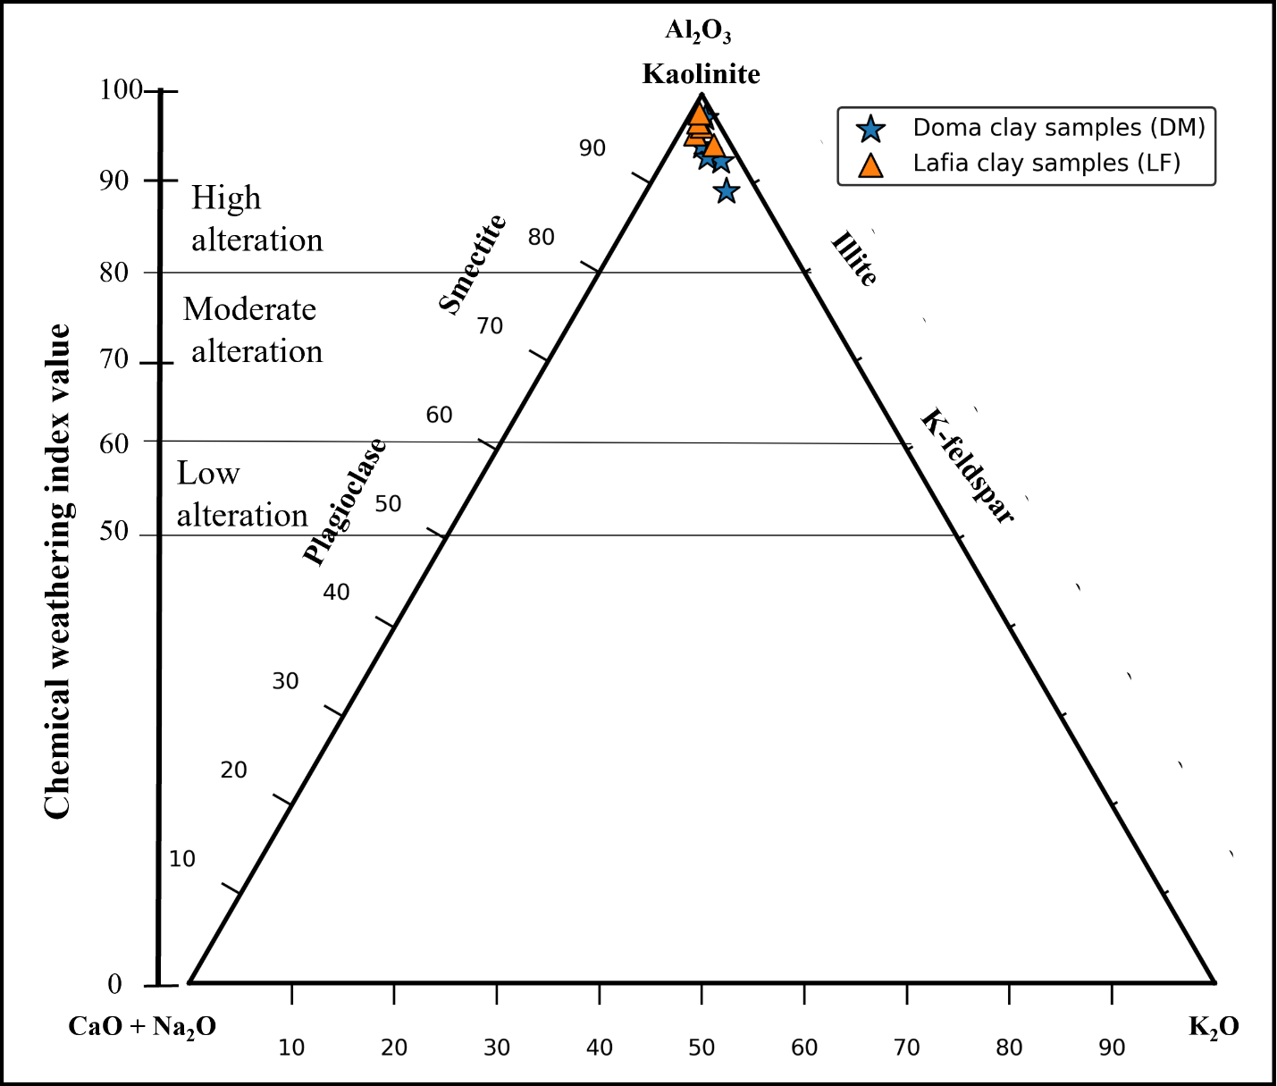
Figure 7. Ternary plot showing the degree of alteration of clay in the study area (after Nesbitt & Young, 1984)
The grain size distribution indicates that the clay samples are predominantly silty clays according to the Shepard (1954) classification (Figure 8). Comparative analysis shows that Lafia samples contain a higher proportion of clay-sized particles, whereas Doma samples are relatively enriched in sand and silt fractions. This variation is consistent with differences in mineralogical composition, particularly the higher quartz content observed in Doma samples.
The particle size characteristics further influence the inferred hydrogeological properties of the clays. Based on the McManus (1988) classification (Figure 9), the samples generally exhibit low porosity and low permeability, with some Lafia samples showing relatively higher porosity but very low permeability. These properties are consistent with fine-grained, kaolinitic clay systems.
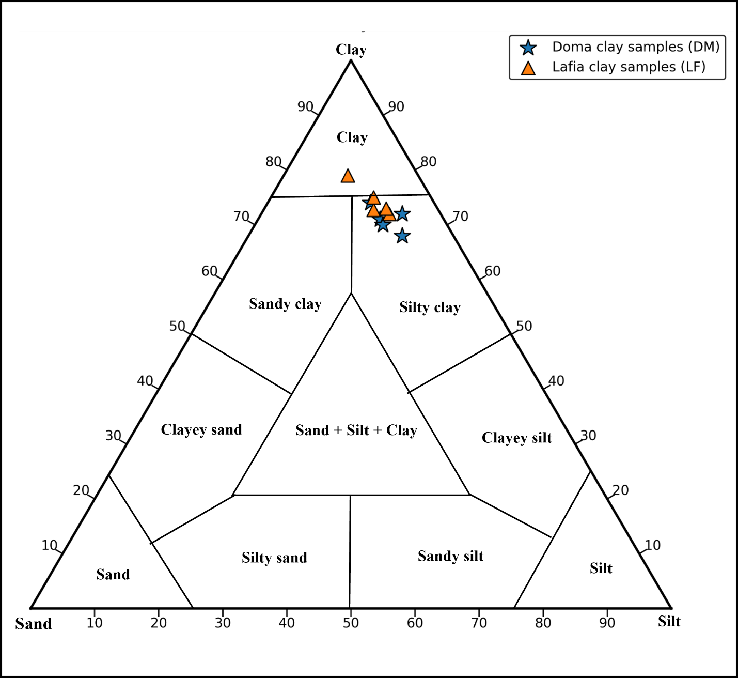
Figure 8. Ternary diagram showing particle size of clay samples in the study area (after Shepard, 1954)
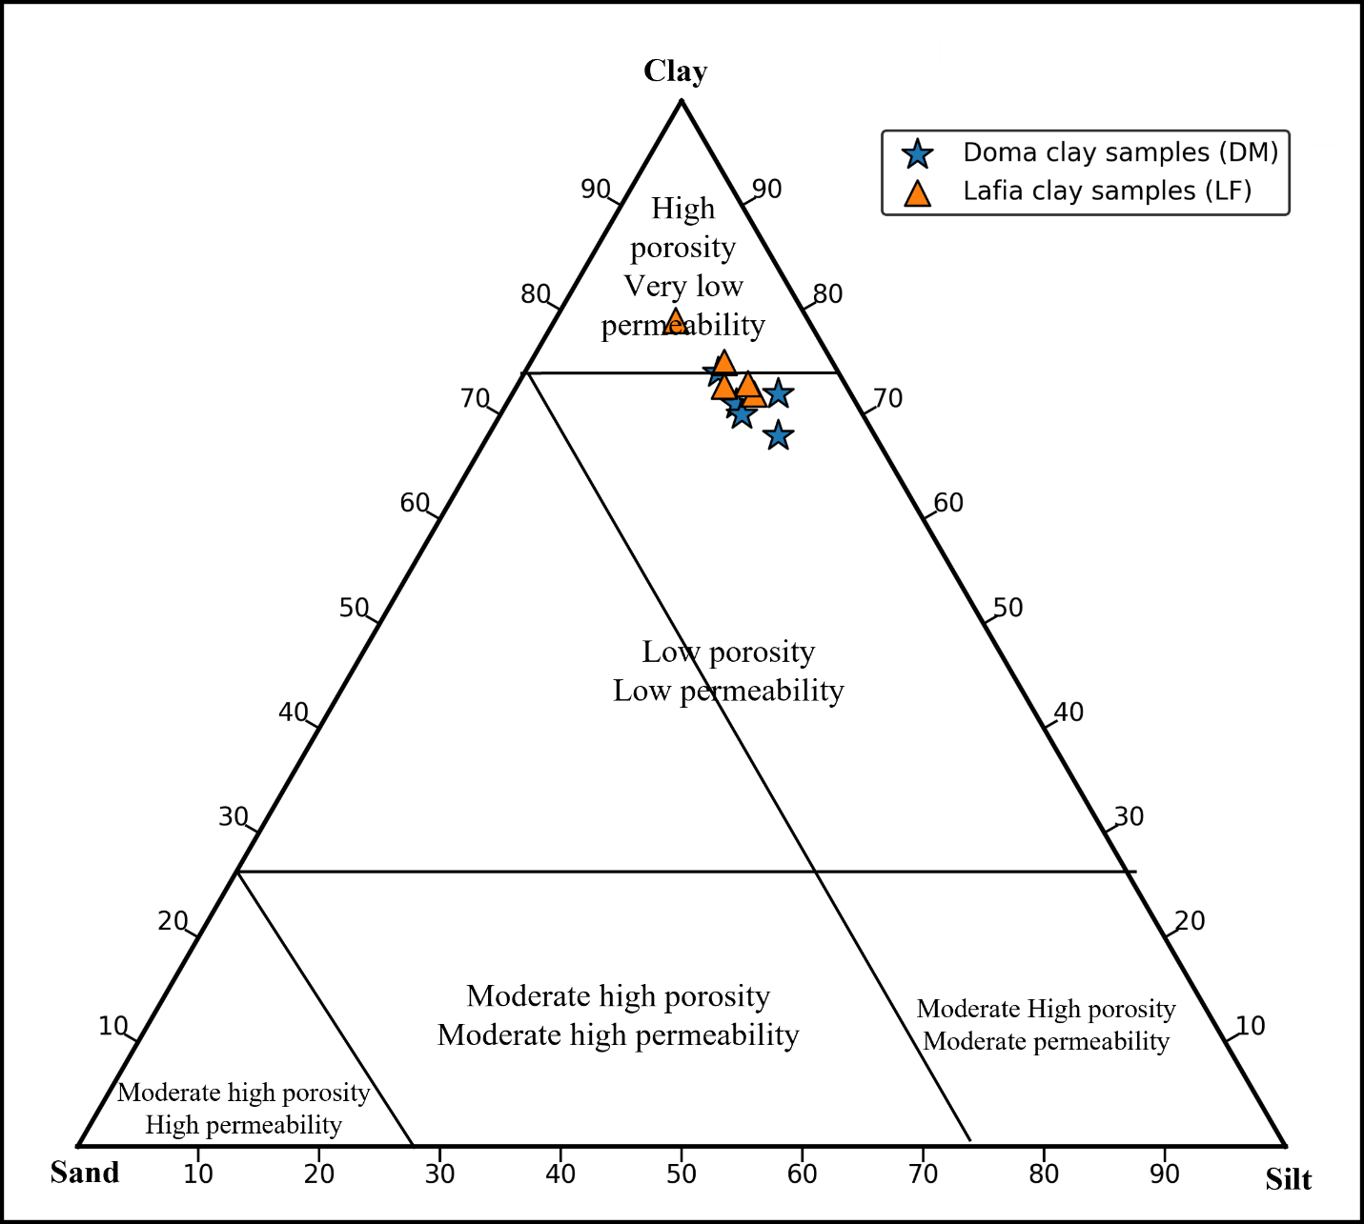
Figure 9. Triangular diagram of particle sizes showing porosity and permeability of clay samples (after McManus, 1988)
Generally, the clay content of clay samples influenced the plasticity (Oumar et al., 2022); hence, clay samples in Lafia have high clay content. The plasticity index determines the plasticity and compressibility of clays. A higher plasticity index indicates increased flexibility, compressibility, and larger volume change characteristics of the clays (Ihekweme et al., 2021). The Casagrande plasticity chart was used to show the degree of plasticity and classification of the clay samples (Figure 10). All the clay samples were plotted above the A-line, signifying inorganic clays. However, the clay samples in Doma can be described as medium-plastic inorganic clays, while the clay samples in Lafia are high-plastic clays.
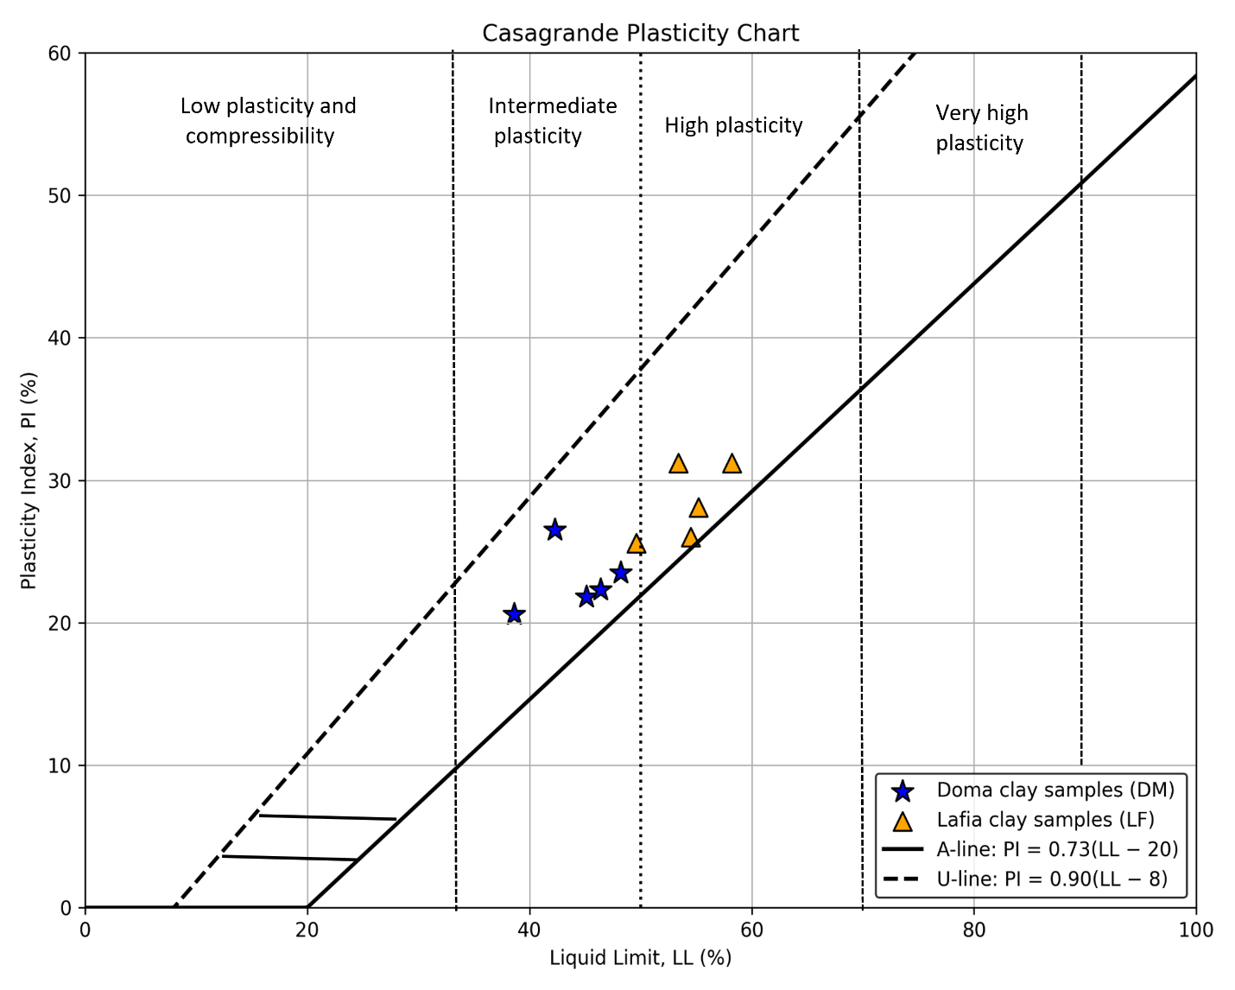
Figure 10. The Casagrande soil classification plot shows Doma and Lafia clay samples plotted in intermediate and high plasticity, respectively (Casagrande, 1948).

Industrial Potential
Clays are important raw materials in several industrial sectors, particularly ceramics, cement, bricks, and coatings. Their industrial applicability depends on mineralogical composition, oxide chemistry, particle size distribution, plasticity, and performance during thermal processing. The present assessment is based on mineralogical, geochemical, and geotechnical screening and therefore represents a preliminary evaluation rather than a full performance-based validation.
The compositional thresholds used for this assessment are derived from published case-specific studies and serve as comparative indicators rather than universal or globally applicable standards. Industrial suitability is presented as application-dependent, and these benchmarks provide a preliminary screening within the context of existing literature .In ceramic applications, desirable compositional ranges often include moderate to high Al₂O₃ content, controlled SiO₂ proportion, and low Fe₂O₃ to minimize coloration effects during firing (Abyzov, 2019; Kočí et al., 2022; Tsozué et al., 2022). The Lafia and Doma clay samples mainly contain kaolinite and quartz, with Al₂O₃ and SiO₂ levels that are similar to those found in materials used for making tiles, bricks, and stoneware. However, the relatively elevated Fe₂O₃ content, particularly in Doma samples, may influence fired color and require further thermal and firing evaluation to confirm product suitability.
Ternary diagrams based on chemical composition (Figure 11) and particle size distribution (Figure 12) indicate that the samples plot within fields commonly associated with raw materials for ceramics and, with the addition of 10–20 wt% sand and silt particles, will be favorable as raw materials for bricks. The Bain & Highley (1979) diagram, based on plasticity index and plastic limit (Figure 13), also shows the favorability of the clays as raw materials for pottery. These graphical comparisons suggest potential applicability, although additional tests, such as firing shrinkage, mechanical strength, and thermal behavior analysis, would be necessary to confirm industrial performance.
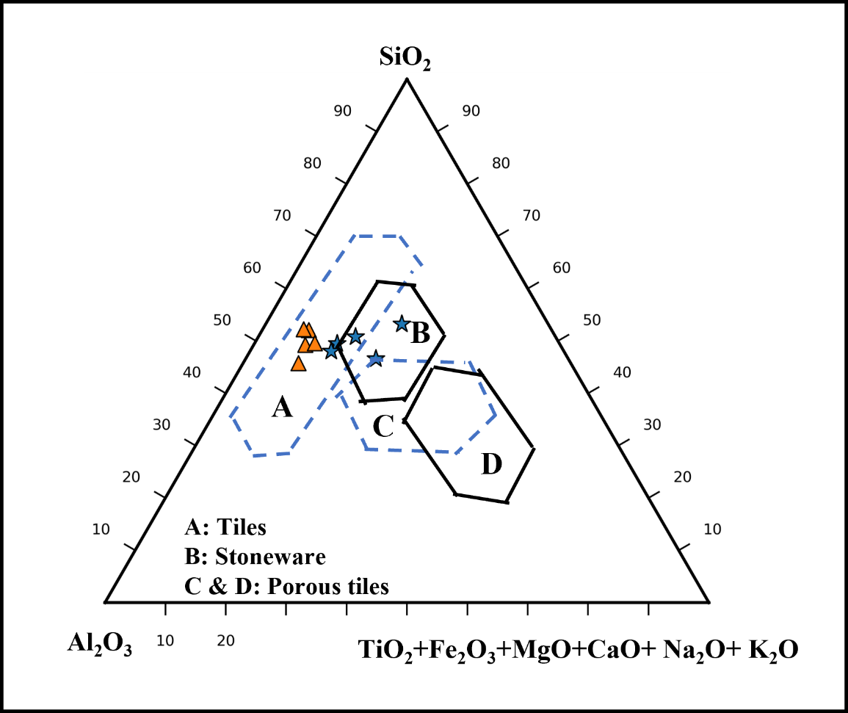
Figure 11: Suitability of clay materials in different ceramic tiles (after Fiori et al., 1989)
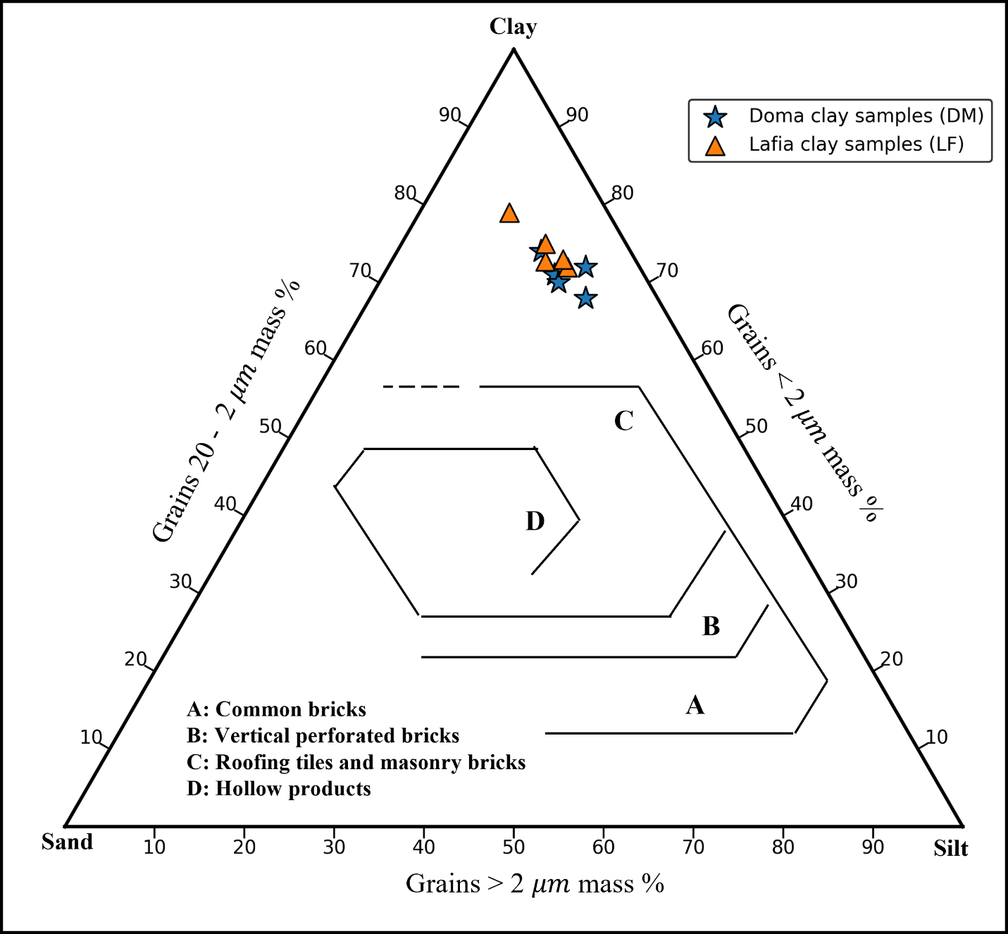
Figure 12. Winkler ternary diagram for suitability of clay materials for brick production (after Winkler, 1954)
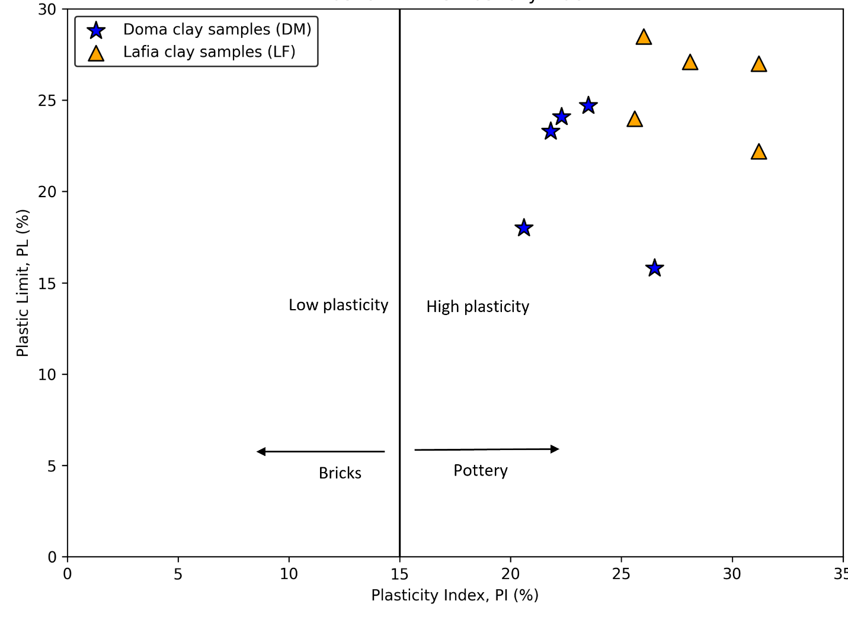
Figure 13. A Bain diagram for the potential molding of clay materials (after Bain & Highley, 1979).
In the cement industry, clay materials serve as sources of silica, alumina, and iron in kiln feed and may also function as calcined clay supplementary cementitious materials when properly processed (Mousavi et al., 2021; Cheah et al., 2025). The Lafia samples, characterized by higher average Al₂O₃ and kaolinite content, compare favorably with reported compositional ranges for raw feed blending or calcined clay applications. The Doma samples show slightly lower kaolinite content but still fall within ranges reported in similar studies. Nevertheless, performance testing, such as calcination reactivity and strength contribution, would be required before industrial implementation to ensure that the Doma samples meet the necessary quality and performance standards for practical applications.
For painting and coating applications, specifications commonly emphasize low Fe₂O₃ to avoid discoloration and adequate TiO₂ content for opacity enhancement (Buyondo et al., 2022; Igwe et al., 2016). The Fe₂O₃ content in several samples exceeds some reported reference ranges, while TiO₂ values are comparatively moderate. These characteristics may limit direct use in high-grade paint formulations without processing. Beneficiation techniques could potentially reduce iron-rich fractions; however, no beneficiation experiments were conducted in this study. Therefore, suitability for coating applications should be regarded as conditional pending further material upgrading and testing.
Overall, the mineralogical and chemical properties indicate that the Lafia and Doma clays have qualities similar to those of kaolinitic industrial clays. Based on a screening-level comparison with published industrial reference ranges, the deposits demonstrate potential for ceramic and cement-related applications. Further evaluation involving thermal analysis, firing tests, mechanical strength assessment, and beneficiation trials is recommended to validate performance under industrial processing conditions.

Conclusions
The clay deposits occur as sedimentary layers within the stratigraphic succession of the Lafia and Awgu formations in the study area. The dominance of kaolinite and quartz from XRD mineralogical studies and the dominance of Al₂O₃ and SiO₂ from XRF geochemical analysis of the clay samples from Lafia and Doma affirm that the clays are kaolin. The particle size distribution shows that the clays are silty, low-porosity, and low-permeability clays with moderate plasticity in Doma and high plasticity in Lafia samples.
This mineral and chemical composition of the clays indicates excellent potential for industrial applications in tiles, bricks, stoneware, pottery, and cement. However, the elevated iron content in the raw clay samples presents a significant limitation for direct use in the paint industry, where color and behavior are critical, as it can lead to undesirable coloration and affect the drying properties of the paint.

Conflict of Interest
The authors assert the absence of any conflict of interest.

Author Contributions
Ahmad Ibrahim Aliyu: Fieldwork and sampling, supervision, and writing the original draft. Lucy Ooja Agho: Fieldwork and sampling, writing—review and editing, visualization. Muhammad Sanusi Idris: Fieldwork and sampling, writing, reviewing, and editing. Usman Shehu Saeed: Fieldwork and sampling, laboratory work. Fatima Idris Adamu: Fieldwork and sampling, laboratory work. Beatrice Imona Amos: Fieldwork and sampling, laboratory work. Sheriff Abdulrafiu: Visualize, digitize, and update geological maps.

Funding
This research does not receive any funding. It is a personal contribution by the authors.

Acknowledgments
The authors express their gratitude and recognition to all researchers whose works this study has cited. Their original findings serve important roles in data analysis and interpretation, particularly in enhancing the reliability of the results presented in this study. Appreciation also goes to TRIACTA Construction Company, Lafia, for permission to carry out the Atterberg limit test in their laboratory.

Ethical Statements
This research did not include human or animal subjects.

Data and Code Availability
The data used in this work can be obtained through a formal request to the corresponding author.

References
Abubakar, M. B. (2014). Petroleum Potentials of the Nigerian Benue Trough and Anambra Basin: A Regional Synthesis. Natural Resources, 05(01), 25–58.
https://doi.org/10.4236/nr.2014.51005
Abyzov, A. M. (2019). Aluminum Oxide and Alumina Ceramics (review). Part 1. Properties of Al2O3 and Commercial Production of Dispersed Al₂O₃. Refractories and Industrial Ceramics, 60(1), 24–32. https://doi.org/10.1007/s11148-019-00304-2
Adeola, A. J., Odunayo, A. M., & Ifeoluwa, O. D. (2020). Geochemical and mineralogical characteristics of clay deposits at Ijesha–Ijebu and its environs, southwestern Nigeria. Global Journal of Pure and Applied Sciences, 26(2), 119–130.
https://doi.org/10.4314/gjpas.v26i2.4
Afolayan, D. O., Komadja, G. C., & Onwualu, A. P. (2022). Physicochemical studies and mineralogical characterization of clays for ceramic raw materials. Arabian Journal of Geosciences, 15(17). https://doi.org/10.1007/s12517-022-10716-z
Akande, S. O., Egenhoff, S. O., Obaje, N. G., Ojo, O. J., Adekeye, O. A., & Erdtmann, B. D. (2012). Hydrocarbon potential of Cretaceous sediments in the Lower and Middle Benue Trough, Nigeria: Insights from new source rock facies evaluation. Journal of African Earth Sciences, 64, 34–47. https://doi.org/10.1016/j.jafrearsci.2011.11.008
Akinyemi, S. A., Hower, J. C., Madukwe, H. Y., Nyakuma, B. B., Nasirudeen, M. B., Olanipekun, T. A., Mudzielwana, R., Gitari, M. W., & Silva, L. F. O. (2022). Geochemical, mineralogical, and petrological characteristics of the Cretaceous coal from the middle Benue Trough Basin, Nigeria: Implication for coal depositional environments. Energy Geoscience, 3(3), 300–313. https://doi.org/10.1016/j.engeos.2022.04.004
Avet, F., Snellings, R., Alujas Diaz, A., Ben Haha, M., & Scrivener, K. (2016). Development of a new rapid, relevant, and reliable (R3) test method to evaluate the pozzolanic reactivity of calcined kaolinitic clays. Cement and Concrete Research, 85, 1–11.
https://doi.org/10.1016/j.cemconres.2016.02.015
Awad, M. E., López-Galindo, A., Setti, M., El-Rahmany, M. M., & Iborra, C. V. (2017). Kaolinite in pharmaceutics and biomedicine. International Journal of Pharmaceutics, 533(1), 34–48. https://doi.org/10.1016/j.ijpharm.2017.09.056
Ayalew, A. A., & Demir, I. (2023). Physicochemical Characterization of Ethiopian-Mined Kaolin Clay through a Beneficiation Process. Advances in Materials Science and Engineering, 2023. https://doi.org/10.1155/2023/9104807
Bain, J. A., & Highley, D. E. (1979). Regional Appraisal of Clay Resources - A Challenge to the Clay Mineralogist. In M. M. Mortland & V. C. B. T.-D. in S. Farmer (Eds.), International Clay Conference 1978 (Vol. 27, pp. 437–446). Elsevier. https://doi.org/https://doi.org/10.1016/S0070-4571(08)70741-6
Benkhelil, J. (1989). The origin and evolution of the Cretaceous Benue Trough (Nigeria). Journal of African Earth Sciences (and the Middle East), 8(2), 251–282. https://doi.org/https://doi.org/10.1016/S0899-5362(89)80028-4

Bolarinwa, A. T., Idakwo, S. O., & Bish, D. L. (2021). Source area weathering, provenance, and tectonic setting of the Campanian-Maastrichtian clay sequences in the Lower Benue Trough of Nigeria. Journal of African Earth Sciences, 173.
https://doi.org/10.1016/j.jafrearsci.2020.104050
Botto, I. L., Tuti, S., Gonzalez, M. J., & Gazzoli, D. (2016). Correlation between Iron Reducibility in Natural and Iron-Modified Clays and Its Adsorptive Capability for Arsenic Removal. Advances in Materials Physics and Chemistry, 06(05), 129–139. https://doi.org/10.4236/ampc.2016.65014
Boukoffa, Mechati, Lamouri, B., Bouabsa, L., & Fagel, N. (2021). Mineralogical, Physicochemical, and Geochemical Characterization of Three Kaolinitic Clays (Ne Algeria): Comparative Study. 1–28.
https://www.researchsquare.com/article/rs-198012/v1
Buyondo, K. A., Kasedde, H., & Kirabira, J. B. (2022). A comprehensive review on kaolin as a pigment for paint and coating: Recent trends of chemical-based paints, their environmental impacts, and regulation. Case Studies in Chemical and Environmental Engineering, 6. https://doi.org/10.1016/j.cscee.2022.100244
Casagrande, A. (1948). Classification and Identification of Soils. Transactions of the American Society of Civil Engineers, 113, 901–930.
https://api.semanticscholar.org/CorpusID:131840675
Cheah, C. B., Liew, J. J., Khaw, K. L. P., bin Md Akil, H., & Alengaram, U. J. (2025). Calcined clay as a low-carbon cementitious material: Comprehensive review of treatment method, properties, and performance in concrete. Cleaner Waste Systems, 11. https://doi.org/10.1016/j.clwas.2025.100323
Dewi, R., Agusnar, H., Alfian, Z., & Tamrin. (2018). Characterization of technical kaolin using XRF, SEM, XRD, and FTIR and its potentials as industrial raw materials. Journal of Physics: Conference Series, 1116(4). https://doi.org/10.1088/1742-6596/1116/4/042010
Enea, D., Bellardita, M., Scalisi, P., Alaimo, G., & Palmisano, L. (2019). Effects of weathering on the performance of self-cleaning photocatalytic paints. Cement and Concrete Composites, 96, 77–86. https://doi.org/10.1016/j.cemconcomp.2018.11.013
Erkmen, J., Yavuz, H. I., Kavci, E., & Sari, M. (2020). A new environmentally friendly insulating material designed from natural materials. Construction and Building Materials, 255. https://doi.org/10.1016/j.conbuildmat.2020.119357
Eyankware, M. O., Ogwah, C., & Ike, J. C. (2021). A Synoptic Review of Mineralogical and Chemical Characteristics of Clays in the Southern Part of Nigeria. Research in Ecology, 3(2), 32–45. https://doi.org/10.30564/re.v3i2.3057
Fairhead, J. D., Green, C. M., Masterton, S. M., & Guiraud, R. (2013). The role that plate tectonics, inferred stress changes, and stratigraphic unconformities have on the evolution of the West and Central African Rift System and the Atlantic continental margins. Tectonophysics, 594, 118–127. https://doi.org/https://doi.org/10.1016/j.tecto.2013.03.021
Fiori, C., Fabbri, B., Donati, G., & Venturi, I. (1989). Mineralogical composition of the clay bodies used in the Italian tile industry. Applied Clay Science, 4(5), 461–473. https://doi.org/https://doi.org/10.1016/0169-1317(89)90023-9
Garcia-Valles, M., Alfonso, P., Martínez, S., & Roca, N. (2020). Mineralogical and thermal characterization of kaolinitic clays from terra alta (Catalonia, Spain). Minerals, 10(2). https://doi.org/10.3390/min10020142
Goldberg, K., & Humayun, M. (2010). The applicability of the Chemical Index of Alteration as a paleoclimatic indicator: An example from the Permian of the Paraná Basin, Brazil. Palaeogeography, Palaeoclimatology, Palaeoecology, 293, 175–183.
https://doi.org/10.1016/j.palaeo.2010.05.015
Gu, X., & Ling, Y. (2024). Characterization and properties of Chinese red clay for use as ceramic and construction materials. Science Progress, 107(1).
https://doi.org/10.1177/00368504241232534
Idrissi, H., Daoudi, L., Alami, J., El Ouahabi Meriam, & Fagel, N. (2021). Main parameters influencing the plastic behavior of clays used for traditional ceramic production. https://doi.org/10.31224/OSF.IO/USHM4
Igwe, I. O., Ewulonu, C. M., Chikei, A. N., & Nicholas, B. (2016). Performance Evaluation of Aro-Ndizuogu Local Clay in Alkyd Paint Production. International Journal of Engineering and Technologies, 7, 87–93.
https://doi.org/10.18052/www.scipress.com/ijet.7.87
Ihekweme, G. O., Obianyo, I. I., Orisekeh, K. I., Kalu-Uka, G. M., Nwuzor, I. C., & Onwualu, A. P. (2021). Plasticity characterization of certain Nigerian clay minerals for their application in ceramic water filters. Science Progress, 104(2). https://doi.org/10.1177/00368504211012148
Kadyrova, Z. R., Purkhanatdinov, A. P., & Niyazova, S. M. (2021). Study of Karakalpakstan Bentonite Clay for Producing Ceramic Heat-Insulating Materials. Refractories and Industrial Ceramics, 61(5), 478–480. https://doi.org/10.1007/s11148-021-00528-1
Kočí, V., Keppert, M., Trník, A., & Černý, R. (2022). Characterization of Brick Clays Suitable for Advanced Ceramic Building Elements. AIP Conference Proceedings, 2425. https://doi.org/10.1063/5.0081385
Kumari, N., & Mohan, C. (2021). Basics of Clay Minerals and Their Characteristic Properties. Clay and Clay Minerals. https://doi.org/10.5772/intechopen.97672
Lar, U. A., Bata, T., Dibal, H., Yusuf, S. N., Lekmang, I., Goyit, M., & Yenne, E. (2023). Potential petroleum prospects in the middle Benue Trough, central Nigeria: Inferences from integrated applications of geological, geophysical, and geochemical studies. Scientific African, 19. https://doi.org/10.1016/j.sciaf.2022.e01436
Lee, H. J., Jung, K. Y., & Kim, Y. S. (2021). Nanostructured Fe₂O₃/TiO₂ composite particles with enhanced NIR reflectance for application to LiDAR-detectable cool pigments. RSC Advances, 11(28), 16834–16840. https://doi.org/10.1039/d1ra02614c
Lei, H., Huang, W., Jiang, Q., & Luo, P. (2022). Genesis of clay minerals and its insight for the formation of limestone marl alterations in the Middle Permian of the Sichuan Basin. Journal of Petroleum Science and Engineering, 218.
https://doi.org/10.1016/j.petrol.2022.111014
Lorentz, B., Shanahan, N., Stetsko, Y. P., & Zayed, A. (2018). Characterization of Florida kaolin clays using a multiple-technique approach. Applied Clay Science, 161, 326–333. https://doi.org/https://doi.org/10.1016/j.clay.2018.05.001
Mangold, N., Dehouck, E., Fedo, C., Forni, O., Achilles, C., Bristow, T., Downs, R., Frydenvang, J., Gasnault, O., L’Haridon, J., Deit, L., Maurice, S., McLennan, S., Meslin, P., Morrison, S., Newsom, H., Rampe, E., Rapin, W., Rivera‐Hernández, F., … Wiens, R. (2019). Chemical alteration of fine-grained sedimentary rocks at Gale Crater. Icarus. https://doi.org/10.1016/j.icarus.2018.11.004
Mangs, A. D., Wagner, N. J., Moroeng, O. M., & Lar, U. A. (2022). Petrographic composition of coal within the Benue Trough, Nigeria, and a consideration of the paleodepositional setting. International Journal of Coal Science and Technology, 9(1). https://doi.org/10.1007/s40789-022-00500-5
Molinari, C., Alaya, Y., Pasti, L., Guarini, G., Dondi, M., & Zanelli, C. (2023). Assessing white clays from Tabarka (Tunisia) in the production of porcelain stoneware tiles. Applied Clay Science, 231. https://doi.org/10.1016/j.clay.2022.106741
Mousavi, S. S., Bhojaraju, C., & Ouellet-Plamondon, C. (2021). Clay as a Sustainable Binder for Concrete—A Review. Construction Materials, 1(3), 134–168.
https://doi.org/10.3390/constrmater1030010
Nesbitt, H. W., & Young, G. M. (1984). Prediction of some weathering trends of plutonic and volcanic rocks based on thermodynamic and kinetic considerations. Geochimica et Cosmochimica Acta, 48(7), 1523–1534. https://doi.org/https://doi.org/10.1016/0016-7037(84)90408-3
Nguyen, T. T. T., & Bui, H. B. (2024). Characterization and thermal behavior of some types of kaolin of different origin from Northern Vietnam. Mining Science and Technology (Russian Federation), 9(1), 30–40. https://doi.org/10.17073/2500-0632-2023-12-189
Obrike S.E, Maina B.M, & Ofoegbu C.O. (2019). Mineralogical, Geochemical, and Geotechnical Characteristics of the Maastrichtian Clay Member of the Lafia Formation in the Doma and Shabu Areas, Middle Benue Trough. Journal of Mining and Geology, 55(2), 109–118.
Offodile, M. E. (1976). The geology of the Middle Benue, Nigeria. In the geology of the Middle Benue, Nigeria. Diss. Uppsala: Univ.
Oha, I. A., Okonkwo, I. A., & Dada, S. S. (2020). Wrench Tectonism and Intracontinental Basin Sedimentation: A Case Study of the Moku Sub-Basin, Upper Benue Trough, Nigeria. Journal of Geography and Geology, 12(1), 65.
https://doi.org/10.5539/jgg.v12n1p65
Olade, M. A. (1975). Evolution of Nigeria’s Benue Trough (Aulacogen): a tectonic model. Geological Magazine, 112(6), 575–583.
https://doi.org/DOI:10.1017/S001675680003898X
Olakunle Osinowo, O., Abdulmumin, Y., & Faweya, T. V. (2023). Analysis of high-resolution airborne-magnetic data for hydrocarbon generation and preservation potential evaluation of Yola sub-basins, northern Benue Trough, northeastern Nigeria. Energy Geoscience, 4(1), 33–41. https://doi.org/10.1016/j.engeos.2022.08.002
Onyekuru, S. O., Iwuoha, P. O., Iwuagwu, C. J., Nwozor, K. K., & Opara, K. D. (2018). Mineralogical and geochemical properties of clay deposits in parts of southeastern Nigeria. International Journal of Physical Sciences, 13(14), 217–229.
https://doi.org/10.5897/ijps2018.4733
Oumar, K. O., Gilbert François, N. N., Bertrand, M. M., Nathanael, T., Constantin, B. E., Simon, M. J., & Jacques, E. (2022). Mineralogical and Geochemical Characterization and Physicochemical Properties of Kaolinitic Clays of the Eastern Part of the Douala Sub-Basin, Cameroon, Central Africa. Applied Sciences, 12(18).
https://doi.org/10.3390/app12189143
Patrick, N. O., Fadele, S. I., & Adegoke, I. (2013). Stratigraphic report of the Middle Benue Trough, Nigeria: Insights from petrographic and structural evaluation of Abuni and environs, part of Late Albian-Cenomanian Awe and Keana formations. The Pacific Journal of Science and Technology, 14(1), 557–570.
Peys, A., Isteri, V., Yliniemi, J., Yorkshire, A. S., Lemougna, P. N., Utton, C., Provis, J. L., Snellings, R., & Hanein, T. (2022). Sustainable iron-rich cements: Raw material sources and binder types. Cement and Concrete Research, 157.
https://doi.org/10.1016/j.cemconres.2022.106834
Saikia, N. J., Bharali, D. J., Sengupta, P., Bordoloi, D., Goswamee, R. L., Saikia, P. C., & Borthakur, P. C. (2003). Characterization, beneficiation, and utilization of a kaolinite clay from Assam, India. Applied Clay Science, 24(1–2), 93–103.
https://doi.org/10.1016/S0169-1317(03)00151-0
Sam-Tunsa Alarba, A., Epey, N., Nana, A., Tome, S., Mache, J. R., & Nchare, M. (2022). Mineralogical and physicochemical characterization of clayey materials from Meiganga (Adamawa-Cameroon): potential application in traditional ceramic. Journal of Building Pathology and Rehabilitation, 7(1). https://doi.org/10.1007/s41024-022-00203-z
Sawadogo, M., Seynou, M., Zerbo, L., Sorgho, B., Laure Lecomte-Nana, G., Blanchart, P., & Ouédraogo, R. (2020). Formulation of Clay Refractory Bricks: Influence of the Nature of Chamotte and the Alumina Content in the Clay. Advances in Materials, 9(4), 59. https://doi.org/10.11648/j.am.20200904.11
Shepard, F. P. (1954). Nomenclature Based on Sand-silt-clay Ratios. Journal of Sedimentary Research, 24, 151–158. https://api.semanticscholar.org/CorpusID:129806833
Singh, N. B. (2022). Clay and Clay Minerals in the Construction Industry. Minerals, 12(3). https://doi.org/10.3390/min12030301
Tsozué, D., Nzeukou, A. N., Kagonbé, B. P., Madi, A. B., Mache, J. R., Bitom, D. L., & Fagel, N. (2022). Genesis and assessment of clay materials' suitability for earthenware production in northern Cameroon. Arabian Journal of Geosciences, 15(16). https://doi.org/10.1007/s12517-022-10603-7
Winkler, H. G. F. (1954). Bedeutung der Korngrößenverteilung und des Mineralbestandes von Tonen r die Herstellung grobkeramischer Erzeugnisse. Ber. Dtsch. Keram. Ges., 31, 337–343.
Yenne, E. Y., Green, C., & Torvela, T. (2024). Implications to basin evolution from the interpretation of superficial and buried geological features from remote sensing and magnetic data sets, Lower and Middle Benue Trough, Nigeria. Results in Earth Sciences, 2, 100029. https://doi.org/10.1016/j.rines.2024.100029
Yuan, G., Cao, Y., Schulz, H. M., Hao, F., Gluyas, J., Liu, K., Yang, T., Wang, Y., Xi, K., & Li, F. (2019). A review of feldspar alteration and its geological significance in sedimentary basins: From shallow aquifers to deep hydrocarbon reservoirs. Earth-Science Reviews, 191, 114–140. https://doi.org/10.1016/j.earscirev.2019.02.004
.

