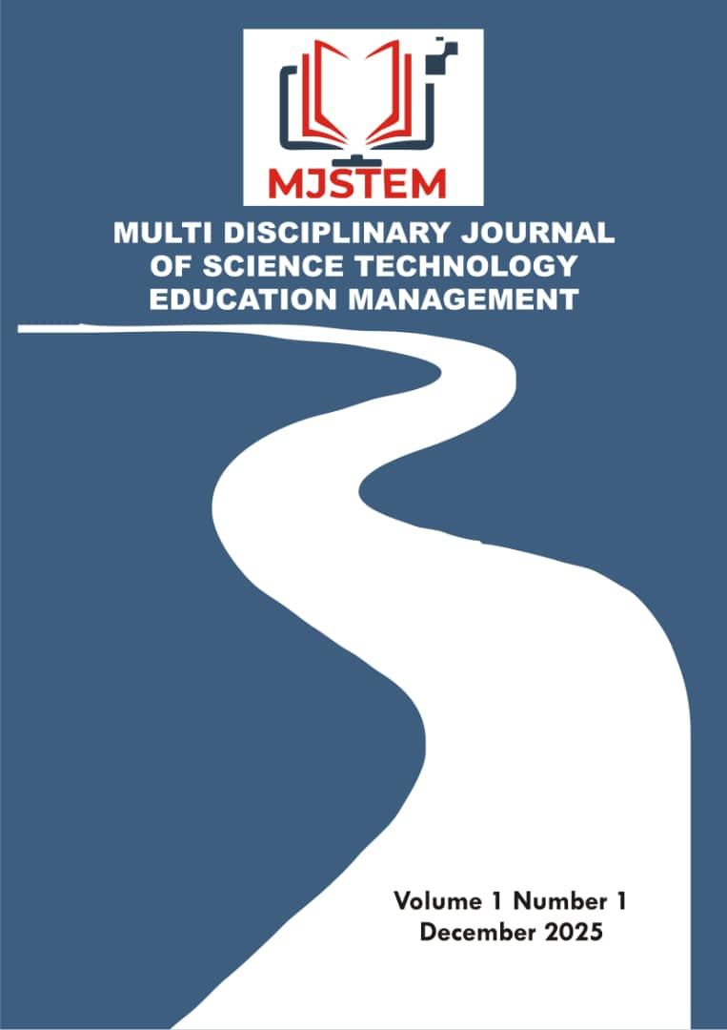

Multidisciplinary Journal of Science Technology Education and Management
Journal homepage: http://www.mjstem.org

Effects of Methanol Seed Extracts of Carica papaya and Ricinus communis on Reproductive Hormones in

Male Wistar Rats: Implications for

Antifertility Activity
Zainab Yakubu^{a,b*}, Wali U.^{b}, H. M. Alhassan^{c}, A. J. Yusuf^{d}, Salihu Halimatu Husaini^{e} and Ibrahim A. Musa^{f}
ªDepartment of Medical Laboratory, General Hospital Minna, Niger State, Nigeria;
^{b}Department of Chemical Pathology, School of Medical Laboratory Science, Usmanu Danfodiyo University Sokoto, Sokoto State, Nigeria;
^{c}Department of Immunology, School of Medical Laboratory Science, Usmanu Danfodiyo University Sokoto, Sokoto State, Nigeria;
^{d}Department of Pharmaceutical and Medicinal Chemistry, Faculty of Pharmaceutical Sciences, Usmanu Danfodiyo University Sokoto, Sokoto State, Nigeria;
^{e}Department of Medical Laboratory, General Amadi Rimi Specialist and Orthopedic Hospital Batagarawa, Katsina State, Nigeria;
^{f}Solina Center for International Development and Research Sokoto, Sokoto State, Nigeria;
*Correspondence: Zainab Yakubu (zeeyakubu16.zy@gmail.com).

Abstract
The increasing search for effective, affordable, and reversible male contraceptive agents has stimulated interest in medicinal plants with potential antifertility properties. This study evaluated the effects of methanol seed extracts of Carica papaya and Ricinus communis on reproductive hormone profiles in male Wistar rats. Thirty-five adult male Wistar rats were randomly assigned to seven groups of five animals each. Group 1 served as the control, while Groups 2 and 3 received C. papaya extract at 250 mg/kg and 500 mg/kg, respectively. Groups 4 and 5 received R. communis extract at the same doses, whereas Groups 6 and 7 received combined extracts at 250 mg/kg and 500 mg/kg. Administration was carried out orally for 21 days, after which serum luteinizing hormone (LH), follicle-stimulating hormone (FSH), and testosterone levels were determined using ELISA kits. Statistical analysis revealed significant differences among groups for LH (p = 0.014), FSH (p = 0.046), and testosterone (p = 0.022). Testosterone levels were significantly reduced in treated groups compared with the control, while LH and FSH were elevated, indicating disruption of the hypothalamic–pituitary–gonadal axis. The combined extract groups showed more pronounced hormonal alterations, particularly at higher doses. These findings demonstrate that methanol seed extracts of C. papaya and R. communis alter male reproductive hormone profiles and suggest potential antifertility activity mediated through endocrine modulation. However, functional fertility outcomes were not assessed in this study, limiting direct inference on fertility suppression.
Keywords: Antifertility, Carica papaya, follicle stimulating hormone, luteinizing hormone, Ricinus communis, testosterone, wistar rats

Introduction
Fertility regulation remains an important aspect of reproductive health research because of its implications for population management, family planning, and public health. Although several contraceptive methods are available for women, the options for men remain limited largely to condoms, vasectomy, and periodic abstinence. Condoms are associated with relatively high user failure rates, whereas vasectomy is often regarded as a permanent procedure despite advances in reversal techniques. These limitations have encouraged continued efforts to identify safe, effective, affordable, and reversible male contraceptive agents. Interest has increasingly shifted toward medicinal plants because many plant species contain biologically active compounds capable of influencing reproductive processes (Bhardwaj et al., 2025).
Antifertility refers to the ability of a substance to reduce or prevent reproductive capacity through interference with gamete production, fertilization, implantation, or the development of viable offspring (Zhu et al., 2023). Plant-derived antifertility agents have attracted considerable scientific attention because they offer a potential source of novel contraceptive compounds. Many medicinal plants contain secondary metabolites that exert physiological effects on the reproductive system. These compounds may alter sperm production, impair sperm function, disrupt reproductive hormone secretion, or affect the structure and function of reproductive organs. Such findings have stimulated extensive research into the reproductive effects of plant extracts and their possible application in fertility control (Otieno, 2025).
Several classes of phytochemicals have been implicated in reproductive modulation. Alkaloids, flavonoids, saponins, tannins, glycosides, and terpenoids have been reported to influence spermatogenesis, steroidogenesis, and endocrine regulation in experimental animals (Wadhawan et al., 2026). Spermatogenesis is a highly coordinated process that depends on the normal functioning of the testes and the maintenance of hormonal balance. Steroidogenesis involves the synthesis of steroid hormones, particularly testosterone, which plays a central role in male reproductive function. Alterations in these processes may result in reduced fertility, impaired reproductive performance, and changes in hormonal status. Consequently, medicinal plants that possess the capacity to modify reproductive physiology have become important subjects of investigation in reproductive biology and pharmacology.
Among the medicinal plants that have received considerable attention for their reproductive effects are Carica papaya and Ricinus communis. Carica papaya, commonly known as papaya, is a tropical plant cultivated widely across Africa, Asia, and South America. The plant has long been used in traditional medicine for the management of various ailments, including digestive disorders, inflammatory conditions, parasitic infections, and metabolic diseases (Babalola et al., 2024). Different parts of the plant possess pharmacological activities, although the seeds have attracted particular interest because of their reported antifertility properties.
The seeds of Carica papaya contain numerous bioactive constituents, including flavonoids, alkaloids, saponins, tannins, and benzyl isothiocyanate. These compounds have been associated with alterations in male reproductive function. Experimental studies have shown that administration of papaya seed extracts can reduce sperm count, sperm motility, sperm viability, and fertility rates in laboratory animals (Airaodion et al., 2019). Histological examinations have also revealed structural changes within the seminiferous tubules following prolonged exposure to papaya seed preparations. Such observations suggest that the seeds may interfere with spermatogenesis and other physiological processes required for normal reproductive function. Evidence from previous investigations further indicates that papaya seed extracts may influence testosterone production, thereby affecting endocrine regulation within the male reproductive system (Ghaffarilaleh et al., 2019).
Ricinus communis, commonly referred to as the castor plant, is another medicinal plant known for its diverse biological activities. The plant is widely distributed in tropical and subtropical regions and has been utilized traditionally for medicinal and industrial purposes. Castor seeds contain several bioactive compounds, including ricin, ricinine, flavonoids, alkaloids, and fatty acids. Ricin is particularly recognized for its potent biological activity and toxicological significance. Research has demonstrated that exposure to castor seed extracts may adversely affect reproductive function through mechanisms involving cellular damage, oxidative stress, and endocrine disruption (Abomughaid et al., 2024).
Previous studies have reported reductions in sperm concentration, sperm motility, and reproductive performance following administration of Ricinus communis seed extracts in experimental animals (Umar et al., 2025). Histopathological alterations within the testes have also been documented, suggesting impaired spermatogenic activity and reproductive toxicity. Despite these findings, the precise mechanisms through which castor seed extracts influence male fertility remain incompletely understood. A clearer understanding of their effects on hormonal regulation may provide valuable insight into their reproductive actions.
The male reproductive system is regulated by a complex neuroendocrine network known as the hypothalamic-pituitary-gonadal (HPG) axis. This system coordinates the production of reproductive hormones required for spermatogenesis and sexual function. The hypothalamus secretes gonadotropin-releasing hormone, which stimulates the anterior pituitary gland to release luteinizing hormone (LH) and follicle-stimulating hormone (FSH). Luteinizing hormone acts primarily on the Leydig cells of the testes and promotes testosterone synthesis. Follicle-stimulating hormone acts on Sertoli cells and supports the development and maturation of spermatozoa. Testosterone subsequently maintains spermatogenesis, reproductive organ function, libido, and secondary sexual characteristics.
Normal reproductive function depends on the coordinated interaction of these hormones. Disturbances in the secretion or activity of LH, FSH, and testosterone may compromise fertility and impair reproductive capacity. Many plant-derived compounds have been shown to affect endocrine function through direct effects on hormone-producing tissues or indirect effects on regulatory pathways within the HPG axis. Assessment of reproductive hormone levels therefore provides important information regarding the mechanisms through which antifertility agents exert their effects.
Existing studies on Carica papaya and Ricinus communis have largely concentrated on sperm parameters, fertility indices, and histopathological changes in reproductive tissues. Although these studies have established the antifertility potential of both plants, limited attention has been directed toward their comparative effects on reproductive hormones. Information concerning the influence of methanol seed extracts of these plants on LH, FSH, and testosterone levels remains inadequate. This gap in knowledge restricts a comprehensive understanding of the endocrine mechanisms that may underlie their antifertility actions.
Methanol extraction is widely employed in phytochemical and pharmacological investigations because it facilitates the extraction of a broad spectrum of biologically active compounds. The use of methanol extracts may therefore provide a more comprehensive representation of the phytochemical constituents responsible for reproductive effects. Comparative evaluation of methanol seed extracts of Carica papaya and Ricinus communis may reveal differences in potency, hormonal responses, and mechanisms of action.
Male Wistar rats are frequently used in reproductive toxicology and endocrinology research because of their well-characterized physiology, predictable reproductive patterns, and suitability for experimental studies. Their reproductive endocrine system exhibits functional similarities to that of humans, making them an appropriate model for investigating the effects of plant-derived substances on reproductive hormones.
Despite growing evidence supporting the antifertility properties of Carica papaya and Ricinus communis, comparative data concerning their effects on reproductive hormone regulation remain scarce. Understanding how these plants influence the HPG axis is essential for determining their suitability as potential male contraceptive agents and for evaluating possible reproductive risks associated with their use. Therefore, this study was designed to investigate the antifertility effects of methanol seed extracts of Carica papaya and Ricinus communis on reproductive hormones in male Wistar rats. Particular attention was given to the assessment of luteinizing hormone, follicle-stimulating hormone, and testosterone concentrations as indicators of endocrine function and reproductive status. Findings from this study may contribute to the growing body of knowledge on plant-based fertility regulation and provide a scientific basis for future development of novel male contraceptive agents.

Aim and Objectives of the Study
The aim of this study is to evaluate the antifertility effects of methanol seed extracts of Carica papaya and Ricinus communis on reproductive hormones in male Wistar rats. Specifically, the study:
- Determine the effect of methanol seed extract of Carica papaya on serum LH, FSH, and testosterone levels in male Wistar rats.
- Determine the effect of methanol seed extract of Ricinus communis on serum LH, FSH, and testosterone levels in male Wistar rats.
- Evaluate the effect of the combined administration of methanol seed extracts of Carica papaya and Ricinus communis on serum LH, FSH, and testosterone levels in male Wistar rats.
- Compare the reproductive hormone profiles of male Wistar rats treated with methanol seed extracts of Carica papaya, Ricinus communis, and their combined extracts with those of the control group.

Materials and Methods

Chemicals and Reagents
Analytical graded chemicals and reagents were used for this research. Testosterone, FSH, LH assay kits were purchased from Monobind Inc. Lake Forest, USA.

Study Location
The study was conducted in the Pharmacognosy and Ethnopharmacy Laboratory and Animal house at the Faculty of Pharmaceutical Sciences, Usmanu Danfodiyo University, Sokoto and Chemical Pathology Laboratory Usmanu Danfodiyo University Teaching Hospital, Sokoto (UDUTH), Nigeria.

Plant Collection and Identification
Carica papaya fruits and Ricinus communis seeds were purchased from kasuwan Daji and Sokoto central market, Sokoto State respectively. The plants were identified and authenticated at the Herbarium unit, Department of Pharmacognosy and Ethnopharmacy, Faculty of Pharmaceutical Sciences, Usmanu Danfodiyo University, Sokoto. Specimen voucher number of C. papaya and R. communis were assigned as PCG/UDUS/CARI/005 and PCG/UDUS/EUPH/0016 respectively.

Preparation of Extracts
Each of the Carica papaya and Ricinus communis seeds were washed thoroughly with tap water. Both seeds were shade-dried and ground into fine powder with an electric blender. Maceration as described by Azwanida (2015) was used. 1000 g of the powdered dried Carica papaya and Ricinus communis seeds were suspended in 4500 ml of methanol each for 72 hours and shaken at regular intervals. The extracts were sieved first with cheese cloth and then with Whatman filter paper No 1. The filtrates were concentrated to dryness in a water bath preset at 55ºC and were kept in the refrigerator at 4ºC until required (Kanadi et al., 2019).

Ethical Consideration
Ethical approval was obtained from the University Animal Research and Ethics Committee on Animal of the Usmanu Danfodiyo University, Sokoto with ethical number NHREC/UDU-HREC/25/06/2023- PGM 28.

Method 2
The sample size for this study was determined using the Cohen's sample size estimation procedure (Cohen, 1988):
$$N=\frac{(K-1){\left(Z_{1-α}+Z_{1-β}\right)}^{2}}{Kf^{2}}$$where:
- $N$= total sample size
- $K$= number of groups
- $Z_{1-α}$= standard normal deviate corresponding to the level of significance
- $Z_{1-β}$= standard normal deviate corresponding to the desired statistical power
- $f$= Cohen's effect size for one-way ANOVA
$$N=\frac{({7-1)(1.96+0.84)}^{2}}{7(0.5)^{2}} \\ N=\frac{6(2.80)^{2}}{7(0.25)} \\ N=\frac{6(7.84)}{1.75} \\ N=\frac{47.04}{1.75} \\ N=26.88≈27$$Number of rats per each group (n) = 27/7 = 3.9 = 4 rats
Where; Sample size calculated (n) = 4 rats per 7 groups
Expected attrition = 10%
Corrected sample size (n) = Sample size/ (1 – {% attrition/100})
Therefore: n = 4/0.9= 5.6 = 5 rats per group
n = 5 rats per group
Therefore, total number of rats per 7 groups = 5×7 = 35

Experimental Animals
Thirty-five (35) male Wistar rats weighing between 180 to 200g were purchased from the Animal House, Faculty of Veterinary Medicine, Ahmadu Bello University Zaria. The rats were housed in well aerated cages under hygienic conditions, fed pelletized growers feed and allowed access to clean drinking water ad libitum throughout the experimental period. They were allowed to acclimatized for a period of 2 weeks before the commencement of the experiment (Aniagu et al., 2005).

Experimental Design
The animals were placed into 7 groups of 5 rats each. Group 1(Control group) received normal Vital feed and distilled water. Group 2 and 3 received 250 mg/kg and 500 mg/kg of Carica papaya seeds extract orally respectively for 21days. Group 4 and 5 received 250 mg/kg and 500 mg/kg of Ricinus communis seeds extract orally respectively for 21days. Group 6 and 7 received 250 mg/kg and 500 mg/kg of combined Carica papaya + Ricinus communis seeds extract orally respectively for 21days.

Animal Sacrifice and Sample collection
After 21 days period, the animals were fasted for 12hours, and were anaesthetized using ketamine: xylazine (50:10 mg/kg). 5mL of blood samples were collected from the animals through cardiac puncture, into clean, plain vacutainer tubes. The samples collected were allowed to clot at room temperature and later centrifuged at 4000 rpm (revolution per minute) for 10 minutes. The sera were then transferred into labelled sterile serum bottles and tightly caped and stored at -20ᴼC until the time of assay for the serum levels of testosterone, FSH and LH.

Analytical methods
Testosterone was determined according to the procedure described by Tietz (1985) by using ELISA kits. LH was determined according to the procedure described by Kosasa (1981), by using ELISA kits. FSH was determined according to the procedure described by Simoni et al., (1997), by using ELISA kit.

Data Analysis
The data obtained were analysed using Statistical Package for Social Sciences (SPSS) version 25. All data were first checked for normal distribution using Shapiro wilk test. The Kruskal-Wallis test and Dunn’s post hoc test (with Bonferroni correction) were used for the group comparisons. Spearman correlation was used for the correlation studies. The results were expressed as median and interquartile ranges. p value less than or equal to 0.05 (p≤ 0.05) was considered significant. Figure 1 shows the methodological framework for the study.
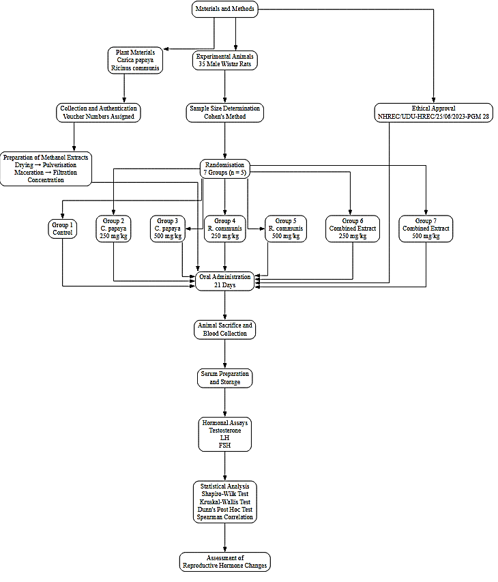
Figure 1: Methodological Framework

Results
The effects of methanol seed extracts of Carica papaya and Ricinus communis on male reproductive hormones are presented in Table 1. The results showed statistically significant differences in serum levels of LH, FSH, and testosterone among the experimental groups.

Table 1: Effects of Methanol Extract of Carica papaya and Ricinus communis seeds on Reproductive Hormones (LH, FSH, Testosterone) in Male Wistar Rats Compared with Control.
GROUP | N | LH (mIU/mL) | FSH (mIU/mL) | TESTOSTERONE (ng/mL)
1 | 5 | 0.20 (0.10-0.30) ª | 0.20 (0.15-0.35) ª | 2.80 (0.75-7.55) ª
2 | 5 | 0.65 (0.45-0.70) ^{ab} | 0.80 (0.35-1.10) ^{ab} | 2.10 (0.10-4.20) ^{ab}
3 | 5 | 1.30 (0.25-2.10) ^{b} | 1.30 (0.45-3.95) ^{b} | 0.30 (0.10-1.40) ^{b}
4 | 5 | 0.50 (0.40-0.55) ^{ab} | 0.90 (0.55-1.20) ^{ab} | 1.10 (0.65-1.35) ^{ab}
5 | 5 | 0.80 (0.55-1.00) ^{ab} | 1.00 (0.80-1.50) ^{ab} | 0.30 (0.30-0.40) ^{b}
6 | 5 | 1.10 (0.60-1.25) ^{b} | 0.95 (0.70-1.00) ^{ab} | 0.40 (0.20-0.60) ^{b}
7 | 5 | 1.50 (0.85-1.70) ^{b} | 0.90 (0.85-1.35) ^{ab} | 0.30 (0.20-0.30) ^{b}
KWS |  | 15.937 | 12.824 | 14.779
P-value |  | 0.014 | 0.046 | 0.022
Df |  | 6 | 6 | 6
η²H |  | 0.35 | 0.24 | 0.31
Values are expressed as median and interquartile ranges (Q1-Q3), values with different superscript letters (a, b) within same column are significantly different, KWS: Kruskal-Wallis H, FSH: Follicle Stimulating Hormone, LH: Luteinizing Hormone, Group 1: Normal control, Group 2: C. papaya 250 mg/kg, Group 3: C. papaya 500 mg/kg, Group 4: R. communis 250 mg/kg, Group 5: R. communis 500 mg/kg, Group 6: Combined extract 250 mg/kg, Group 7: Combined extract 500 mg/kg, N: Number of animals per group, df = degree of freedom, η²H = effect size.
For LH, there was a significant difference across the groups (Kruskal–Wallis H = 15.937, p = 0.014, η² = 0.35). The control group (Group 1) recorded the lowest median LH value of 0.20 mIU/mL, while higher values were observed in Groups 3, 6, and 7. Groups treated with higher doses of the extracts generally demonstrated elevated LH levels compared to the control, suggesting a possible compensatory pituitary response to impaired gonadal function.
Similarly, FSH levels differed significantly among the groups (Kruskal–Wallis H = 12.824, p = 0.046, η² = 0.24). The control group had the lowest FSH level (0.20 mIU/mL), whereas Group 3 showed the highest median value (1.30 mIU/mL). The increase in FSH levels in treated groups may indicate disruption of normal spermatogenic activity, leading to feedback stimulation of the pituitary gland.
Testosterone levels also showed significant variation across groups (Kruskal–Wallis H = 14.779, p = 0.022, η² = 0.31). The control group exhibited the highest testosterone concentration (2.80 ng/mL), while markedly reduced testosterone levels were observed in most treated groups, particularly Groups 3, 5, and 7. The decline in testosterone suggests that the extracts may exert inhibitory effects on Leydig cell function and androgen production.

Discussion and Limitations
The present study evaluated the effects of methanol seed extracts of Carica papaya and Ricinus communis, administered individually and in combination, on serum LH, FSH, and testosterone concentrations in male Wistar rats. Significant differences were observed among the experimental groups for all three reproductive hormones, indicating that exposure to the extracts altered endocrine regulation of male reproductive function.

Effect of Carica papaya Seed Extract on Reproductive Hormones
Administration of C. papaya seed extract resulted in significant alterations in reproductive hormone profiles. Rats treated with 500 mg/kg exhibited markedly elevated LH and FSH concentrations accompanied by substantial reductions in serum testosterone relative to the control group. The hormonal pattern observed suggests disruption of normal testicular endocrine activity. Testosterone is principally synthesized by Leydig cells under LH stimulation, and any impairment of steroidogenic processes may reduce circulating androgen concentrations. The decline in testosterone observed in the present study agrees with previous reports demonstrating that C. papaya seed extracts possess antifertility and antiandrogenic properties capable of suppressing testicular steroidogenesis (Lohiya et al., 2002; Udoh et al., 2005; Satriyasa et al., 2020).
The concomitant elevation of LH and FSH may reflect a compensatory response of the hypothalamic-pituitary-gonadal axis to reduced androgen availability. Under normal physiological conditions, testosterone exerts negative feedback on the hypothalamus and anterior pituitary. Suppression of testosterone production therefore reduces inhibitory feedback, resulting in increased gonadotropin secretion. The significantly higher gonadotropin concentrations recorded in the high-dose C. papaya group support this interpretation and suggest that the extract interferes with endocrine mechanisms governing male reproductive function.

Effect of Ricinus communis Seed Extract on Reproductive Hormones
Treatment with R. communis seed extract also altered reproductive hormone concentrations, although the magnitude of change varied with dose. Testosterone concentrations were substantially lower in treated animals than in controls, particularly at 500 mg/kg, where values were comparable to those observed in the high-dose C. papaya group. This finding supports earlier studies reporting that constituents of R. communis may impair steroidogenic activity and adversely affect male reproductive physiology (Raji et al., 2006; Jimoh et al., 2021).
Elevated LH and FSH concentrations in the treated groups further indicate disruption of endocrine homeostasis. Similar hormonal responses have been reported in experimental models of reproductive toxicity, where reduced androgen production triggers compensatory increases in pituitary gonadotropin secretion. The present findings therefore suggest that R. communis seed extract possesses endocrine-modulating properties capable of altering hormonal regulation associated with male fertility.

Effect of Combined Administration of Carica papaya and Ricinus communis Seed Extracts
Combined administration of both extracts produced notable hormonal alterations, particularly at 500 mg/kg, where the highest median LH concentration and one of the lowest testosterone concentrations were recorded. The combined treatment groups exhibited hormonal profiles that were broadly comparable to, and in some cases more pronounced than, those observed following administration of the individual extracts. These findings suggest that concurrent exposure to the two plant extracts may intensify disruption of reproductive endocrine function.
The enhanced hormonal response may be attributed to the combined action of bioactive constituents present in both plants, including alkaloids, flavonoids, saponins, tannins, and phenolic compounds, which have been associated with reproductive toxicity and endocrine modulation in previous investigations (Akinola et al., 2020; Rotimi & Adeyemi, 2023). Nevertheless, the present study was not designed to evaluate pharmacological interactions between the extracts. Consequently, the findings support a stronger inhibitory effect of combined administration but do not provide sufficient evidence to conclude a true synergistic interaction.

Comparison of Hormonal Profiles Between Treated and Control Groups
Comparison of treated groups with the control group revealed a consistent endocrine pattern characterized by elevated LH and FSH concentrations alongside reduced testosterone levels. The control animals exhibited the lowest gonadotropin concentrations and the highest testosterone concentration, indicating normal reproductive endocrine function. In contrast, exposure to either extract individually or in combination shifted the hormonal balance towards increased gonadotropin secretion and reduced androgen production.
The significant Kruskal-Wallis statistics obtained for LH (H = 15.937, p = 0.014), FSH (H = 12.824, p = 0.046), and testosterone (H = 14.779, p = 0.022) confirm that treatment significantly influenced reproductive hormone concentrations. The corresponding effect sizes (η² = 0.24-0.31) indicate moderate to substantial treatment effects, suggesting that the observed hormonal alterations were not only statistically significant but also biologically meaningful.
The hormonal profile observed in the treated animals is indicative of disruption of the hypothalamic-pituitary-gonadal axis and reduced androgenic activity. Since testosterone plays a central role in spermatogenesis, libido, and maintenance of male reproductive capacity, sustained suppression of this hormone may adversely affect fertility potential. Although direct measures of sperm production and testicular histology were not assessed in the present study, the endocrine changes observed provide evidence that methanol seed extracts of C. papaya and R. communis possess significant antifertility potential in male Wistar rats. Taken together, the findings demonstrate that both plant extracts, whether administered individually or in combination, altered reproductive hormone regulation, with the combined high-dose treatment producing the greatest endocrine disturbance. These results support the proposition that methanol seed extracts of C. papaya and R. communis exert antifertility effects through disruption of hormonal mechanisms involved in male reproduction.
The present study addressed the research problem by providing experimental evidence that methanol seed extracts of Carica papaya and Ricinus communis, administered individually and in combination, significantly altered reproductive hormone profiles in male Wistar rats. The observed reduction in testosterone concentrations, accompanied by elevations in LH and FSH levels, suggests disruption of the hypothalamic-pituitary-gonadal axis and supports the proposition that these plant extracts possess antifertility potential. This finding is important because testosterone plays a critical role in the regulation of spermatogenesis and the maintenance of normal male reproductive function. The more pronounced hormonal alterations observed in the combined-treatment groups indicate that concurrent administration may exert stronger endocrine effects than individual treatments. Interpretation of these findings should, however, consider certain methodological limitations. The relatively small sample size, assessment of only two dose levels, and measurement of hormonal parameters at a single experimental endpoint may have influenced the magnitude and interpretation of the observed effects. Furthermore, the study was limited to hormonal assessment and did not evaluate sperm characteristics, fertility outcomes, histopathological alterations, oxidative stress biomarkers, or steroidogenic enzyme activities. Consequently, the findings provide evidence of endocrine disruption and antifertility potential rather than direct confirmation of infertility. In addition, although combined administration produced greater hormonal disturbances, the experimental design did not permit a definitive determination of whether these effects were additive or synergistic. Nevertheless, the statistically significant differences and moderate-to-large effect sizes observed across the treatment groups indicate that the extracts exert meaningful biological effects on male reproductive endocrine function and provide substantial support for their proposed antifertility activity.

Conclusion and Future Work
This study investigated the effects of methanol seed extracts of Carica papaya and Ricinus communis, administered individually and in combination, on reproductive hormone profiles in male Wistar rats. The findings revealed significant alterations in serum luteinizing hormone (LH), follicle-stimulating hormone (FSH), and testosterone concentrations following treatment with the extracts. Animals exposed to the extracts generally exhibited elevated LH and FSH levels together with reduced testosterone concentrations compared with the control group. The most pronounced hormonal disturbances were observed in rats receiving the higher extract doses and the combined extract treatment. These findings indicate that both C. papaya and R. communis can interfere with the normal regulation of the hypothalamic-pituitary-gonadal axis and may exert antifertility effects through suppression of androgen production and disruption of reproductive endocrine function. The study contributes to existing knowledge by providing experimental evidence that the reproductive effects of these medicinal plants extend beyond traditional observations of fertility impairment to include measurable alterations in key reproductive hormones. The results further suggest that concurrent administration of both extracts may produce stronger endocrine effects than administration of either extract alone. The statistically significant differences and moderate-to-large effect sizes observed across the treatment groups indicate that the hormonal changes were biologically meaningful and support the proposed antifertility activity of the extracts.
The study employed a relatively small sample size, evaluated only two dose levels, and assessed reproductive hormones at a single experimental endpoint. In addition, direct indicators of fertility, including sperm characteristics, reproductive performance, histopathological changes, oxidative stress markers, and steroidogenic enzyme activities, were not investigated. Consequently, the findings demonstrate endocrine disruption and antifertility potential rather than direct evidence of infertility. Furthermore, although the combined extract produced greater hormonal alterations, the study design did not permit a definitive determination of whether the interaction between the extracts was additive or synergistic. Despite these limitations, the findings provide important insight into the reproductive toxicity and endocrine-modulating properties of C. papaya and R. communis seed extracts. The study highlights the potential reproductive risks associated with exposure to these plant extracts and underscores their possible application as sources of antifertility agents. Further investigations incorporating fertility indices, histopathological assessments, molecular analyses, and larger experimental populations are necessary to establish the precise mechanisms involved and to determine the extent to which the observed hormonal disturbances translate into functional impairment of male fertility.

Conflict of Interest
The authors do not have any conflict of interest.

Author Contributions
Zainab Yakubu: Conceptualization, Investigation, Data curation, Methodology, Formal analysis, Writing – original draft.
Wali U.: Supervision, Methodology, Validation, Formal analysis, Writing – review & editing.
H. M. Alhassan: Methodology, Validation, Investigation, Writing – review & editing.
A. J. Yusuf: Methodology, Resources, Validation, Writing – review & editing.
Halimatu Hussaini: Investigation, Data curation, Laboratory analysis, Writing – review & editing.
Ibrahim A. Musa: Conceptualization, Supervision, Project administration, Writing – review & editing.

Funding
The authors did not receive any funding for this study.

Acknowledgments
The authors sincerely appreciate the support and assistance provided by the Department of Pharmacognosy and Ethnopharmacy, Faculty of Pharmaceutical Sciences, Usmanu Danfodiyo University, Sokoto, for plant authentication and access to laboratory facilities. Gratitude is also extended to the staff of the Animal House, Faculty of Pharmaceutical Sciences, Usmanu Danfodiyo University, Sokoto, for their assistance with animal care and handling, and to the personnel of the Chemical Pathology Laboratory, Usmanu Danfodiyo University Teaching Hospital (UDUTH), Sokoto, for their technical support during sample analysis. The authors further acknowledge the University Animal Research and Ethics Committee of Usmanu Danfodiyo University, Sokoto, for granting ethical approval and providing oversight for the conduct of this study.

Ethical Statements
This study was conducted in accordance with internationally accepted principles for the care and use of laboratory animals and complied with the ethical guidelines of Usmanu Danfodiyo University, Sokoto, Nigeria. Ethical approval was obtained from the University Animal Research and Ethics Committee, Usmanu Danfodiyo University, Sokoto, with approval number NHREC/UDU-HREC/25/06/2023-PGM 28. All experimental procedures involving animals were performed in accordance with the approved protocol, and appropriate measures were taken to minimize animal discomfort and suffering throughout the study.

Data and Code Availability
The datasets generated and/or analysed during the current study are available from the corresponding author upon reasonable request. No custom code was generated or used in the analysis of this study beyond standard statistical procedures performed using Statistical Package for the Social Sciences (SPSS) version 25.

Supplementary Materials
No supplementary materials are associated with this article.

References
Abomughaid, M. M., Teibo, J. O., Akinfe, O. A., Adewolu, A. M., Teibo, T. K. A., Afifi, M., Al-Farga, A. M. H., Al-kuraishy, H. M., Al-Gareeb, A. I., Alexiou, A., Papadakis, M., & Batiha, G. E. S. (2024). A phytochemical and pharmacological review of Ricinus communis L. Discover Applied Sciences, 6, Article 315. https://doi.org/10.1007/s42452-024-05964-5
Adebayo, A. H., Abolaji, A. O., Opata, T. K., & Adegbenro, I. K. (2010). Effects of ethanolic leaf extract of Chrysophyllum albidum G. on biochemical and haematological parameters of albino Wistar rats. African Journal of Biotechnology, 9(14), 2145–2150.
Airaodion, A. I., Ogbuagu, E. O., Ekenjoku, J. A., Okoroukwu, V. N., Ogbuagu, U., & Airaodion, E. O. (2019). Antifertility effect of ethanolic leaf extract of Carica papaya in male Wistar rats. Merit Research Journal of Medicine and Medical Science, 7(10), 374–381.
Akinola, A. O., Oyeyemi, A. W., Daramola, O. O., & Raji, Y. (2020). Effects of the methanol root extract of Carpolobia lutea on sperm indices, acrosome reaction, and sperm DNA integrity in cadmium-induced reproductive toxicity in male Wistar rats. JBRA Assisted Reproduction, 24(4), 454–462.
Aniagu, S. O., Nwinyi, F. C., Akumka, D. D., Ajoku, G. A., & Dzarma, S. (2005). Toxicity studies in rats fed Nature Cure Bitters. African Journal of Biotechnology, 4, 72–78.
Azwanida, N. N. (2015). A review on the extraction methods used in medicinal plants, principle, strength and limitation. Medicinal & Aromatic Plants, 4(3), 196.
Babalola, B. A., Akinwande, A. I., Otunba, A. A., Adebami, G. E., Babalola, O., & Nwufo, C. (2024). Therapeutic benefits of Carica papaya: A review on its pharmacological activities and characterization of papain. Arabian Journal of Chemistry, 17(1), 105369.
Bhardwaj, G. S., Jain, A., Jangid, T., & Jangir, R. N. (2025). Exploring the male antifertility potential of medicinal plants: A comprehensive review. Pharmacognosy Research, 17(2).
Cohen, J. (1988). Statistical power analysis for the behavioral sciences (2nd ed.). Lawrence Erlbaum Associates.
Ghaffarilaleh, V., Fisher, D., & Henkel, R. (2019). Carica papaya seed extract slows human sperm. Journal of Ethnopharmacology, 241, 111972.
Gharahdaghi, N., Phillips, B. E., Szewczyk, N. J., Smith, K., Wilkinson, D. J., & Atherton, P. J. (2021). Links between testosterone, oestrogen, and the growth hormone/insulin-like growth factor axis and resistance exercise muscle adaptations. Frontiers in Physiology, 11, 621226.
Gupta, R., Chaudhary, A. K., & Sharma, R. (2024). Analgesic and anti-inflammatory potential of Ricinus communis Linn.: Evidence from pharmacology to clinical studies. Current Pharmacology Reports, 10(1), 27–67.
Ismael, Z. K., Al-Anbari, L. A., & Mossa, H. A. (2017). Relationship of FSH, LH, DHEA and testosterone levels in serum with sperm function parameters in infertile men. Journal of Pharmaceutical Sciences and Research, 9(11), 2056–2061.
Jimoh, O. A., Oyeyemi, W. A., Okin-Aminu, H. O., & Oyeyemi, B. F. (2021). Reproductive characteristics, semen quality, seminal oxidative status, steroid hormones, sperm production efficiency of rabbits fed herbal supplements. Theriogenology, 168, 41–49.
Kanadi, M. A., Alhassan, A. J., Ngwuen, A. L., Yaradua, A. I., Nasir, A., & Wudil, A. M. (2019). Acute toxicity studies and phytochemical constituents of different solvent extracts of Carica papaya seeds. Asian Journal of Research in Botany, 2(3), 1–9.
Kosasa, T. S. (1981). Measurement of human luteinizing hormone. Journal of Reproductive Medicine, 26, 201–206.
Li, L., Lin, W., Wang, Z., Huang, R., Xia, H., Li, Z., Deng, J., Ye, T., Huang, Y., & Yang, Y. (2024). Hormone regulation in testicular development and function. International Journal of Molecular Sciences, 25(11), 5805.
Lohiya, N. K., Manivannan, B., Mishra, P. K., Pathak, N., Sriram, S., Bhande, S. S., & Panneerdoss, S. (2002). Chloroform extract of Carica papaya seeds induces long-term reversible azoospermia in langur monkey. Asian Journal of Andrology, 4(1), 17–26.
Oduwole, O. O., Huhtaniemi, I. T., & Misrahi, M. (2021). The roles of luteinizing hormone, follicle-stimulating hormone and testosterone in spermatogenesis and folliculogenesis revisited. International Journal of Molecular Sciences, 22(23), 12735.
Otieno Karanja, J. (2025). Plant-derived phytochemicals and their impact on endocrine regulation of reproduction. Eurasian Experimental Journal of Medical and Medical Sciences, 6(3), 138–142.
Raji, Y., Oloyo, A. K., & Morakinyo, A. O. (2006). Effect of methanol extract of Ricinus communis seed on reproduction of male rats. Asian Journal of Andrology, 8(1), 115–121.
Rotimi, D. E. & Adeyemi, O. S. (2023). Plantain-based diet decreases oxidative stress and inflammatory markers in the testes of rats exposed to atrazine. Molecular and Cellular Biochemistry, 478(9): 2041-2056.
Satriyasa, B. K., Indrayani, A. W., Arijana, I. G. K. N., Ruspawan, D. M., & Ryalino, C. (2020). Ethanolic extracts of young papaya seed (Carica papaya Linn.) decrease spermatocytes, Leydig cells, and androgen receptor of Leydig cells of adult mice (Mus musculus). Journal of Global Pharma Technology, 12(1), 167–171.
Santi, D., Crépieux, P., Reiter, E., Spaggiari, G., Brigante, G., Casarini, L., Rochira, V., & Simoni, M. (2020). Follicle-stimulating hormone (FSH) action on spermatogenesis: A focus on physiological and therapeutic roles. Journal of Clinical Medicine, 9(4), 1014.
Sengupta, P., Dutta, S., Karkada, I. R., & Chinni, S. V. (2021). Endocrinopathies and male infertility. Life, 12(1), 10.
Simoni, M., Gromoll, J., & Nieschlag, E. (1997). The follicle-stimulating hormone receptor: Biochemistry, molecular biology, physiology and pathophysiology. Endocrine Reviews, 18(6), 739–773.
Tietz, N. W. (1995). Clinical guide to laboratory tests (3rd ed.). W. B. Saunders.
Udoh, F. V., Udoh, P. B., & Umoh, E. E. (2005). Activity of alkaloid extract of Carica papaya seeds on reproductive functions in male Wistar rats. Pharmaceutical Biology, 43(6), 563–567.
Umar, B., Bako, I. G., Dawud, F. A., & Maje, I. M. (2025). Antifertility effects of ricinine-enriched extract of Ricinus communis in female Wistar rats. Sahel Journal of Life Sciences FUDMA, 3(4), 285–293.
Wadhawan, S., Chaudhary, A., Biswkarma, V. K., Arora, M. K., & Koul, S. (2026). Pre-clinical outcomes of plant-based male oral contraceptive: A critical review. Current Bioactive Compounds, 22(3), e15734072346159.
Zaitoon, H., Perl, L., Sverdlove, R., Segev-Becker, A., Lebenthal, Y., & Oren, A. (2025). Gonadotropins dynamics in transgender male youth shifting from GnRH analogs and testosterone to testosterone monotherapy. International Journal of Transgender Health. Advance online publication. https://doi.org/10.1080/26895269.2025.2553735

