Multidisciplinary Journal of Science Technology Education and Management
Journal homepage: http://www.mjstem.org



Confident Learning and Minimal Feature Sets for Accurate Maintainability Classification of Feature Models in Software Product Line
Armaya'u Zango Umar ^{a, *}, Mustapha Shu'aibu ^{b}
ª Department of Software Engineering and Cybersecurity, Al-Qalam University Katsina, Katsina, Nigeria;
^{b} Department of Computer Science and Information Technology, Al-Qalam University Katsina, Katsina, Nigeria;
*Correspondence: Armaya'u Zango Umar (azumar@auk.edu.ng).
ORCID ID https://orcid.org/0000-0002-3015-8146

Abstract- Software Product Line Engineering (SPLE) is a paradigm for developing a family of software systems as a developing a single software system. Feature Model (FM) has been a defacto tool for capturing and presenting the variables and common characteristics of the entire product line, in the form of discriminating features. A Feature Model can become too complex, which makes it challenging to maintain. Consequently, this study is a follow-up on the application of machine learning models in predicting the maintainability of a Feature Model. We evaluate the impact of feature selection, ensemble learning, and label noise correction on the predictive power of machine learning models on the SPLOT dataset of 342 feature models. The results show that feature selection techniques can significantly improve model efficiency. Ensemble methods yield mixed results, while label noise correction substantially enhances model performance. The study identifies the Number of Features (NF), Number of Leaf Features (NLeaf), and Maximum Tree Depth (DTMax) as the three(3) most influential features in determining Feature Model maintainability. In particular, a simple Decision Tree model trained on a dataset free of label noise and with only the three most influential features mentioned above, achieves the highest accuracy (92.45%) and F1 score (93%).

Keywords- Software product line engineering, Feature Model maintainability, label noise correction, Cleanlab.

1. Introduction
Software Product Line Engineering (SPLE) is a paradigm for developing a family of software systems rather than developing a single software system. The software systems are the products in the product line, share some specific core features and differ in other differentiating features. The discriminating features, known as variable features, may be included/excluded in a given product configuration to create a customized product(Gomaa 2005). Thus, the concept of a feature is used to discriminate between the different products in the product line. This engineering approach has been successfully adopted in industries such as automotive, aerospace, and consumer electronics(Beuche and Weiland 2009; van Ommering 2000). Feature Model (FM) is widely used to capture the variables and common characteristics of the entire product line effectively, in the form of discriminating features(Kang, Kyo C; Cohen, Sholom G.; Hess, James A.; Novak, William E.; Peterson 1990; K. Lee, Kang, and Lee 2002). For example, Fig.1 is a partial Feature Model for a Virtual Office product line, a software product line for managing a collection of devices to provide services to mobile office users(J. Lee, Muthig, and Naab 2010). In Fig.1, common features such as Resource Manager and Smart Fax are marked by a solid circle (●)). Resource Manager is a feature that keeps track of the availability of office peripherals (e.g., printers, fax machines, scanners). A Smart Fax has a child feature, Online fax send, that supports online fax send/receive services. The Recipient Notification is an optional feature (indicated by an open circle (○)) that can detect a recipient of the fax by using an Optical Character Recognition (OCR) function and send a notification to its recipient. Thus, Email and SMS in the logical OR group means either of the two or both can be included in a specific product. The Virtual Printer is responsible for selecting the nearest printer to a user with the most appropriate printing quality. User Authentication is an abstract parent feature of which Automatic and Manual are the concrete children.

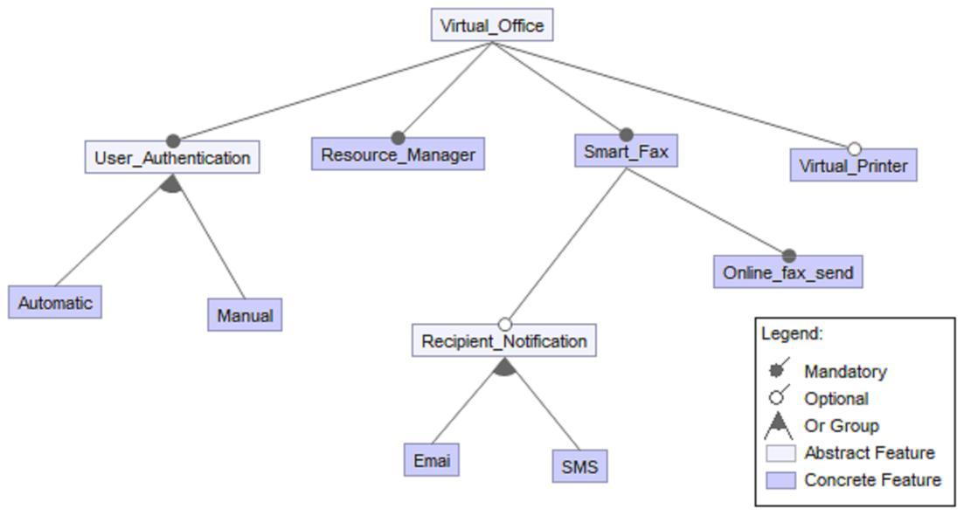

- Feature Model of Virtual Office
The example of the FM in Figure 1 is but trivial, as it contains only eleven (11) features, Virtual Office inclusive (root feature). A real-world FM can have hundreds of features(Berger 2012). In Figure 1, Email and SMS are examples of leaf features. The tree depth is the longest path from the root feature to a leaf node. In Figure 1, the longest path is from Virtual Office to either Email or SMS, which is 3 levels.
FM can quickly become too complex, which makes it challenging to maintain. Therefore, it is essential to evaluate its maintainability continuously. Nonetheless, as the number of features and their inter-relationships grow, FM can become intricate and challenging to maintain(Pohl, Stricker, and Pohl 2013). There have been considerable efforts to predict the maintainability of a Feature Model using machine learning(Bezerra, Andrade, and Monteiro 2014, 2017). In their earlier work(Bezerra, Andrade, and Monteiro 2014), the authors identified 32 quality measures for Feature Models using a systematic mapping study. In their subsequent work(Bezerra, Andrade, and Monteiro 2017), they further analysed the correlations between some of these measures and determined that 15 measures could sufficiently characterize Feature Model quality. These 15 measures were later used to point to the maintainability index in(De Oliveira and Bezerra 2019; Públio Silva et al. 2020). Subsequently, the 15 measures were used as machine learning features by (Públio Silva, Bezerra, and Machado 2023) on a dataset consisting of 342 features extracted from the SPLOT repository(Mendonca, Branco, and Cowan 2009). The authors in (Públio Silva, Bezerra, and Machado 2023)proposed reducing the number of measures needed to evaluate Feature Model maintainability from 15 to 9 measures based on correlation analysis.

In spite of the several contributions of the work in(Públio Silva, Bezerra, and Machado 2023), the approach did not evaluate the impact of various feature selection techniques in further scaling down the number of features while equally maintaining the predictive power of the model. In addition, detection and correction of label noise (Northcutt, Jiang, and Chuang 2021) in the dataset was not explored to improve the generalizability and robustness of the model. Furthermore, the optimal ensemble strategies for maximizing model robustness and accuracy in the context of Feature Model maintainability prediction remain underexplored. To address these gaps, this study focuses on the following objectives:

1.1 Objectives
- To evaluate the efficacy of various feature selection techniques in improving model performance.
- To identify the feature subset that maximizes predictive accuracy while minimizing redundancy.
- To investigate the impact of label noise detection on classification accuracy across multiple models.
- To determine the optimal ensemble strategy for maximizing model robustness and accuracy in the given problem domain.

The review of related works is presented in Section II. The detailed methodology of the study is presented in Section III. Section IV presents and discusses the results, followed by the conclusion in Section V.

2. Related Works
There were concerns about convenient metrics to assess maintainability of variability models. For instance, (El-Sharkawy, Yamagishi-Eichler, and Schmid 2019) conducts a systemic review of existing research to catalogue metrics explicitly developed for managing variability in software product lines. The review identified 42 relevant papers containing 147 metrics used to measure different aspects of variability. The authors later developed MetricHaven, an automated tool that implements these measures(El-Sharkawy, Krafczyk, and Schmid 2020). They then used the tool to evaluate a set of these automated metrics on the Linux Kernel. While the approach supports a vast number of measures, most of them specifically require code artefacts for their computation.
With specific focus of Feature Model, the study in (Bezerra, Andrade, and Monteiro 2014) identified 32 quality measures through a systematic mapping study. In their subsequent work(Bezerra, Andrade, and Monteiro 2017), the authors conducted a deeper analysis of the 32 maintainability measures to determine whether all were necessary for effective Feature Model quality assessment. They used a dataset with 218 Feature Models from the SPLOT repository (Mendonca, Branco, and Cowan 2009). Their findings, based on statistical correlation analysis, revealed that only 15 measures were sufficient to characterize Feature Model quality.
The fifteen (15) measures, as independent variables, were initially aggregated, into one dependent variable in(De Oliveira and Bezerra 2019) using fuzzy logic. Similarly, (Publio Silva et al. 2020) applied machine learning clustering techniques to aggregate the same set of 15 measures into one dependent variable. In both approaches, the aggregated variable represents the maintainability index of a given Feature Model and serves as the class label for machine learning models. Subsequently, (Públio Silva, Bezerra, and Machado 2023) conducted a comparative analysis between the fuzzy logic-based aggregation proposed in (De Oliveira and Bezerra 2019) and the machine learning-based aggregation presented in (Publio Silva et al. 2020) using human experts. The findings indicated that human expert evaluations showed greater agreement with the machine learning-based aggregation method proposed in (Publio Silva et al. 2020). Building on the findings in(Públio Silva, Bezerra, and Machado 2023), the fifteen (15) measures were employed as machine learning features in a dataset consisting of 342 Feature Models extracted from the SPLOT repository(Mendonca, Branco, and Cowan 2009). To further streamline Feature Model maintainability evaluation, the authors proposed reducing the number of measures from 15 to 9 using correlation analysis to identify and eliminate redundant features.
This paper acknowledges that the work in (Públio Silva, Bezerra, and Machado 2023) made several contributions. Nonetheless, the study did not comprehensively examine how different feature selection techniques affect the predictive accuracy of maintainability models. In addition, they did not address the robustness of their models in the presence of label noise, nor did they explore the potential benefits of employing Confident Learning (CL)(Northcutt, Jiang, and Chuang 2021). Furthermore, optimal ensemble strategies in predicting the maintainability of Feature Models are evidently absent. To address these gaps and to achieve the objective set out, this study employed the methodology detailed in the next section.

3. Methodology
This section presents machine learning experiments designed to evaluate the effects of feature selection, ensemble learning, and label noise correction on classification model performance. The pipeline comprised five major processes: data pre-processing, label noise cleaning, hyper parameter tuning, feature selection, and model evaluation. Cleanlab was integrated both before and after feature selection to fully observe its impact on model performance. The entire process followed a modular pipeline as depicted in Figure 2.

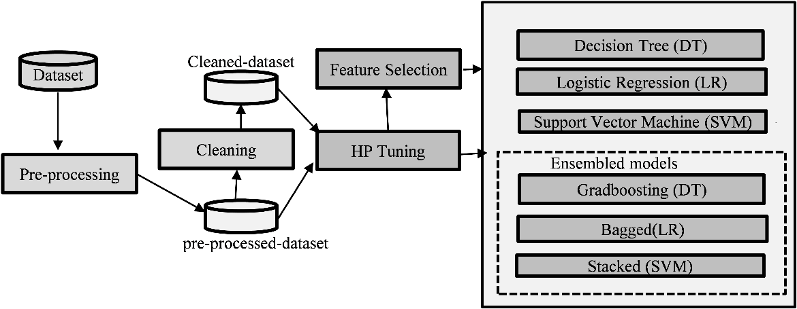
- Overview of the research process

3.1 Dataset and Pre-processing
The same dataset from the previous study on Feature Model maintainability(Públio Silva, Bezerra, and Machado 2023) was used. The dataset consists of 342 records of Feature Models. Each Feature Model’s maintainability index was labelled (bad, good, moderate, very good). For the pre-processing, the labels were encoded and transformed into categorical variables using OneHotEncoder. The other features (numericals) were standardized using StandardScaler. The pre-processed dataset was then passed to the subsequent phases for further refinements.

3.2 Confident Learning for Label Noise Correction
We employed Confident Learning (CL) (Northcutt, Jiang, and Chuang 2021) to systematically estimate label errors. Cleanlab detects noise instances by leveraging predictions from an observer model. The observer model estimates posterior class probabilities which are used to estimate noise in the dataset. It leverages its understanding of the data distribution to detect noise. In this study, both Decision Tree and Logistic Regression were tested as the observer models and both detected roughly the same number of label noise in the dataset.
Eighty (80) records were flagged by Cleanlab suggesting that 23% of the records (or instances) were incorrectly labelled. The flagged records were removed leaving 262 Feature Models. The cleaned dataset was used in parallel with the pre-processed dataset for comparison. Algorithm 1 presents the succinct steps in the noise corrections implemented in Cleanlab.

Algorithm 1: Label Noise Correction with Cleanlab
- Input: raw dataset
- Output: cleaned_dataset
- Load dataset
- Encode target labels
- Set up preprocessing pipeline:
preprocessor ← ColumnTransformer with:
- StandardScaler for numeric_features
- OneHotEncoder for categorical_features
- Build classification pipeline:
model_pipeline ← Pipeline with:
- 'preprocessor': preprocessor
- 'classifier': LogisticRegression(max_iter=1000)
- Perform cross-validated prediction:
predicted_probabilities ← cross_val_predict(
model_pipeline, X, y, cv=5, method='predict_proba' )
- Detect potential label issues
- Remove noisy records

Save cleaned dataset

3.3 Hyperparameter Tuning
Hyperparameter optimisation was conducted using grid search combined with 10-fold cross-validation. Thus, all the models were evaluated under their best-performing parameter settings. The tuned hyperparameters were consistently applied across all experimental runs.

3.3 Feature Selection
To reduce dimensionality and improve model efficiency, we performed feature selection tailored to the model type, resulting in two distinct approaches: (i) Tree-Based Models (Decision Tree) and (ii) Linear-Based Models (Logistic Regression and Support Vector Machine). We employed Recursive Feature Elimination (RFE) (Chen and Jeong 2007) for tree-based models due to its ability to account for feature interactions and dependencies during the elimination process. RFE is a versatile technique compatible with any supervised learning estimator that provides feature importance scores reflecting each feature's contribution to the predicted outcome(Umar, Galadima Ibrahim, and Ndanusa 2023). In this study, we evaluated RFE with Decision Tree Classifier (RFE-DT) and Extra Trees Classifier (RFE-ETC). The Decision Tree Classifier and the Extra Trees Classifier were used here as the sources of determining feature importance.
For linear-based models (Logistic Regression and SVM), we utilized SelectKBest(Ayyanar et al. 2022), a filter-based(Stańczyk 2015) feature selection method that identifies the top k features based on a scoring function. For classification tasks, the default scoring function, Chi², evaluates the influence of each feature on the predictor variable. Additionally, we explored Mutual Information (Mutual Info) as an alternative scoring function to capture feature-target relationships. Thus, we applied SelectKBest with Chi² (SB- Chi²) and Mutual Information (SB-Mutual Info).
Each feature selection method yielded a reduced subset of seven features. These subsets were compared against the full 15-feature set to evaluate their effectiveness in improving model performance.

3.4 Model Development and Evaluation
Decision Tree (DT), Logistic Regression (LR), and Support Vector Machine (SVM) were used. Both baseline models and ensemble-enhanced models were developed: Baseline Models: DT, LR, and SVM without ensembling or noise correction. Ensemble models combine the predictions of multiple individual models trained on a dataset. In this paper, the ensemble techniques were Gradient Boosting for Decision Tree (DT), Logistic Regression (LR) with Bagging, and Support Vector Machines (SVM) with Stacking.

3.5 Identification of Influential Features
In an attempt to further identify the most influential in predicting maintainability, feature importance was assessed by analysing the rankings generated by various feature selection methods, identifying those unanimously 'voted' as important by all the methods. If a feature is consistently "voted" as important by different methods, it is likely to be a truly influential factor. This approach helps build consensus and increases confidence in the results, as it is not reliant on a single method's ranking.

4. Results and Discussions
This section presents and interprets the experimental results. Figure 3 presents a comparison between Decision Tree, Logistic Regression, and SVM. The results were obtained after replicating the experiment in [16] with the same hyper-parameters and 10-step cross-validation. The graph shows that the Decision Tree model has the highest accuracy at 94.12%, followed by Logistic Regression at 77.14%, and SVM at 71.43%. For the Decision Tree, it is approximately the same results obtained in(Públio Silva, Bezerra, and Machado 2023). For the Logistic Regression, we recorded higher results than(Públio Silva, Bezerra, and Machado 2023). Nevertheless, the results are considered a benchmark. However, (Públio Silva, Bezerra, and Machado 2023) did not use the SVM model.
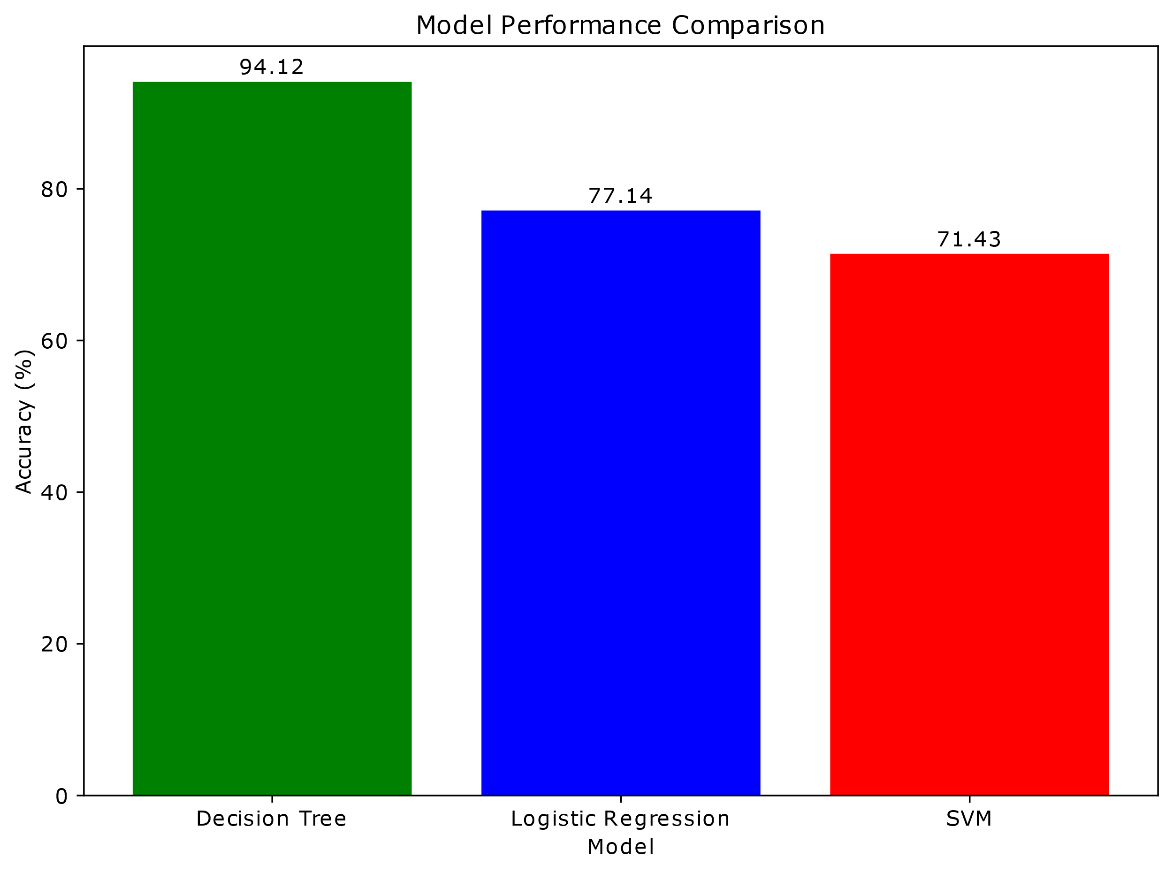
- performance comparisons on three models with the 15 features, no ensembling, and no cleaning of the dataset
Figure 4 compares four Decision Tree models under different configurations: a baseline Decision Tree (without ensembling or Cleanlab), a Decision Tree with GradBoosting (ensembling only), a Decision Tree enhanced with Cleanlab (without ensembling), and a combined approach (Decision Tree GradBoosting + Cleanlab). These models were evaluated using three distinct feature selection methods: (i) a full set of 15 features, (ii) 7 features selected via Recursive Feature Elimination (RFE) with a Decision Tree estimator (RFE-DT), and (iii) 7 features selected via RFE with an Extra Trees Classifier (RFE-ETC).

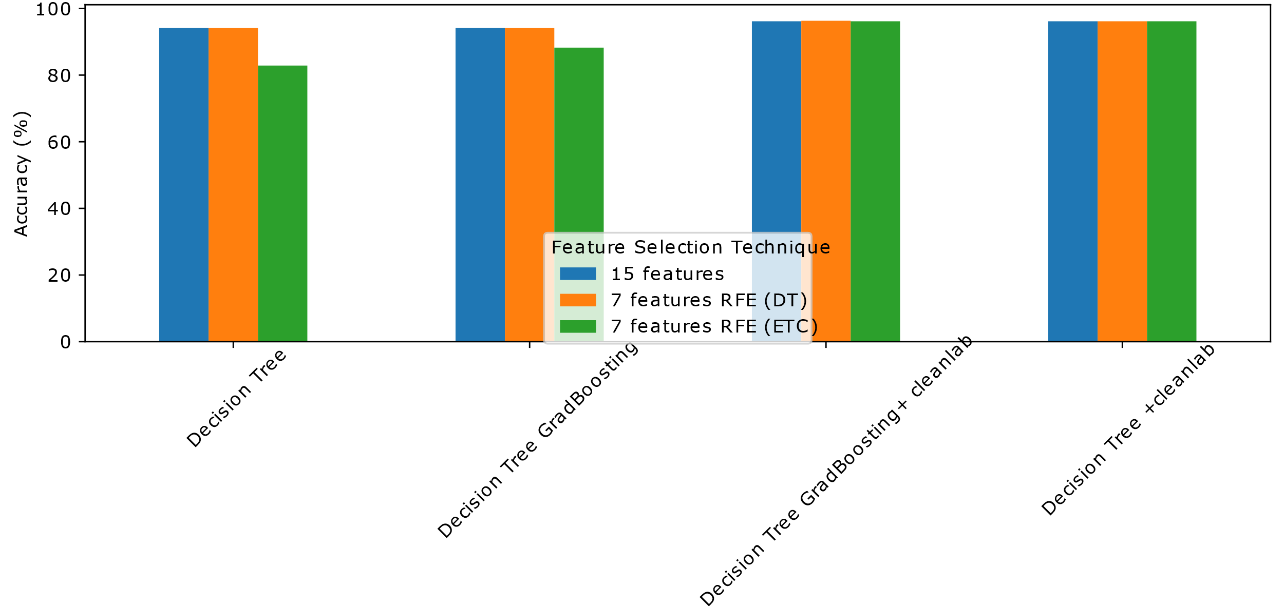
- Comparative analysis of four Decision Tree models, each evaluated using three distinct feature selection methods
A key observation in Figure 4 is that the RFE-DT (orange bar in Fig.4) method-using only 7 features consistently achieves performance comparable to the full 15-feature set across all four models. This suggests that the subset of features selected by RFE-DT sufficiently retain the essential predictive power of the larger feature space. This pattern holds regardless of whether ensembling (GradBoosting) or noise correction (Cleanlab) is applied.

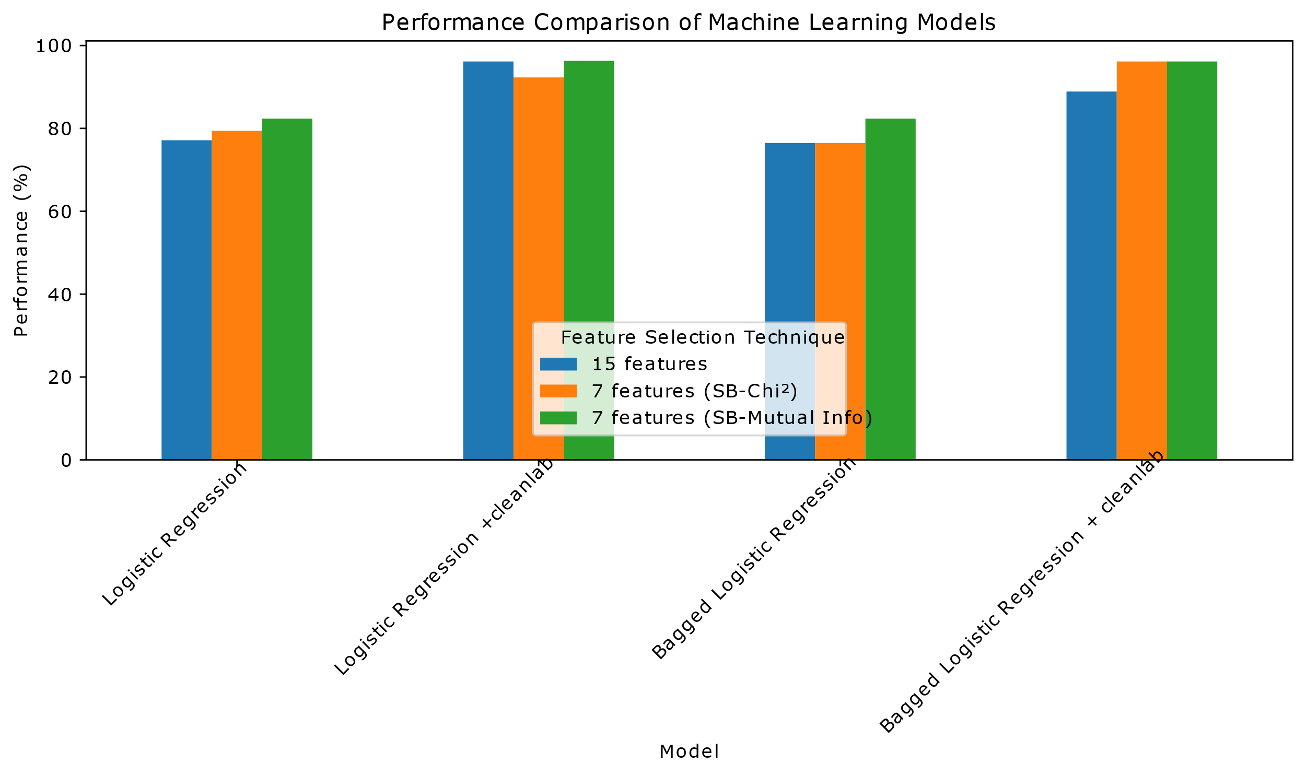
- Comparative analysis of four Logistic Regression models, each evaluated using three distinct feature selection methods
The presented graph in Figure 5 compares four Logistic Regression model configurations: (i) a baseline Logistic Regression model (ii) a Bagged Logistic Regression, (iii) Logistic Regression with Cleanlab, and (iv) a Bagged Logistic Regression + Cleanlab. The four (4) different configurations above were evaluated using the following three (3) feature selection strategies: the complete set of 15 features, a reduced set of 7 features selected through the Chi² statistical method, and another 7-feature subset chosen via Mutual Information criteria.

The results in Figure 5 reveal that models utilizing just 7 features selected through Mutual Information (Green Bar in Fig.5) equalled and, in some cases, slightly surpassed the performance of models employing the full 15-feature set. This outcome suggests that the Mutual Information feature selection method not only maintains but enhances predictive power of a model with fewer features.
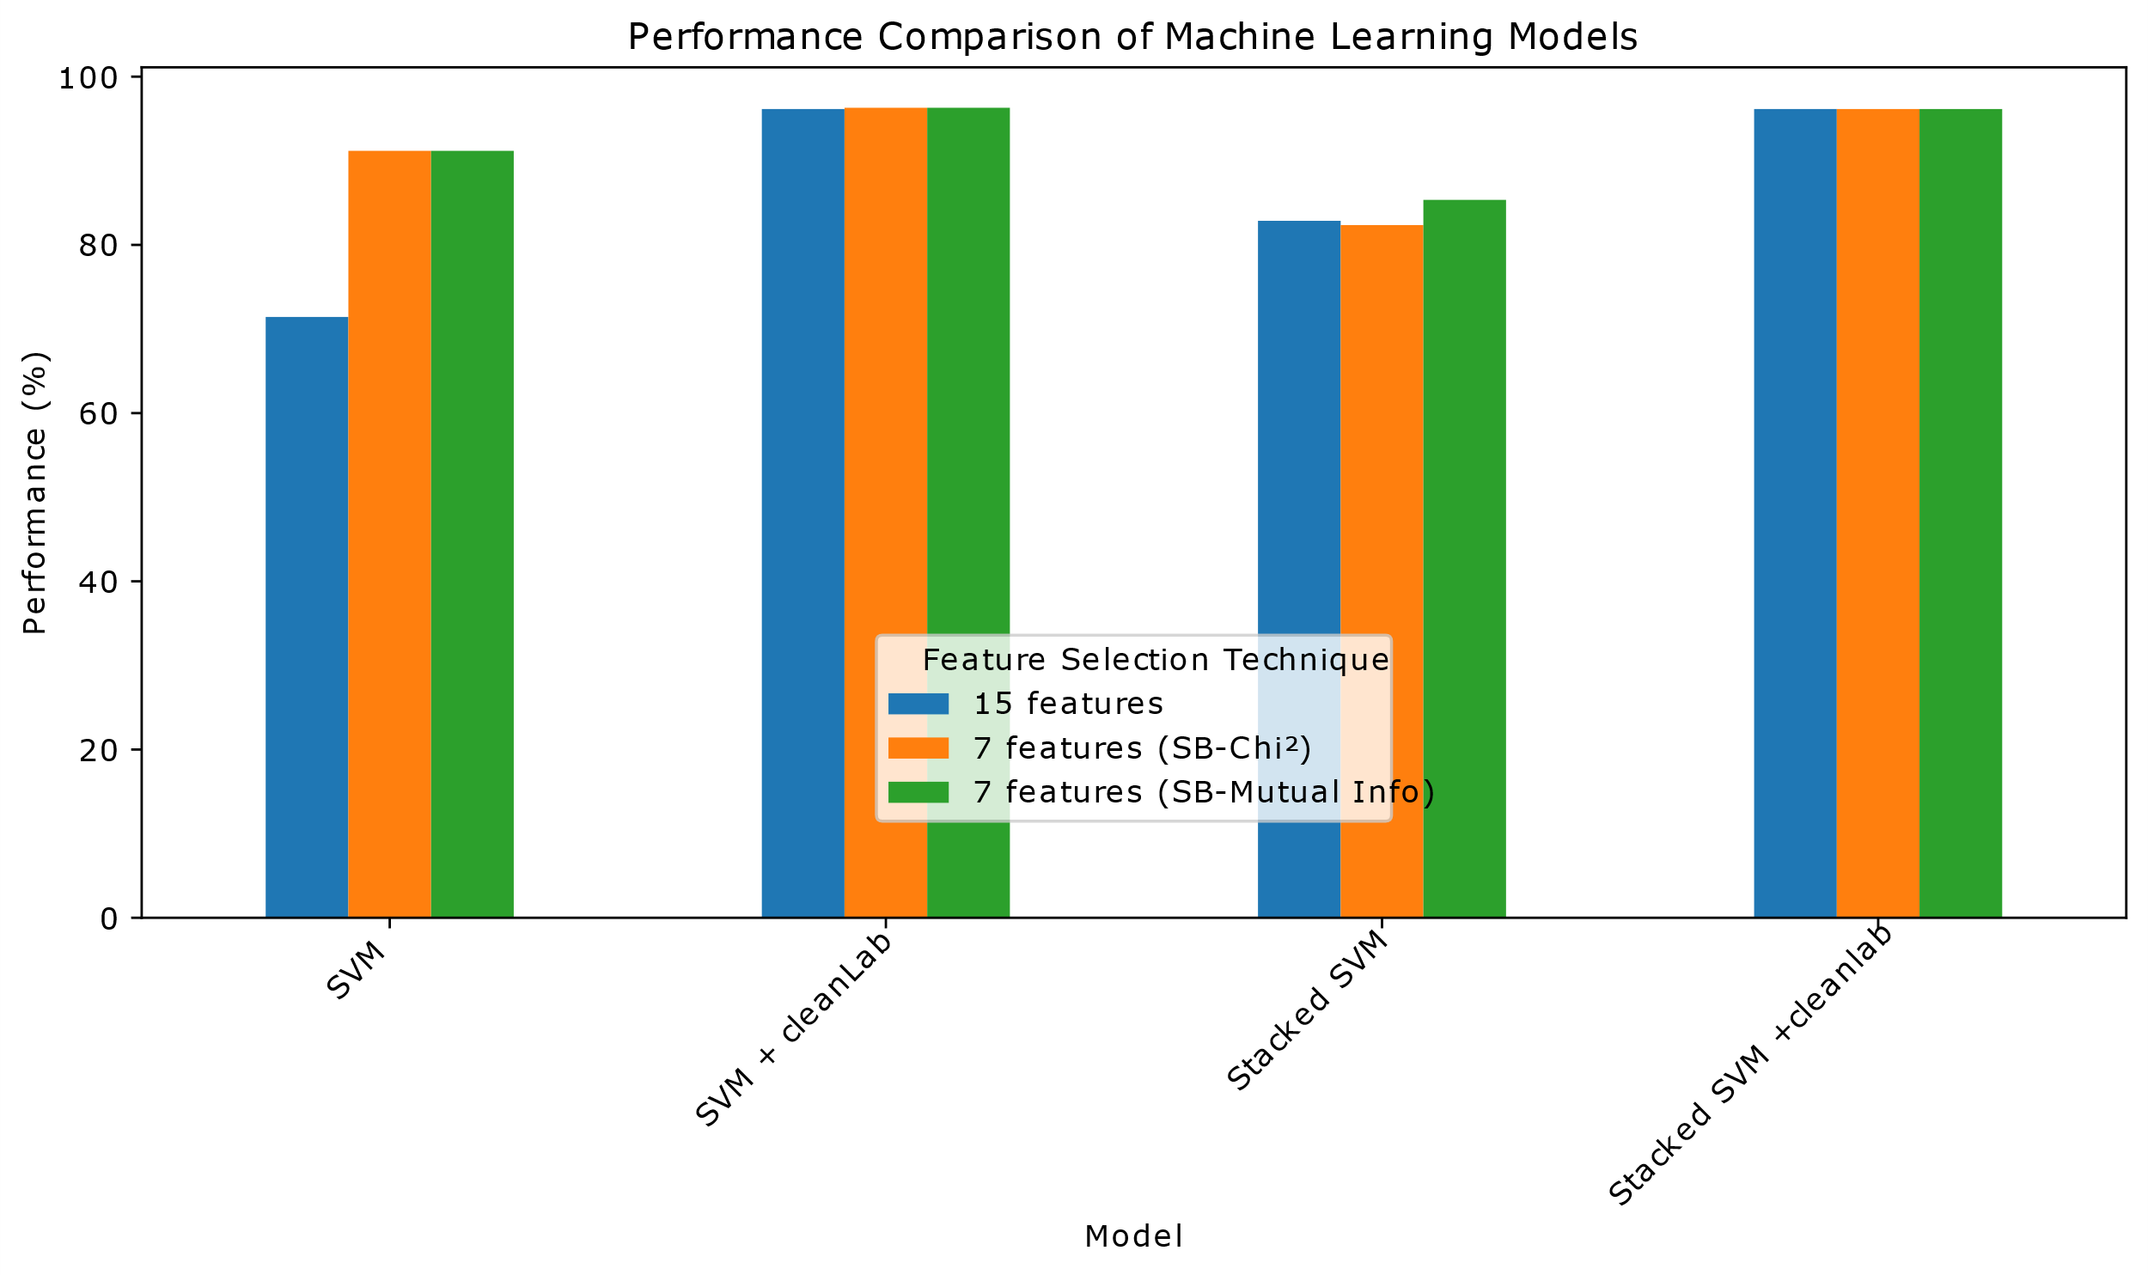
- Comparative analysis of four SVM models, each evaluated using three distinct feature selection methods

The bar graph in Figure 6 compares four Support Vector Machine (SVM) models: (i) a baseline SVM model, (ii) an SVM + Cleanlab (iii) a Stacked SVM model, and (iv) a Stacked SVM + Cleanlab. These configurations were evaluated using three distinct feature selection strategies: the complete set of 15 features, a reduced set of 7 features selected through the Chi² statistical method, and another 7-feature subset chosen via Mutual Information criteria in the graph.
The results in Figure 6 reveal that models utilizing just 7 features selected through Mutual Information (Green Bar in Fig.6) consistently matched and, in some cases, slightly surpassed the performance of models employing the full 15-feature set.
In Figure 7, it can be observed that the accuracy of the Decision Tree model remains unchanged at 94.12% even after applying GradBoosting. The accuracy of the Logistic Regression model decreases from 77.14% to 76.47% after applying bagging. However, ensembling techniques can be effective in improving the performance of SVM models as the accuracy of the SVM model increases from 71.43% to 82.86% after applying stacking.

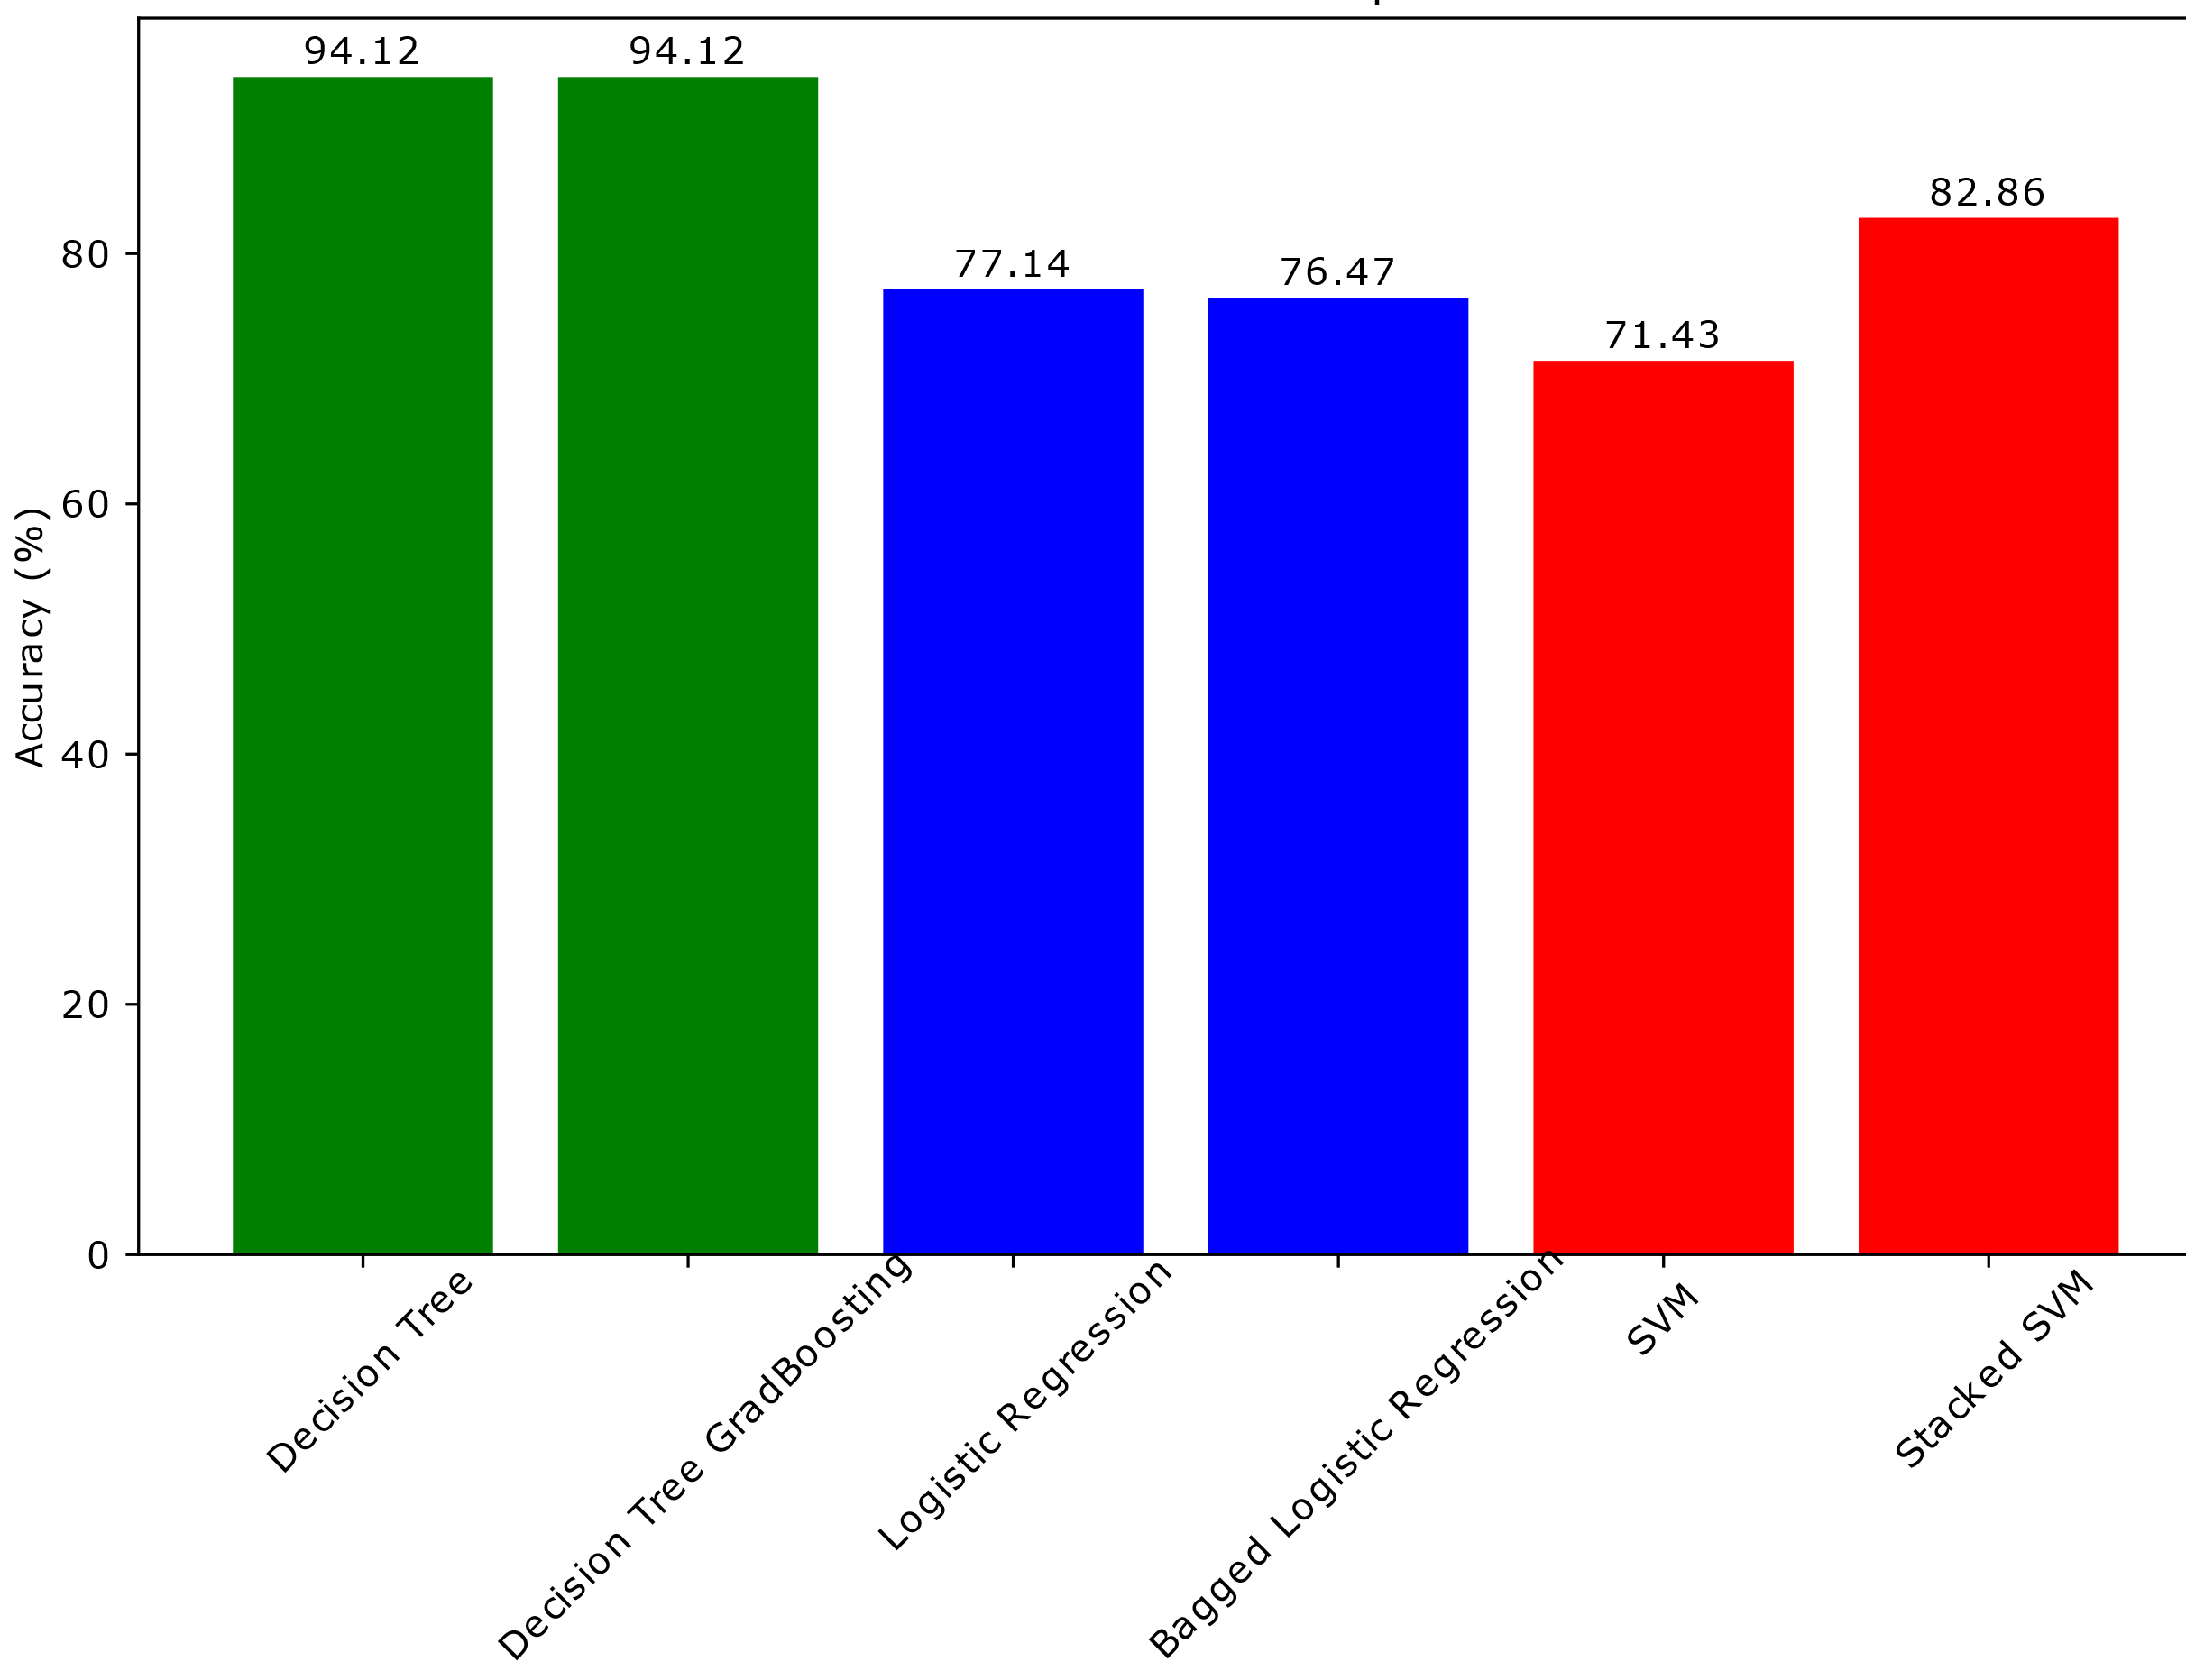
- Comparative analysis of three distinct models, each evaluated using its corresponding ensembling technique
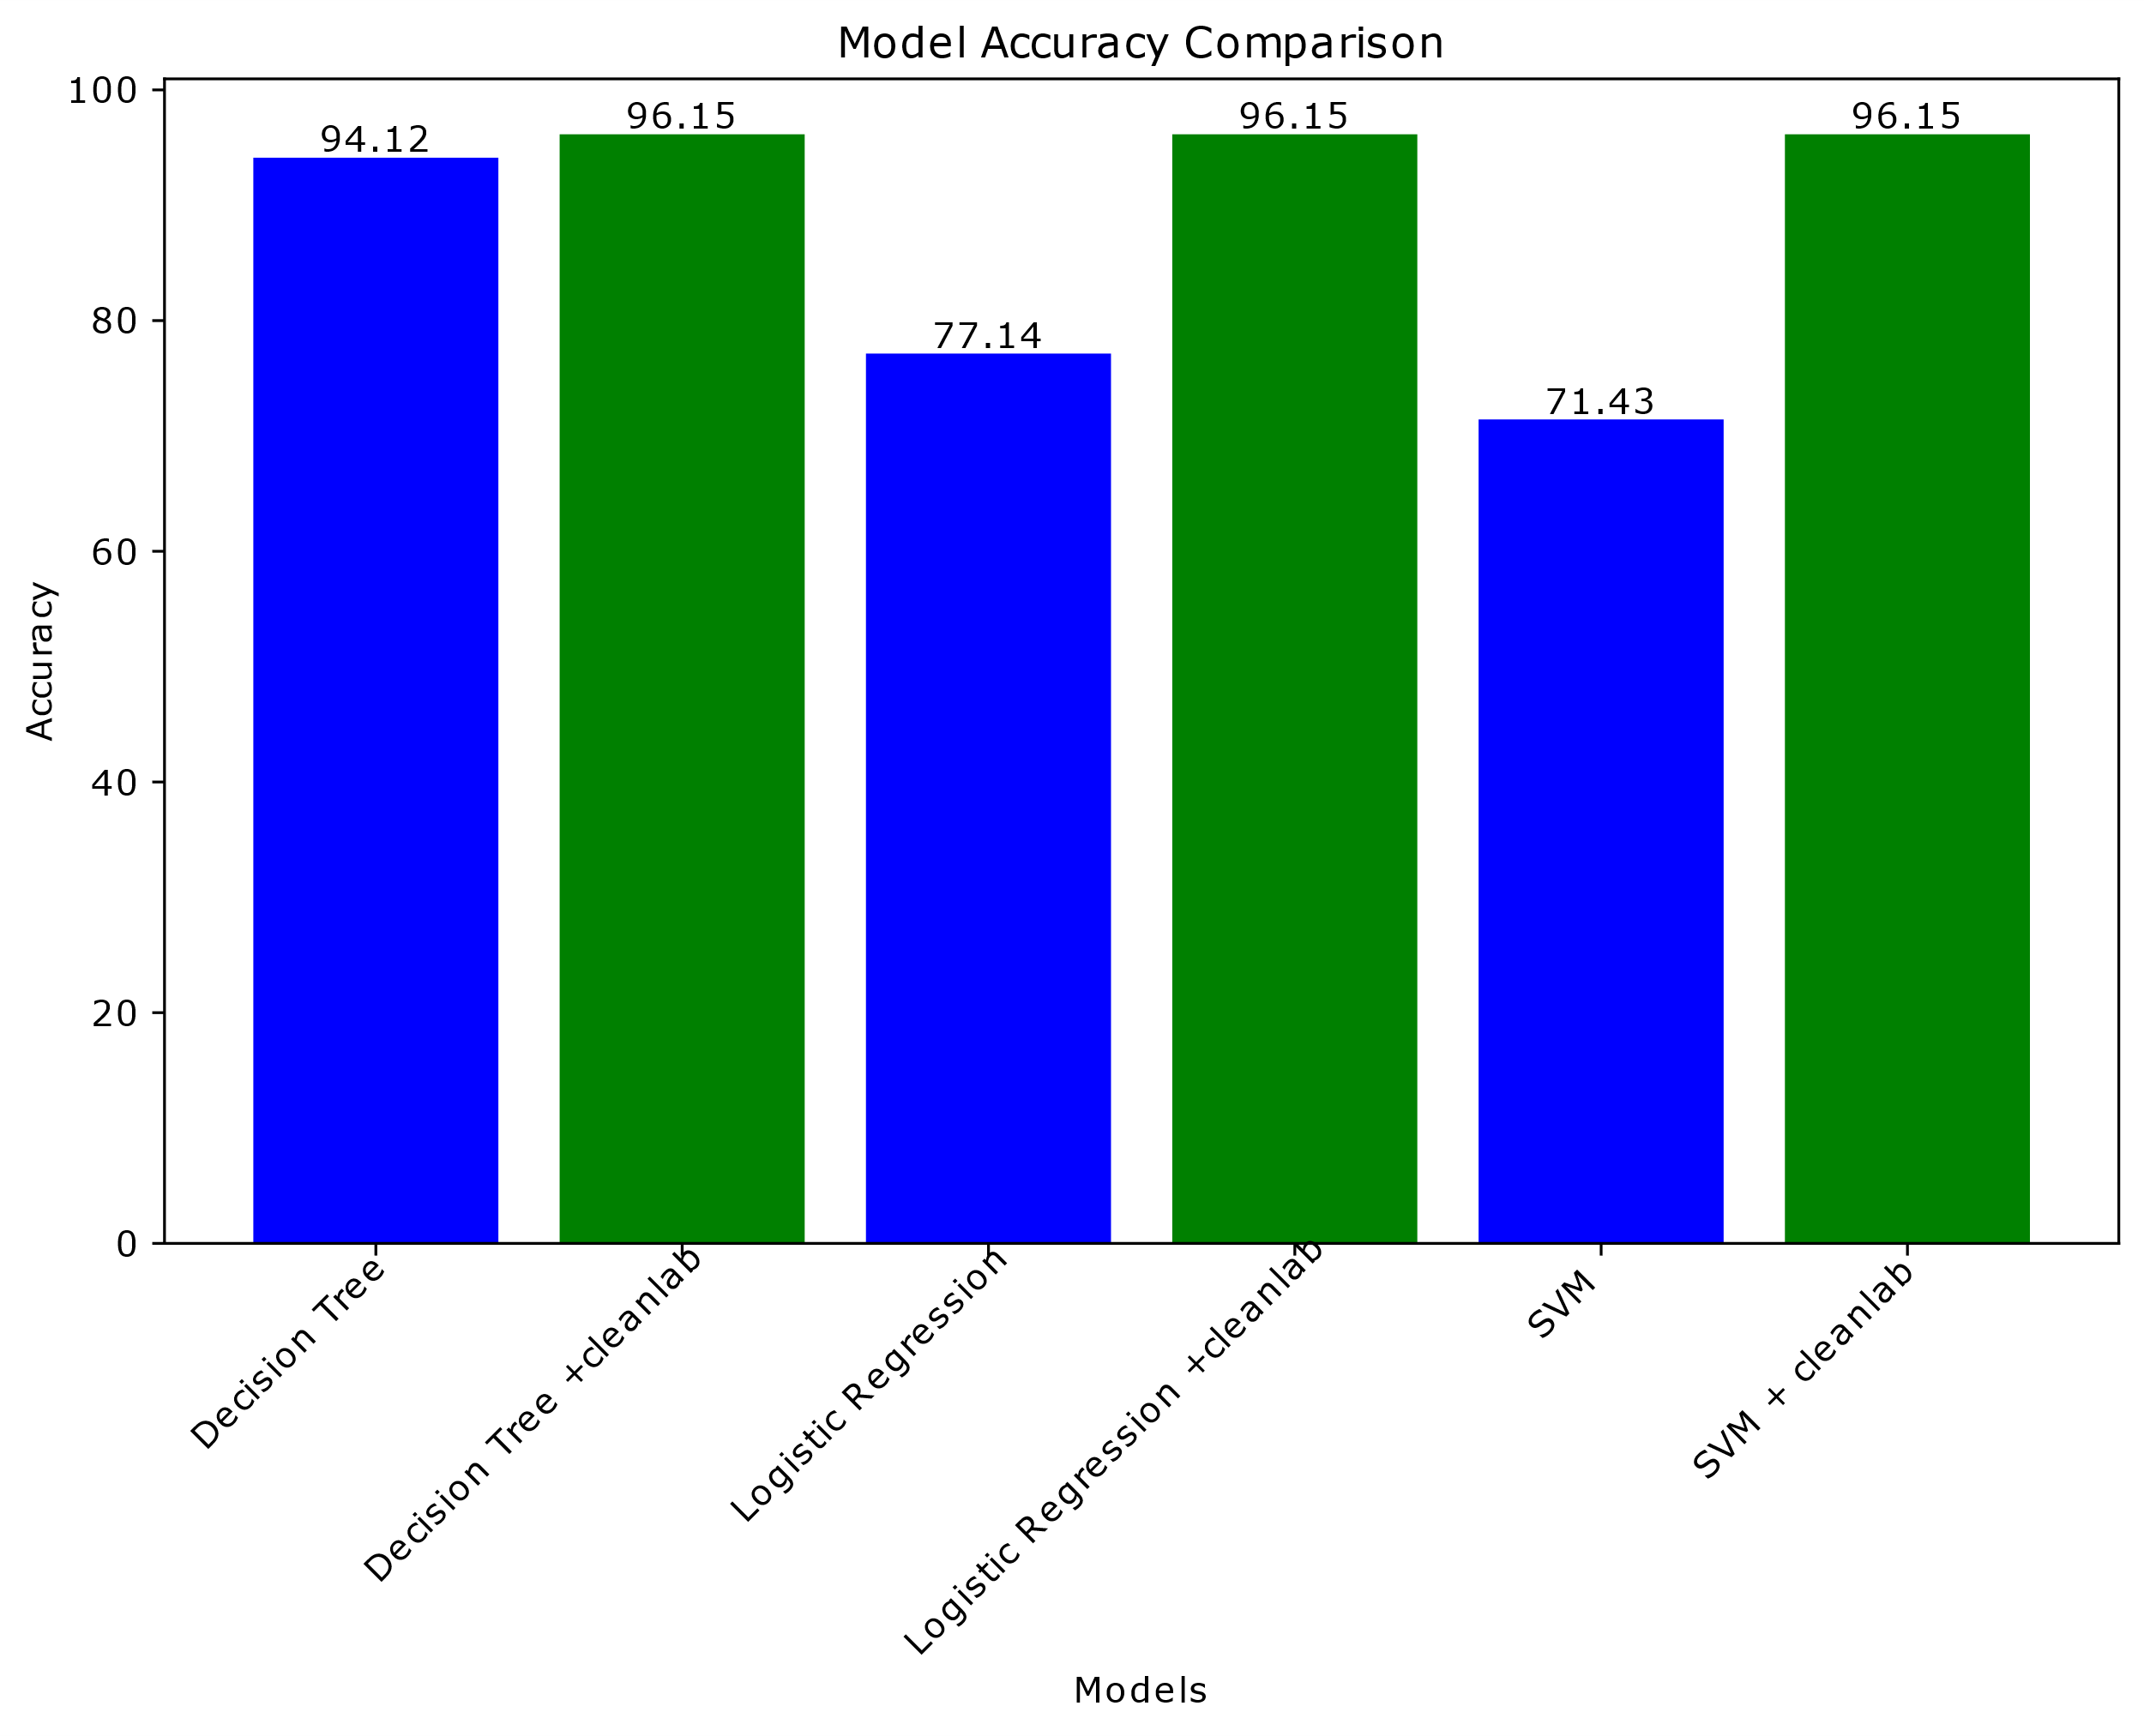
- Comparative analysis of three distinct models, each evaluated with and without Cleanlab
Looking at Figure 8, the accuracy of the Decision Tree model increases from 94.12% to 96.15% when Cleanlab is used. The improvement is relatively modest at 2.03%. In contrast, the impact of Cleanlab on Logistic Regression is more significant as its accuracy increases from 77.14% to 96.15% when Cleanlab is used, representing an improvement of 19.01% (see Figure 8). The most significant impact of Cleanlab is seen in SVM, where the accuracy increases from 71.43% to 96.15%. This represents an improvement of 24.72%. Interestingly, regardless of the initial accuracy of the model, Cleanlab optimizes the performance of all the models to a maximum accuracy of 96.15%. This suggests that whichever model is used, Cleanlab can push its performance to the maximum.

4.1 The most influential features
This study sought to identify the most influential features that affect maintainability, with the goal of prioritizing them not only during the refactoring of existing Feature Models but also during the initial modelling process. By doing so, we can enhance the overall practice of Feature Modelling. To achieve this, we compared and ranked the features selected by various methods, as presented in Table I.
- Feature ranking by selection method

Selection Method | 1st | 2nd | 3rd | 4th | 5th | 6th | 7th
RFE (DT) | NF | NM | NTop | NLeaf | DTMax | FoC | RoV
RFE (ETC) | NF | NM | NLeaf | DTMax | CogC | FEX | FoC
LR (Chi²) | NF | NLeaf | FEX | CogC | NM | NGXOr | DTMax
LR (Mutual Info) | NF | NLeaf | FEX | DTMax | CogC | NGOr | RoV

From Table I, we can notice that the most influential features are NF, NLeaf, and DTMax as these features were picked-up by all the selection methods even though they were ranked differently. These features are explained in Table II. On a closer look, all the other features are derivatives of the three most influential features as explained in Table III. The three most influential features offer a comprehensive, yet minimal lens to assess the structural integrity and evolutionary potential of a Feature Model. All other sophisticated metrics, whether about constraints, cycles, or configurability, can be interpreted as extensions, transformations, or normalizations of these three the most influential features.
- The most influential features
ID | Feature | Description
NF | Number of Features | Total number of features in the model. Forms the foundation for size, variability, and structural metrics.
NLeaf | Number of Leaf Features | Number of terminal nodes (features without children). Reflects model modularity and structural termination.
DTMax | Maximum Tree Depth | Longest path from the root to any leaf. Captures the vertical complexity and hierarchical depth of the model.

- The remaining 12 features and their relationship with the 3 most influential features
ID | Feature | Description
NM | Number of Mandatory Features | Subset of NF. Reflects rigidity and minimum inclusion of features.
NTop | Number of Top Features | Children of the root node; a subset of NF influenced by hierarchy.
CogC | Cognitive Complexity | Inferred from structure and constraints; affected by depth, optionality, and feature relationships.
FEX | Feature Extensibility | Derived from feature optionality and depth.
FoC | Flexibility of Configuration | Reflects the adaptability of the model; indirectly affected by optional/alternative features.
NVC | Number of Valid Configurations | Driven by constraints across NF; reflects functional breadth.
RoV | Ratio of Variability (NVC / NF²) | Normalized variability metric.
RDen | Constraint Density | Average number of features involved in constraints, often scaled by NF.
NGXOr | Number of XOR Groups | Reflects variation architecture; subset of feature relationships.
NGOr | Number of OR Groups | Similar to NGXOr; alternative variability.
SCDF | Single Cycle Dependency Features | Features involved in a single unique cycle.
MCDF | Multiple Cycle Dependency Features | Features involved in multiple cycles; indicates higher complexity.
(Optional)/NF | Ratio of Optional Features | Proportion of features that are optional, derived from NF.
NLeaf + SCDF + MCDF | Composite Structural-Cycle Index | Measures structural termination and cyclicity combined.

To further validate the three features as the most influential, DT models trained with the full 15 features and the three features were compared with and without Cleanlab and the results are presented in Table IV.
Looking at Table IV, first row, where the model is trained with 15 features, the model overfitted as suggested by the wide gap between the training and testing accuracies; F1 and cross-validation accuracies. In contrast, when trained with the only 3 features but with Cleanlab, achieved the highest testing accuracy (92.45%) and F1 Cross-Validation score (93%), suggesting a more stable and generalizable model.
- Comparison between the full 15 features and the three most influential features
No. features | Model | Training Accuracy | Testing Accuracy | Validation F1 | Cross-Validation
15 | Decision Tree | 100 | 79.71 | 78 | 91.18
15 | Decision Tree + Cleanlab | 89.47 | 90.57 | 89 | 96.15
3 | Decision Tree | 86.45 | 78.26 | 79 | 88.24
3 | Decision Tree + Cleanlab | 88.52 | 92.45 | 93 | 96.3

4.2 Discussions
Figures 3, 4, and 5 show that feature selection substantially impacts model performance. Specifically, in Decision Tree, the Recursive Feature Elimination with Decision Tree (RFE-DT) method, using just 7 features, retained comparable accuracy to the full 15-Feature Model. For Logistic Regression and SVM, the Mutual Information method consistently yielded performance on par with, or even superior to, the complete feature set.

Figure 7 demonstrates that ensemble methods show mixed effectiveness: Decision Trees saw no benefit from Gradient Boosting. Logistic Regression performance decreased slightly with Bagging. SVM, however, greatly improved with Stacking, increasing from 71.43% to 82.86%.
Figures 4-8, and particularly Figure 8, highlight the impact of Cleanlab: Decision Tree: Accuracy improved from 94.12% to 96.15%. Logistic Regression: Accuracy jumped significantly from 77.14% to 96.15% (+19.01%). SVM: Improved from 71.43% to 96.15% (+24.72%). Notably, the use of Cleanlab pushed the performance of all models to a maximum accuracy of 96.15%.
Table I reveals that NF (Number of Features), NLeaf (Number of Leaf Features), and DTMax (Maximum Tree Depth) were selected unanimously by all feature selection methods, despite differences in ranking. The results in Table IV show that when the DT model was trained with the only 3 features but with Cleanlab, it achieved the highest testing accuracy (92.45%) and F1 Cross-Validation score (93%), making it the most robust and generalizable model among those tested. In contrast, the baseline Decision Tree model (with all 15 features and no Cleanlab) overfit the training data, achieving 100% training accuracy but only 79.71% testing accuracy. Thus, label correction not only optimizes performance but also strengthens generalizability of models. Nonetheless, the observed performance improvements were not tested for statistical significance and the results may not be generalizable over other datasets of Feature Models.

One of the major practical implications of these findings from this research is that scaling down the number of features (NF) is not only practical but advisable, provided it does not diminish the number of valid product configurations. The number of features without children (NLeaf) often implies mandatory features. However, not all mandatory features need to be explicitly modelled, especially if they do not introduce variation points. This aligns with the “Kernel-First” approach proposed in(Gomaa 2005), which emphasizes platform-based development, and resonates with the concept of core program and deltas in Delta-Oriented Programming(Schaefer et al. 2010); core program and features in Feature Oriented Programming.
The intent of a Feature Model is not to exhaustively list all product features visible to customers, but to represent and manage variability(K. Lee, Kang, and Lee 2002). In this context, mandatory features that do not contribute to variability should not be presented in the model provided that the model’s expressive power is not affected. This ensures that the Feature Modelling focuses on what differentiates one product from another, rather than graphical representation of all features.

5. Conclusion
This study aimed to enhance the prediction of Feature Model maintainability using machine learning techniques. The findings suggest that machine learning models can retain predictive power with fewer, carefully selected features. Specifically, the Recursive Feature Elimination with Decision Tree (RFE-DT) method and Mutual Information method consistently yielded comparable or superior performance to the full feature set. Notably, Cleanlab, a label noise correction technique, had a profound impact on model performance, pushing all models to a maximum accuracy of 96.15%. The study identified the Number of Features (NF), Number of Leaf Features (NLeaf), and Maximum Tree Depth (DTMax) as the most influential features in determining Feature Model maintainability.

References
Ayyanar, Manikandan, Selvaprabu Jeganathan, Saravanan Parthasarathy, Vaishnavi Jayaraman, and Arun Raj Lakshminarayanan. 2022. “Predicting the Cardiac Diseases Using SelectKBest Method Equipped Light Gradient Boosting Machine.” In 2022 6th International Conference on Trends in Electronics and Informatics, ICOEI 2022 - Proceedings, 117–22. doi:10.1109/ICOEI53556.2022.9777224.
Berger, Thorsten. 2012. “Variability Modeling in the Wild.” In Proceedings of the 16th International Software Product Line Conference, 233–40. doi:10.1145/2364412.2364452.
Beuche, Danilo, and Jens Weiland. 2009. “Managing Flexibility: Modeling Binding-Times in Simulink.” In European Conference on Model Driven Architecture-Foundations and Applications, Springer, Berlin, Heidelberg, 289–300. doi:10.1007/978-3-642-02674-4_21.
Bezerra, Carla I.M., Rossana M.C. Andrade, and Jose Maria Monteiro. 2017. “Exploring Quality Measures for the Evaluation of Feature Models: A Case Study.” Journal of Systems and Software 131: 366–85. doi:10.1016/j.jss.2016.07.040.
Bezerra, Carla I.M., Rossana M.C. Andrade, and José Maria S. Monteiro. 2014. “Measures for Quality Evaluation of Feature Models.” In Lecture Notes in Computer Science (Including Subseries Lecture Notes in Artificial Intelligence and Lecture Notes in Bioinformatics), doi:10.1007/978-3-319-14130-5_20.
Chen, Xue Wen, and Jong Cheol Jeong. 2007. “Enhanced Recursive Feature Elimination.” In Proceedings - 6th International Conference on Machine Learning and Applications, ICMLA 2007, doi:10.1109/ICMLA.2007.44.
El-Sharkawy, Sascha, Adam Krafczyk, and Klaus Schmid. 2020. “Fast Static Analyses of Software Product Lines - An Example with More than 42,000 Metrics.” In ACM International Conference Proceeding Series, doi:10.1145/3377024.3377031.
El-Sharkawy, Sascha, Nozomi Yamagishi-Eichler, and Klaus Schmid. 2019. “Metrics for Analyzing Variability and Its Implementation in Software Product Lines: A Systematic Literature Review.” Information and Software Technology 106: 1–30. doi:10.1016/j.infsof.2018.08.015.
Gomaa, Hassan. 2005. “Designing Software Product Lines with UML.” In 29th Annual IEEE/NASA Goddard Software Engineering Workshop - Tutorial Notes, doi:10.1109/SEW.2005.5.
Kang, Kyo C; Cohen, Sholom G.; Hess, James A.; Novak, William E.; Peterson, A. Spencer. 1990. “Feature-Oriented Domain Analysis (FODA) Feasibility Study.” doi:CMU/SEI-90-TR-21.
Lee, Jaejoon, Dirk Muthig, and Matthias Naab. 2010. “A Feature-Oriented Approach for Developing Reusable Product Line Assets of Service-Based Systems.” Journal of Systems and Software 83(7): 1123–36. doi:10.1016/j.jss.2010.01.048.
Lee, K, KC Kang, and J Lee. 2002. “Concepts and Guidelines of Feature Modeling for Product Line Software Engineering.” International Conference on Software Reuse: 62–77.
Mendonca, Marcilio, Moises Branco, and Donald Cowan. 2009. “S.P.L.O.T. - Software Product Lines Online Tools.” In Proceedings of the Conference on Object-Oriented Programming Systems, Languages, and Applications, OOPSLA, doi:10.1145/1639950.1640002.
Northcutt, Curtis G., Lu Jiang, and Isaac L. Chuang. 2021. “Confident Learning: Estimating Uncertainty in Dataset Labels.” Journal of Artificial Intelligence Research 70: 1373–1411. doi:10.1613/JAIR.1.12125.
De Oliveira, Davi Cedraz S., and Carla I.M. Bezerra. 2019. “Development of the Maintainability Index for SPLS Feature Models Using Fuzzy Logic.” In ACM International Conference Proceeding Series, doi:10.1145/3350768.3351299.
van Ommering, Rob. 2000. “Beyond Product Families: Building a Product Population?” International Workshop on Software Architectures for Product Families: 187–98.
Pohl, Richard, Vanessa Stricker, and Klaus Pohl. 2013. “Measuring the Structural Complexity of Feature Models.” 2013 28th IEEE/ACM International Conference on Automated Software Engineering, ASE 2013 - Proceedings: 454–64. doi:10.1109/ASE.2013.6693103.
Schaefer, Ina, Lorenzo Bettini, Viviana Bono, Ferruccio Damiani, and Nico Tanzarella. 2010. “Delta-Oriented Programming of Software Product Lines.” In International Conference on Software Product Lines, Springer Berlin Heidelberg, 77–91. doi:10.1007/978-3-642-15579-6_6.
Silva, Publio, Carla I.M. Bezerra, Rafael Lima, and Ivan Machado. 2020. “Classifying Feature Models Maintainability Based on Machine Learning Algorithms.” In Proceedings of the 14th Brazilian Symposium on Software Components, 2020 dl.acm.org: 1–10. doi:10.1145/3425269.3425276.
Silva, Públio, Carla Bezerra, and Ivan Machado. 2023. “Automating Feature Model Maintainability Evaluation Using Machine Learning Techniques.” Journal of Systems and Software 195. doi:10.1016/j.jss.2022.111539.
Stańczyk, Urszula. 2015. “Feature Evaluation by Filter, Wrapper and Embedded Approaches.” Studies in Computational Intelligence 584: 29–44. doi:10.1007/978-3-662-45620-0_3.
Umar, Armaya’u Zango, Yakubu Galadima Ibrahim, and Ahmad Ndanusa. 2023. “Detecting Anomalies In Network Traffic Using a Hybrid of Linear-Based and Tree-Based Feature Selection Approaches.” In Proceedings of 2nd International Conference on Computing and Advances in Information Technology (ICCAIT 2023), Ahmadu Bello University Zaria., , 21–23. https://iccait.com.ng/wp-content/uploads/2025/01/60.pdf.

